Riparian Buffer Planting and Honeysuckle Removal: Buckingham Pond Conservancy Spring Clean-Up (2019)

Prepared by Gwendolyn Temple, Aquatic Invasive Species Coordinator

Buckingham Pond Conservancy has an annual spring clean-up where the community gets together to clean up the area around Buckingham Pond, a stormwater retention pond centered in Buckingham Pond/Crestwood neighborhood. As part of their clean-up efforts this year, they recruited Gwendolyn Temple from the Capital Mohawk PRISM to cut and plant live stakes of a particular native species along the edge of the pond for soil retention/erosion control. This species was red osier dogwood, a native deciduous multi-stemmed shrub which was found surrounding the pond. A removal of two extensive patches of invasive honeysuckle found alongside the pond was also implemented at this time in order to reduce the potential for ticks to spread to the nearby playground.
Project Description: Planting native live stakes of red osier dogwood and removing two extensive patches of invasive honeysuckle around Buckingham Pond.
Date: April 14, 2019
Participants: Gwendolyn Temple / Spencer Barrett / Buckingham Pond Conservancy / Local volunteers
Point of Contact: Capital Mohawk PRISM / Buckingham Pond Conservancy
County: Albany
Buckingham Pond (City of Albany, Buckingham Pond Conservancy): Prior scouting around Buckingham Pond took place on March 11th with Spencer Barrett, the Capital Mohawk PRISM terrestrial coordinator as well as a PRISM volunteer and Loretta McNamee, one of the PRISM’s interns. During this survey, the patches of honeysuckle were discovered near the local playground, leading Gwendolyn Temple, who had previous contact with the Buckingham Pond Conservancy (BPC), to recommend a removal of the two patches. During her discussion with BPC, a recommendation was also made to plant native species near the removed patches of honeysuckle in order to reduce new growth potential. This led to the discussion of cutting red osier dogwood live stakes from around the pond and planting them during the honeysuckle removal.
On April 7th, BPC had their annual meeting and worked to drum up volunteers for the spring clean-up taking place on April 14th. As a result, 26 participants showed up to help plant native live stakes, remove honeysuckle, and clean up the area surrounding the playground nearby.
Invasive Species Present at Buckingham Pond:
Common Name | Scientific Name | Locations (GPS) | Growth Type | Phenology
Honeysuckle spp. | Lonicera spp. | 42.6643, -73.8088 | Shrub | High seed production/bird dispersal

Native Community Types: Freshwater forested/shrub wetland
Treatment Method: Manual removal
Summary of Work Completed:
  - Education and outreach event: Discussion of native live stake planting was had during the BPC annual meeting on April 7th
  - Invasive species removal (42.6643, -73.8088)
    - 12 direct contacts/participants
    - 6 honeysuckle (spp.) stumps
    - Enough biomass to fill a full-sized pick-up truck
  - Native live stake planting
    - 5 direct contacts/participants
    - 45 red osier dogwood live stakes planted

Recommendations for the Future: Both patches of honeysuckle have been extensively cut back, but the root system remains intact. Therefore, one recommendation would be to go back to the site to fully remove the honeysuckle and plant native shrubs in its place (i.e. gray dogwood, red osier dogwood, nannyberry) both for native restoration purposes and erosion control. The red osier dogwoods should also be monitored to ensure that at least 50% survive into the summer months (survival of live stakes is ensured through repeated monitoring to look for new growth along the stakes).
Due to the location of the site (highly urbanized area), a greater effort needs to be made to reach out to the community and provide education/outreach regarding invasive species. Based on preliminary surveys, the area surrounding the pond is already inundated with terrestrial invasives like phragmites, oriental bittersweet, honeysuckle, garlic mustard, purple loosestrife, privet, and Norway maple. While this may not be a location for extensive invasive species removal due to the number of tier 4 species already impacting the area, it would be a good location to show spread vectors (roads, walking trails, runoff, mowing zones, etc.) and the detriments of invasive species.

Contact Gwendolyn Temple at ggt25@cornell.edu for any questions regarding this report.
Figure 1: Honeysuckle before (left) and after (right). This was directly across from the local playground and thus posed a significant tick threat.
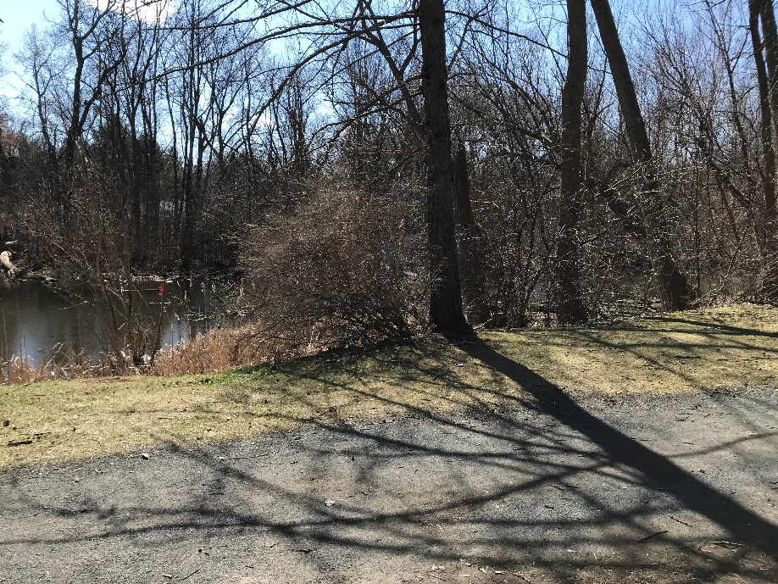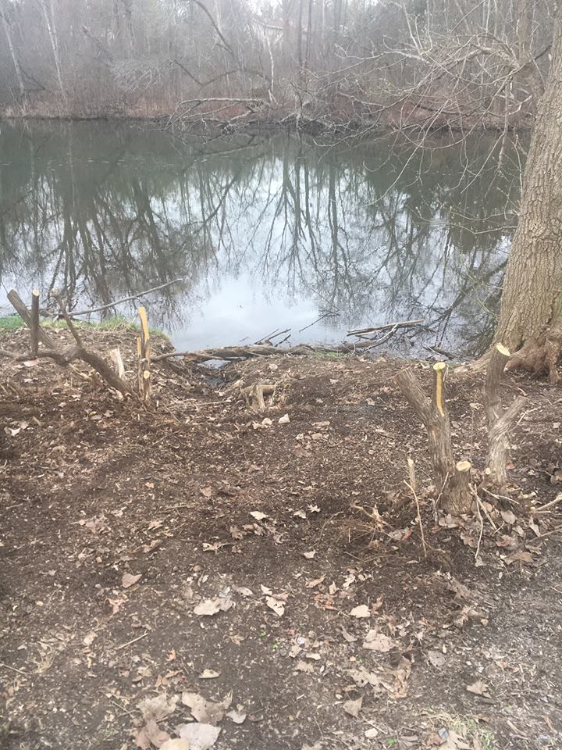

Figure 2: Grace Charlie Noah from Buckingham Pond Conservancy bagging honeysuckle branches for ease of removal.
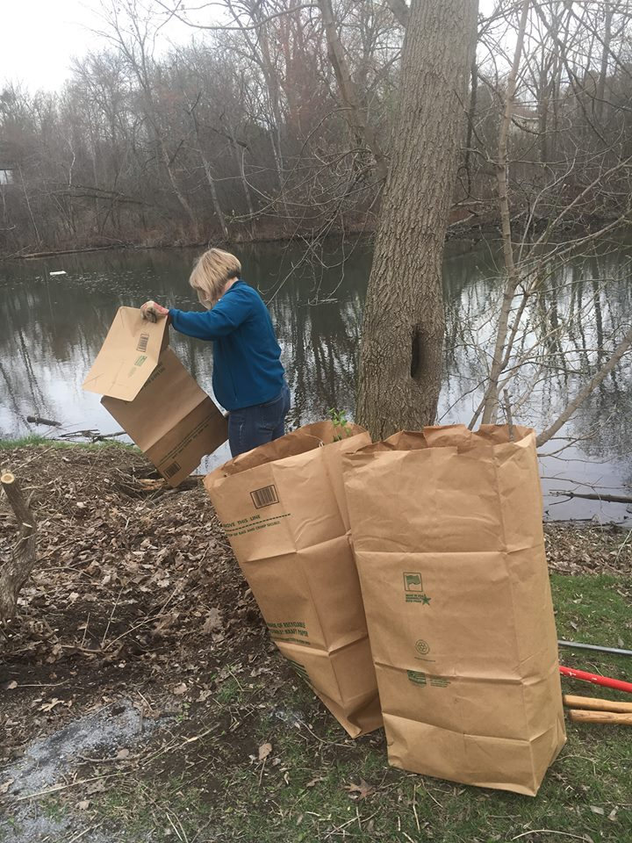
Figure 3: Numerous individuals running for office and professors from local universities came to help out.
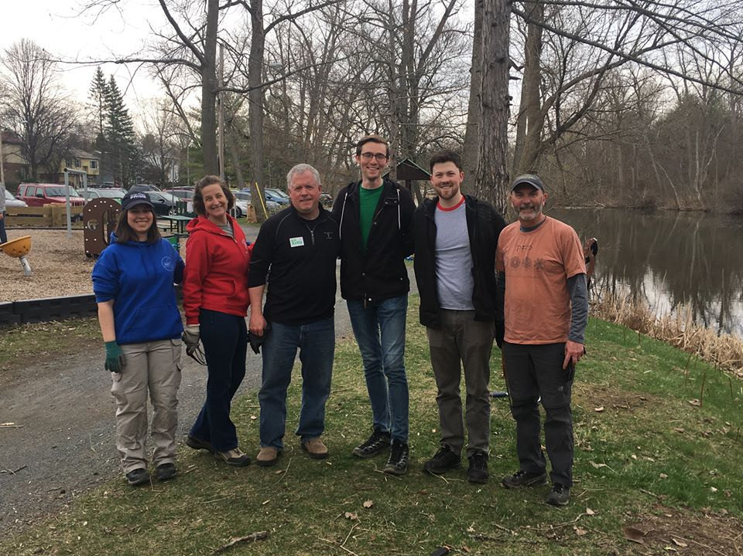

Figure 4 (from left to right): Gwendolyn Temple, Capital Mohawk PRISM Aquatic Invasive Species Coordinator; Alexander Wynkoop, Capital Mohawk PRISM volunteer; Anne Savage, Treasurer for Buckingham Pond Conservancy; Felton McLaughlin, Former President of Buckingham Pond Conservancy; Elizabeth Draper, President of Buckingham Pond Conservancy.
