CAPITAL DISTRICT WMA / CHERRY PLAIN STATE PARK INVASIVE SPECIES SURVEY 2019:
Anna Kuhne, Lauren Mercier, and Kelsey Stevens

Type of Work Performed: Survey for terrestrial invasive plant species

Date: August 14th, 2019

Address: 2 State Park Rd, Petersburg, NY 12138
County: Rensselaer County
Latitude and Longitude: 42.622568, -73.405230
Website: https://www.dec.ny.gov/outdoor/86016.html

Lead Contact Information for Project: Lauren Mercier

Site Owner Contact Information: DEC Region 4 Schenectady Office (518) 357 – 2158 Wildlife.r4@dec.ny.gov

Project Description: Walked along access roads, parking lots, and trails to find terrestrial invasive species. A majority of the surveys were done along the access roads and their parking lots.

Invasive Species Present at Capital District WMA and Cherry Plain State Park:
Common Name | Scientific Name | Locations (GPS) | Growth Type | Phenology | Distribution/ Abundance
Colt’s Foot | Tussilago farfara | 42.64198  -73.40817 | Herbaceous | Vegetative | Dense
Tufted Vetch | Vicia cracca | 42.64426  -73.40903 | Herbaceous | In flower | Record from 2018
Garlic Mustard | Alliaria petiolate | 42.6007  -73.41362 | Herbaceous | In seed | scattered patches
Mugwort | Artemisia vulgaris | 42.63687  -73.40538 | Herbaceous | Vegetative | Dense
Japanese Barberry | Berberis thunbergii | 42.619  -73.4113 | Shrub | Vegetative | Scattered
Hairy Bitter – Cress | Cardamine hirsute | 42.635  -73.39278 | Herbaceous | Record from 2017 | Record from 2017
Narrowleaf Bittercress | Cardamine impatiens | 42.64061  -73.40814 | Herbaceous | Vegetative | Record from 2018
Spotted Starthistle | Centaurea stoebe | 42.62517  -73.41206 | Herbaceous | In flower | Dense
Canada Thistle | Cirsium arvense | 42.62768  -73.4097 | Herbaceous | Vegetative | Record rom 2018
Poison Hemlock | Conium maculatum | 42.6284  -73.40976 | Herbaceous | In flower | Record from 2018
Crown Vetch | Coronilla varia | 42.63984  -73.40796 | Herbaceous | Vegetative | Record from 2018
Burning Bush | Euonymus alatus | 42.64563  -73.40972 | Shrub | Record from 2018 | Record from 2018
Morrow Honeysuckle | Lonicera morrowii | 42.63032  -73.41166 | Shrub | Vegetative | Record from 2018
Honeysuckle | Lonicera spp | 42.62101  -73.41024 | Shrub | Record from 2017 | Record from 2017
Creeping Jenny | Lysimachia nummularia | 42.62466  -73.40926 | Herbaceous | Vegetative | Record from 2018
Purple Loosestrife | Lythrum salicaria | 42.61781  -73.41211 | Herbaceous | Record from 2017 | Record from 2017
Wild Parsnip | Pastinaca sativa | 42.6267  -73.40998 | Herbaceous | In flower | Record from July 2018
Common Reed | Phragmites australis | 42.63852  -73.40341 | Herbaceous | Vegetative | Dense
Multiflora Rose | Rosa multiflora | 42.62267  -73.42946 | Shrub | Vegetative | Scattered
Climbing Nightshade | Solanum sulcamara | 42.63578  -73.40694 | Vine | Vegetative | Record from 2018
Chicory | Cichorium intybus | 42.62515  -73.41216 | Herbaceous | In flower | Dense (parking lots)
Bull Thistle | Cirsium vulgare | 42.63594  -73.39323 | Herbaceous | In flower | Dense
Wild Carrot | Daucus carota | 42.64059  -73.39409 | Herbaceous | In flower | Dense
Common St. Johnswort | Hypericum perforatum | 42.64062  -73.3941 | Herbaceous | In flower | Sparse
Birdfoot Deervetch | Lotus corniculatus | 42.62517  -73.41211 | Herbaceous | In Flower | Scattered
Reed Canarygrass | Phalaris arundinacea | 42.60076  -73.41362 | Herbaceous | In Seed | Single plant
Great Mullein | Verbascum Thapsus | 42.64054  -73.39402 | Herbaceous | In flower | Dense (mostly parking lots)
Common Periwinkle | 42.60411  -73.40883 | 42.60411  -73.40883 | Herbaceous | Vegetative | Sparse plant clumps

Capital Mohawk PRISM Strongly Recommends Uploading Points into https://www.imapinvasives.org/

Native Community Types: Wetland, meadow, and forested
Dominant Native Plants Present: Hemlock, oaks, sugar maples, and swamp milkweed
Summary of Work Completed:
  - Survey for terrestrial invasive plant species
Recommendations for the Future: continue to survey for and document terrestrial invasive plant species
Contact the Capital Mohawk Prism http://www.capitalmohawkprism.org/

Figure 1. Map of points taken at Cherry Plain State Forest and Capital District Wildlife Management Area in Rensselaer County, NY.
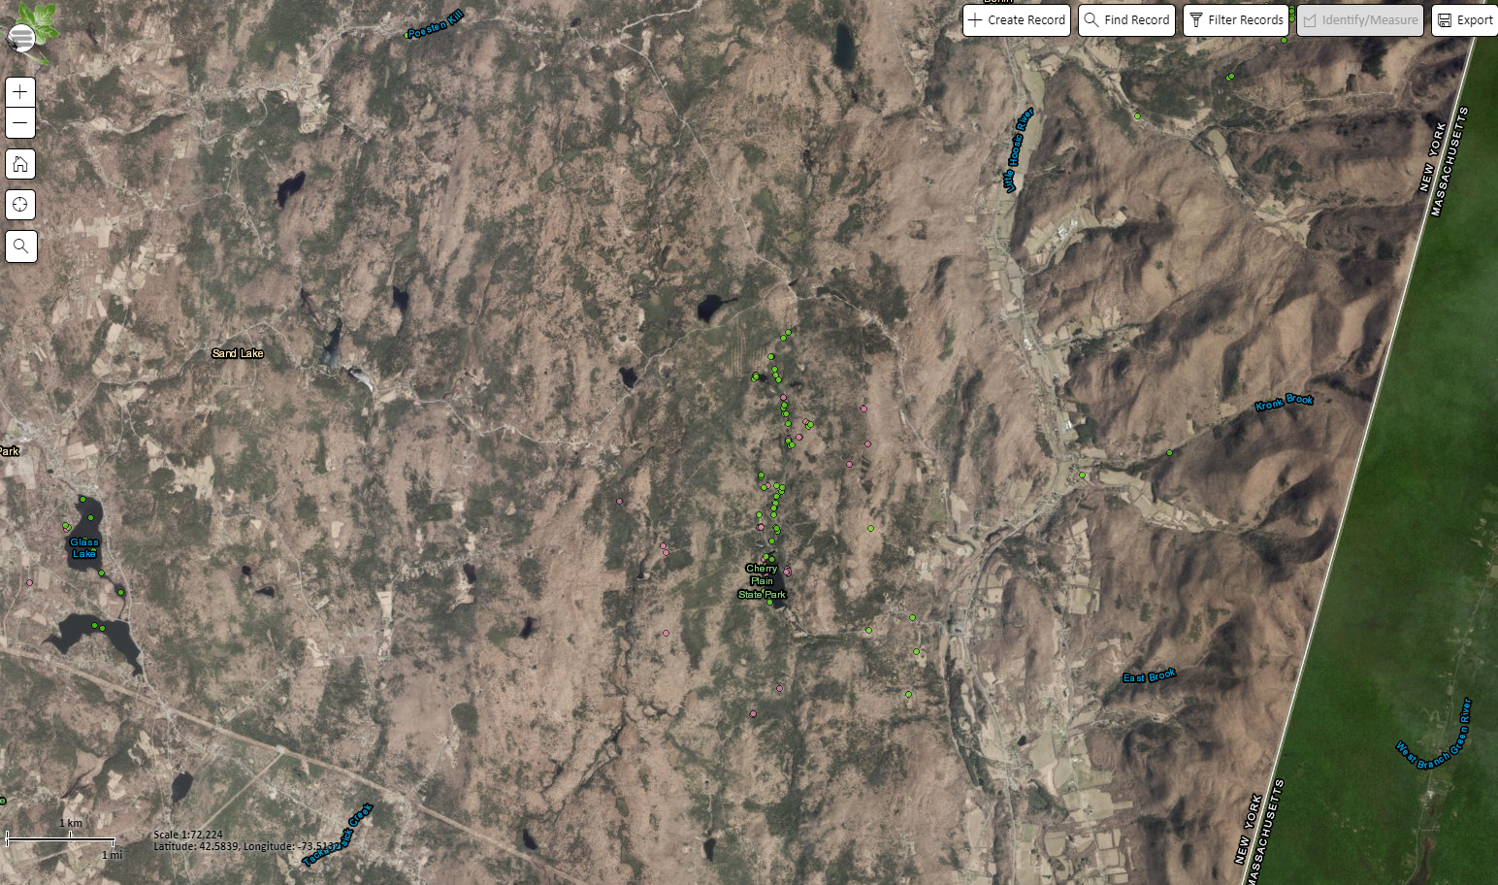

Figure 2. Mugwort in Capital District Wildlife Management Area.
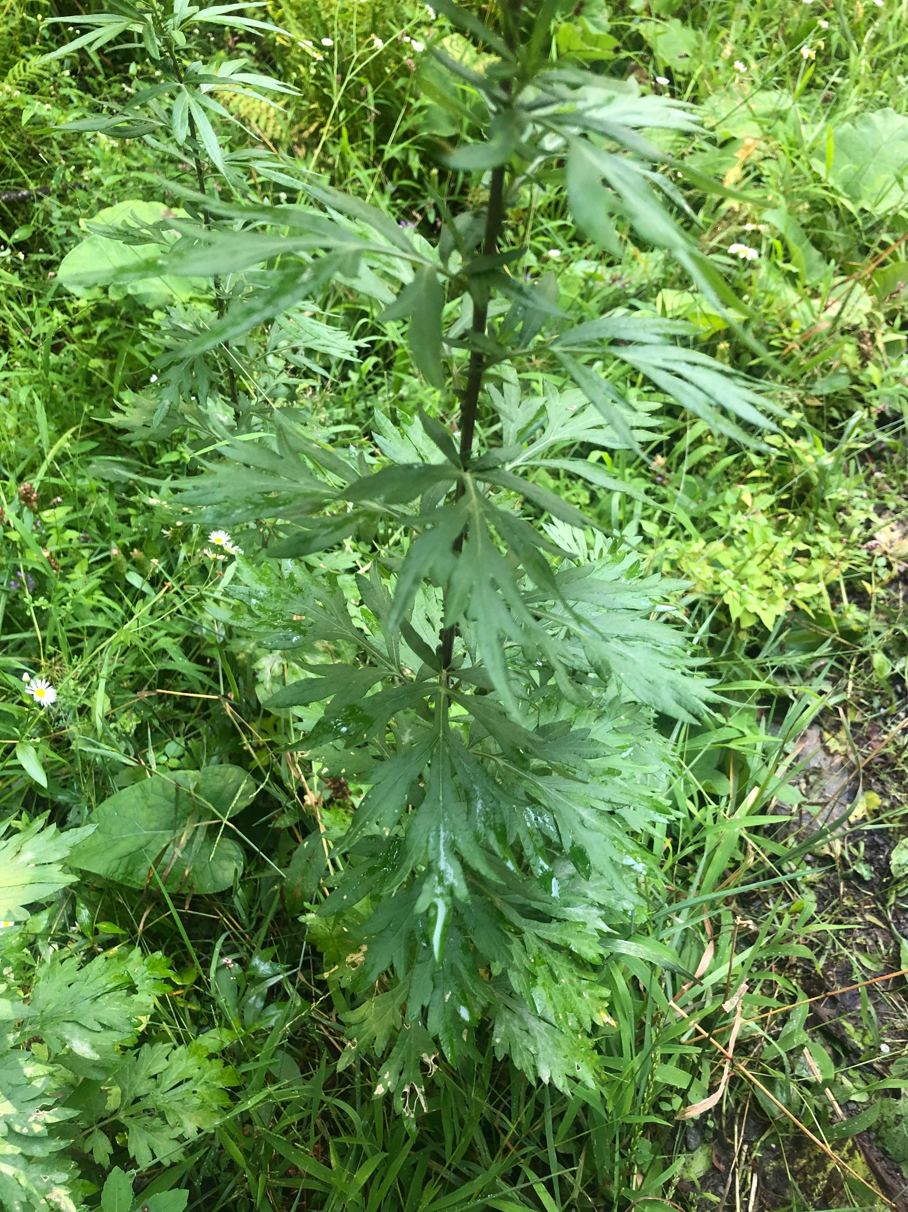

Figure 3. Chicory in Cherry Plain State Park.
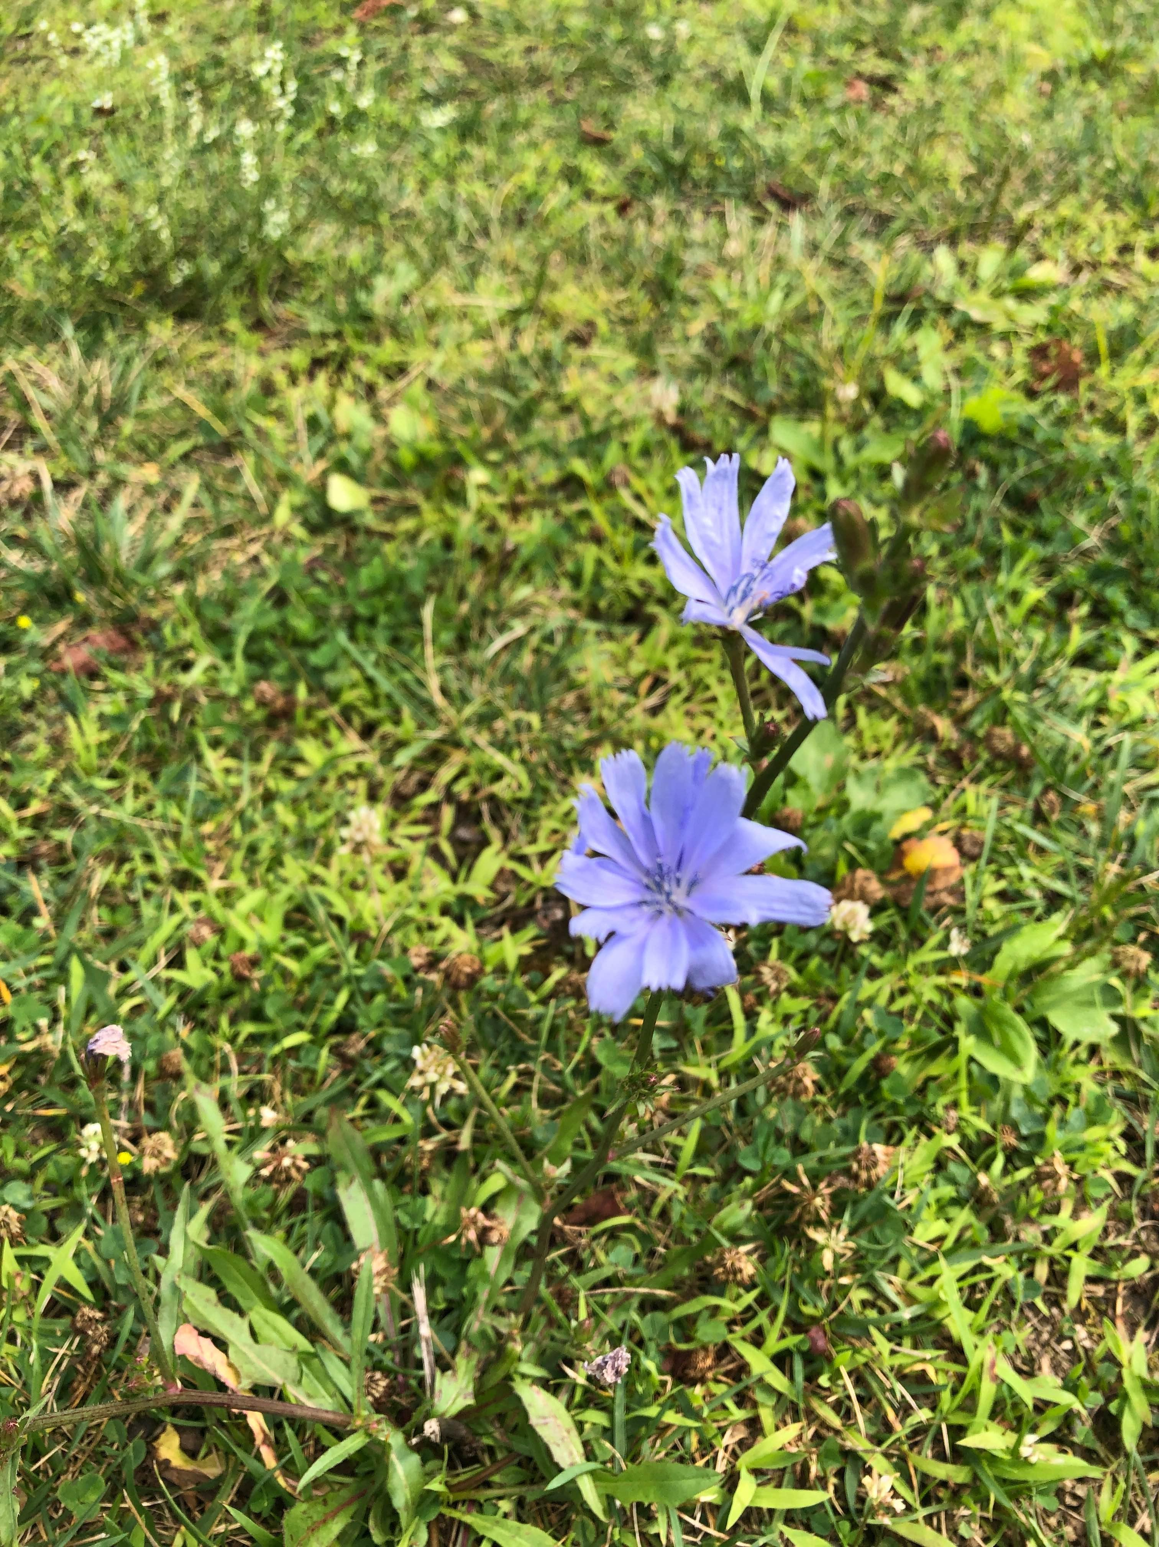

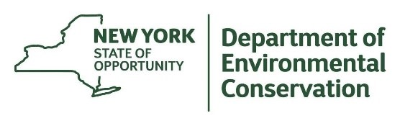
The New York State Department of Environmental Conservation provides financial
support to The Capital Mohawk PRISM via the Environmental Protection Fund.

