Partnership for Regional
Cornell Cooperative Extension│Saratoga County
50 West High St.
Ballston Spa, NY 12020
(518)885-8995
Ballston Spa, NY 12020
(518)885-8995

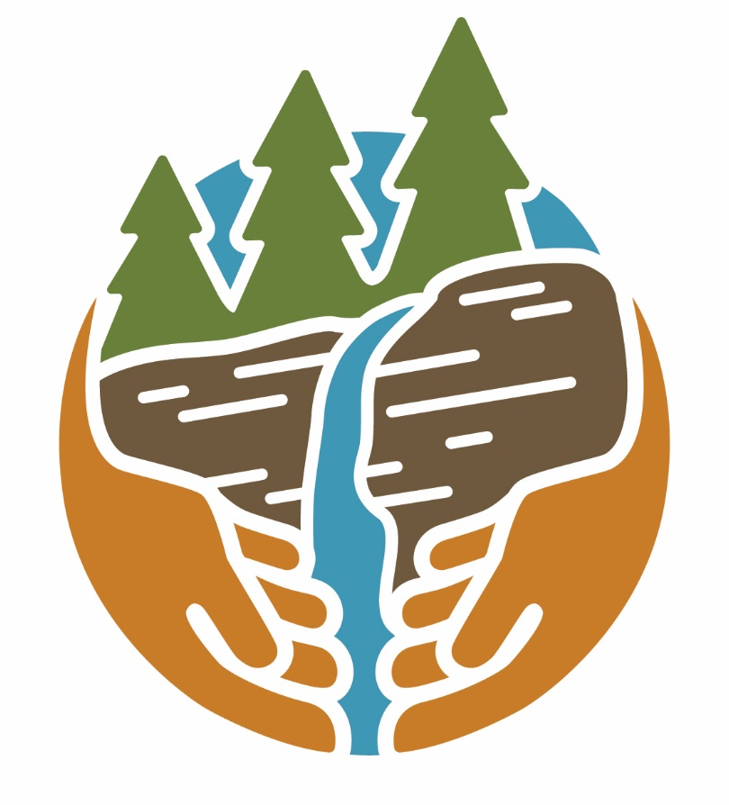
Invasive Species Management
Capital Region

Capital Region PRISM Tier List for Ranking Invasive Species 2020

The PRISM has categorized invasive species based on known populations into a tier ranking system. The purpose of the tier system is to focus attention on high threat species that are not found in our region or are appearing in small populations that are manageable with limited resources. Preventing the introduction of new species is the most cost effective strategy in controlling invasive species. Early identification and rapid response to new infestations that are found in small populations can result in successful eradication that are cost effective. When an invasive species is found regionally over a widespread area the cost to control populations can become prohibitive.

The Invasion Curve below demonstrates that prevention is the most efficient and cost-effective method of controlling invasive species. As invasive species becomes more established over time, the effort and associated costs of addressing infestations increases significantly.

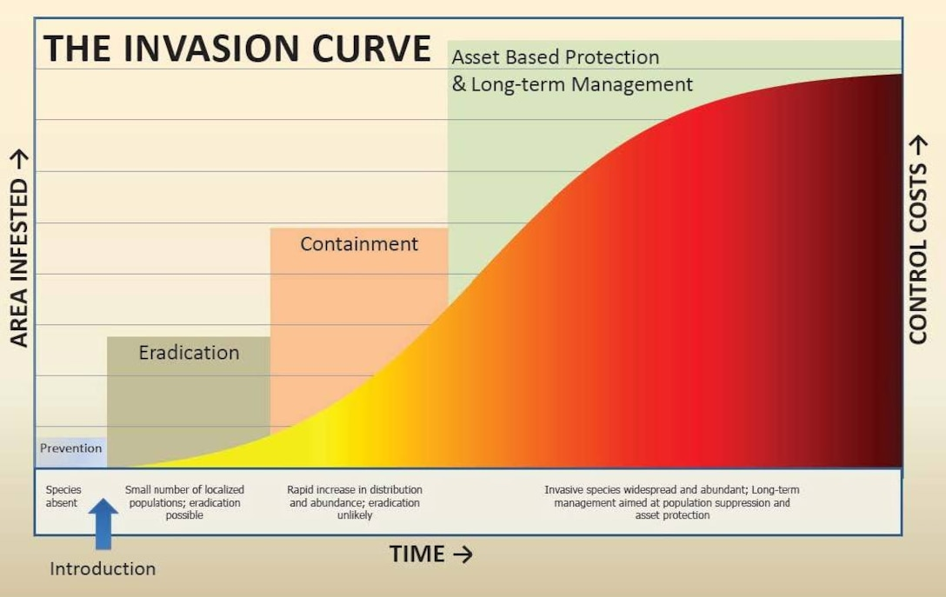
Tier 1
Tier 2
(Photo by: USDA Forest Service 2005 Invasive Plant Environmental Impact Statement) VIRIN: 140305-A-CE999-053.JPG

Capital Region PRISM: Regional Invasive Species Tier List Defined and Ranked
(March 2020 Last Revision)

Tier 1 - Prevention / Early Detection
Not in yet PRISM, with anticipated high or very high impacts. Highest level of survey efforts. Should conduct delineation surveys and assign to appropriate Tier if detected.

Tier 1a: Species not in the PRISM, but in the buffer (surrounding PRISM)
Tier 1b: Species not in PRISM or the buffer, but in Eastern North America (with potential for establishment) Tier 1c: Species far outside PRISM and buffer (not in east NA), but introduction pathway exists

Tier 2 – Eradication / Full Containment may be Feasible
High and very high impact species with low enough abundance to make eradication feasible within the PRISM. Highest level of response efforts. Need delineation surveys to determine full extent.
(at the low end of invasion curve)

Tier 3 – Containment / Strategic Management
High and very high impact species that are likely too widespread for eradication, but low enough abundance to think about regional containment. Target strategic management to slow the spread since many surrounding regions could be at risk if left unattended.

Tier 4 – Local Control / Exclusion or Suppression

Well-established species with high and very high impacts. Eradication efforts not feasible; only localized management over time to contain, exclude, or suppress, if justified to meet local management goals. (Suppression efforts) *Subcategory: Not established outside of PRISM, manage to contain within PRISM.

Tier 5 - Research:

Tier 5a: Species in our PRISM that need more research, mapping, and monitoring to understand invasiveness and impacts.
Tier 5b: Species surrounding our PRISM that need more research, mapping, and monitoring to understand invasiveness and impacts.

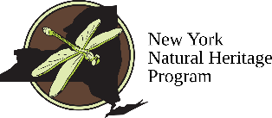

Thank you to the New York Natural Heritage Program
in creating the methodology of the Tier System
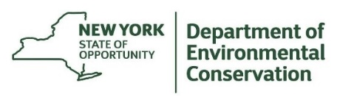
The New York State Department of Environmental Conservation provides financial support to The Capital Region PRISM via the Environmental Protection Fund
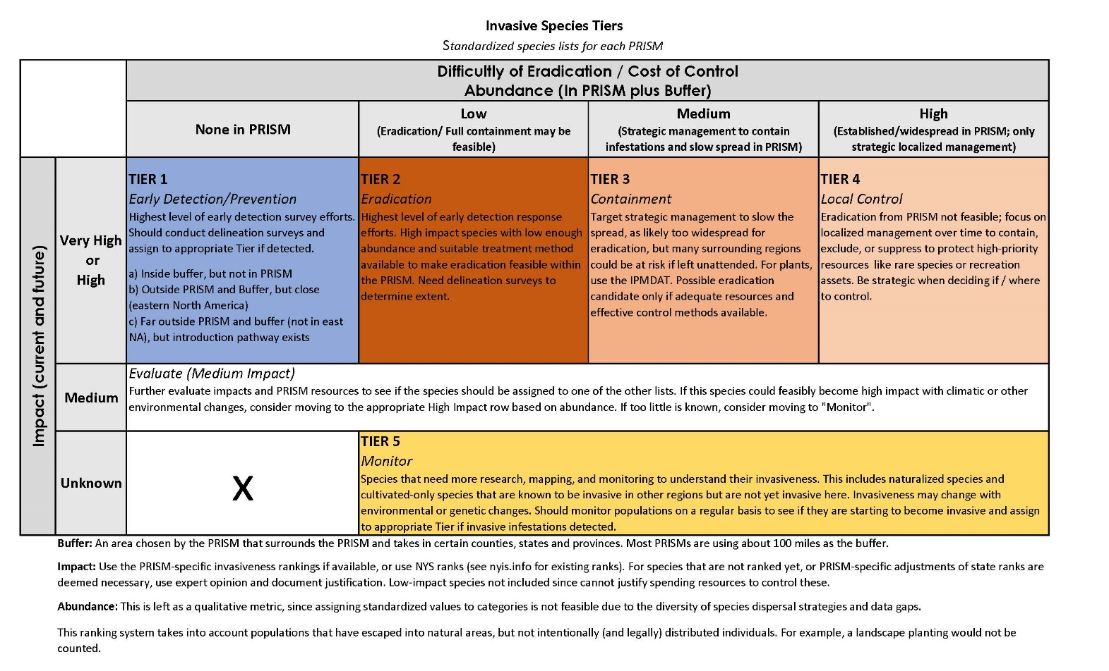

The Capital Region tier list is not comprehensive. The tier list focuses on invasive species found within or near a PRISM that have a high or very high invasiveness ranking, or are found to act aggressively enough in our region to be on the tier list. This is only a subset of all invasive species and does not include all regulated and prohibited species. For a full list of NYS prohibited and regulated species as per NYCRR Part 575, please visit here. For a full list of all currently ranked invasive species for NYS visit the New York Invasive Species Information website here.

Aquatic Invasive Plant Species
Scientific Name | Common Name | Prohibited/  Regulated | 2019 Tier Ranking
Egeria dens | Brazilian elodea | Prohibited | 1a
Cabomba caroliniana | Carolina fanwort | Prohibited | 1a
Hydrilla verticillata | Hydrilla | Prohibited | 1a
Myriophyllum aquaticum | Parrot feather | Prohibited | 1a
Aldrovanda vesiculosa | Waterwheel |  | 1a
Ludwigia peploides | Floating primrose willow | Prohibited | 1b
Nelumbo nucifera | Sacred lotus/Pink lotus |  | 1b
Ludwigia grandiflora | Uruguayan primrose willow | Prohibited | 1b
Alternanthera philoxeroides | Alligatorweed |  | 1c
Salvinia molesta | Water fern, Giant salvinia |  | 1c
Stratiotes aloides L. | Water soldiers |  | 1c
Limnoperna fortunei | Golden mussel |  | 1c
Hydrocharis morsus-ranae | European frogbit | Prohibited | 2
Butomus umbellatus | Flowering rush |  | 2
Nitellopsis obtusa | Starry stonewort |  | 2
Myriophyllum heterophyllum | Variable-leaf watermilfoil; Broad watermilfoil | Prohibited | 2
Nymphoides peltata | Yellow floating heart | Prohibited | 2
Najas minor | Brittle naiad |  | 4
Potamogeton crispus | Curly-leaf pondweed | Prohibited | 4
Myriophyllum spicatum | Eurasian watermilfoil | Prohibited | 4
Trapa natans | Water chestnut | Prohibited | 4
Didymosphenia geminata | Didymo |  | 5
Marsilea quadrifolia | European water fern |  | 5
Eichhornia crassipes | Water hyacinth |  | 5
Pistia stratiotes | Water lettuce |  | 5

Aquatic Invasive Animal Species
Scientific Name | Common Name | Prohibited/  Regulated | 2019 Tier Ranking
Hemigrapsus sanguineus | Asian shore crab | Prohibited | 1a
Pelodiscus sinensis | Chinese softshell |  | 1a
Carcinus maenas | Green crab | Prohibited | 1a
Poecilia reticulata | Guppy |  | 1a
Potamopyrgus antipodarum | New Zealand mud snail | Prohibited | 1a
Channa argus | Northern snakehead | Prohibited | 1a
Misgurnus anguillicaudatus | Oriental weatherfish | Prohibited | 1a
Neogobius menalostomus | Round goby | Prohibited | 1a
Petromyzon marinus | Sea lamprey | Prohibited | 1a
Tinca tinca | Tench | Prohibited | 1a
Gambusia affinis | Western mosquitofish | Prohibited | 1a
Cercopagis pengoi | Fishhook waterflea | Prohibited | 1b
Procambarus clarkia | Red swamp crayfish |  | 1b
Limnoperna fortunei | Golden mussel |  | 1c
Eriocheir sinensis | Chinese mitten crab | Prohibited | 2
Bithynia tentaculata | Mud bithynia |  | 2
Dreissena rostriformus bugensis | Quagga mussel | Prohibited | 2
Bythotrephes longimanus | Spiny waterflea | Prohibited | 2
Viviparus georgianus | Banded mystery snail |  | 3
Hemimysis anomala | Bloody red shrimp | Prohibited | 3
Cipangopaludina chinensis | Chinese mystery snail | Prohibited | 3
Trachemys scripta elegans | Red-eared slider turtle |  | 3
Scardinius erythrophthalmus | Rudd | Prohibited | 3
Corbicula fluminea | Asian clam | Prohibited | 4
Cyprinus carpio | Common carp | Prohibited | 4
Carassius auratus | Goldfish | Prohibited | 4
Lepomis cyanellus | Green sunfish |  | 4
Faxonius rusticus | Rusty crayfish | Prohibited | 4
Faxonius virilis | Virile crayfish |  | 4
Dreissena polymorpha | Zebra mussel | Prohibited | 4
Alosa pseudoharengus | Alewife |  | 5

Terrestrial Invasive Plant Species:

Scientific Name | Common Name | Regulated/Prohibited | 2020 Tier
Acer pseudoplatanus | Sycamore Maple | Prohibited | 1a
Actinidia arguta | Hardy Kiwi; Taravine |  | 1a
Actinidia polygama | Silver Vine |  | 1a
Akebia quinata | Chocolate Vine; Fiveleaf |  | 1a
Arum italicum | Italian Arum |  | 1a
Brachypodium sylvaticum ssp sylvaticum | Slender Falsebrome | Prohibited | 1a
Broussonetia papyrifera | Paper-mulberry |  | 1a
Clematis terniflora | Japanese Virgin's-bower, Sweet Autumn Clematis, Yam-leaf clematis, Japanese virgin's bower | Regulated | 1a
Cytisus scoparius | Scotch Broom |  | 1a
Deutzia scabra | Fuzzy Deutzia; Pride-of-Rochester |  | 1a
Eragrostis curvula | Weeping Lovegrass |  | 1a
Euphorbia virgata | Slender Leafy Spurge |  | 1a
Heracleum mantegazzianum | Giant Hogweed | Prohibited | 1a
Kalopanax septemlobus | Castor-Aralia |  | 1a
Koelreuteria paniculata | Golden-rain Tree |  | 1a
Lepidium latifolium | Perennial Pepperweed; Broadleaf pepperweed | Prohibited | 1a
Lespedeza cuneata | Asian Bush Clover; Chinese Lespedeza; Chinese Bushclover; Sericea Lespedeza |  | 1a
Macleaya cordata | Plume Poppy |  | 1a
Ornithogalum nutans | Drooping Star-of-Bethlehem; Star-of-Bethlehem |  | 1a
Perilla frutescens | Beefsteak Plant |  | 1a
Photinia villosa | Oriental Redtip |  | 1a
Phyllostachys spp. | Bamboo | Prohibited | 1a
Primula japonica | Japanese primrose |  | 1a
Rubus caesius | European Dewberry |  | 1a
Rubus laciniatus | Cutleaf Blackberry |  | 1a
Saccharum ravennae | Ravenna Grass |  | 1a
Salix atrocinerea | Gray Florists Willow | Prohibited | 1a
Salvia glutinosa | Sticky Sage |  | 1a
Symplocos paniculata | Sapphireberry |  | 1a
Viburnum dilatatum | Linden Arrow-wood |  | 1a
 | Beech Leaf Disease*** |  | 1a
Oplismenus hirtellus | Wavyleaf Basketgrass | Prohibited | 1b
Acer palmatum | Japanese Maple |  | 2
Anthriscus sylvestris | Wild Chervil | Prohibited | 2
Aralia elata | Japanese Angelica Tree | Prohibited | 2
Arthraxon hispidus | Small Carpetgrass; Joint-head Arthraxon | Prohibited | 2
Carum carvi | Common Caraway |  | 2
Eleutherococcus pentaphyllus | Five-leaf Aralia |  | 2
Euonymus fortunei | Winter Creeper, Climbing Euonymus, Wintercreeper | Regulated | 2
Euphorbia esula | Leafy Spurge, Wolf's Milk | Prohibited | 2
Impatiens glandulifera | Policemen's Helmet, Ornamental Jewelweed, Himalayan Balsam, Purple Jewelweed |  | 2
Lamiastrum galeobdolon | Yellow Arch-angel |  | 2
Lespedeza bicolor | Shrubby Lespedeza; Shrubby Bush Clover |  | 2
Lysimachia vulgaris | Garden Loosestrife, Yellow Garden Loosestrife | Prohibited | 2
Malus toringo | Toringo crabapple |  | 2
Miscanthus sinensis | Chinese Silver Grass; Eulalia; Chinese Silvergrass; Maiden Grass | Regulated | 2
Persicaria perfoliata | Mile-a-minute Weed, Mile-a-minute Vine, Asiatic Tearthum, Mile a minute weed | Prohibited | 2
Phellodendron amurense | Amur Corktree | Prohibited | 2
Polygonum nepalensis | Nepal Smartweed |  | 2
Pueraria montana var lobata | Kudzu, Japanese arrowroot | Prohibited | 2
Pyrus calleryana, Callery Pear | Bradford Pear |  | 2
Reynoutria sachalinensis: Fallopia sachalinensis | Giant Knotweed | Prohibited | 2
Rhodotypos scandens | Black Jetbead |  | 2
Salix cinerea | European Gray Willow; Gray Florist’s Willow |  | 2
Silphium perfoliatum var perfoliatum | Cup-plant, Indian Cup-plant, Cup plant | Prohibited | 2
Spiraea japonica | Japanese Spiraea, Japanese Meadowsweet |  | 2
Syringa reticulata | Japanese-Tree Lilac |  | 2
Typha x glauca | Blue Cat-tail, Hybrid Cat-tail |  | 2
Viburnum plicatum | Japanese Snowball |  | 2
Viburnum sieboldii | Siebold's Viburnum |  | 2
Wisteria spp | Wisteria |  | 2
Ampelopsis brevipedunculata | Porcelain Berry; Amur Peppervine | Prohibited | 3
Cardamine impatiens | Narrowleaf Bittercress, Bushy Rock-cress | Prohibited | 3
Dipsacus fullonum | Wild Teasel; Fuller s Teasel |  | 3
Ficaria verna ssp verna | Lesser celandine, Fig Buttercup | Prohibited | 3
Frangula alnus | Glossy Buckthorn |  | 3
Humulus japonicas | Japanese Hops | Prohibited | 3
Ligustrum spp | Privet | Prohibited | 3
Lonicera japonica | Japanese Honeysuckle | Prohibited | 3
Lonicera maackii | Amur Honeysuckle | Prohibited | 3
Lychnis floscuculi | Ragged Robin |  | 3
Microstegium vimineum | Japanese Stiltgrass, Nepalese Browntop, Japanese stilt grass, Nepalgrass | Prohibited | 3
Pachysandra terminalis | Japanese-spurge |  | 3
Rubus phoenicolasius | Wineberry | Prohibited | 3
Acer platanoides | Norway Maple | Regulated | 4
Aegopodium podagraria | Bishop’s Goutweed; Goutweed |  | 4
Ailanthus altissima | Tree-of-heaven; Chinese Sumac; Ailanthus |  | 4
Alliaria petiolata, Garlic Mustard | Garlic Mustard | Prohibited | 4
Alnus glutinosa | European Alder, Black Alder |  | 4
Artemisia vulgaris var vulgaris | Mugwort | Prohibited | 4
Berberis thunbergii | Japanese Barberry | Prohibited | 4
Celastrus orbiculatus | Oriental Bittersweet | Prohibited | 4
Centaurea spp. | Brown Starthistle, Brown knapweed | Prohibited | 4
Cirsium arvense | Canada Thistle, Creeping Thistle | Prohibited | 4
Dipsacus laciniatus | Cut-leaved teasel; Cutleaf teasel | Prohibited | 4
Elaeagnus umbellata | Autumn Olive | Prohibited | 4
Euonymus alatus | Burning Bush, Winged Euonymus, Winged Burning Bush, Winged Spindletree | Regulated | 4
Euphorbia cyparissias | Cypress Spurge | Prohibited | 4
Glechoma hederacea | Ground Ivy; Gill-over-the-ground |  | 4
Lonicera spp | Bush Honeysuckle |  | 4
Lythrum salicaria | Purple Loosestrife | Prohibited | 4
Morus alba | White Mulberry |  | 4
Pastinaca sativa | Wild Parsnip |  | 4
Phalaris arundinacea | Reed Canarygrass |  | 4
Phragmites australis ssp australis | Common Reed, phragmites, Common reed grass | Prohibited | 4
Reynoutria spp | Knotweed | Prohibited | 4
Rhamnus cathartica | Common Buckthorn | Prohibited | 4
Robinia pseudoacacia | Black Locust | Regulated | 4
Rosa multiflora | Multiflora Rose; Rambler Rose | Prohibited | 4
Ulmus pumila | Siberian Elm |  | 4
Vincetoxicum spp | Swallowwort | Prohibited | 4
Commelina communis | Asiatic Dayflower |  | 5a
Daphne mezereum | February Daphne |  | 5a
Epilobium hirsutum | Hairy Willow Herb |  | 5a
Hedera helix | English Ivy |  | 5a
Lupinus polyphyllus | Bigleaf Lupine |  | 5a
Malus baccata | Siberian Crabapple, Crabapple |  | 5a
Populus alba | White Poplar |  | 5a
Salvia relfexa | Lanceleaf Sage |  | 5a
Viburnum lantana | Wayfaring-tree |  | 5a
Viburnum opulus var opulus | Guelder Rose; European Cranberrybush |  | 5a
Carlina vulgaris | Carline Thistle |  | 5b
Dioscorea polystachya | Chinese Yam | Prohibited | 5b
Fallopia baldschuanica | China Fleece Vine |  | 5b
Sorghum halepense | Johnsongrass |  | 5b

Terrestrial Invasive Animal Species:

Scientific Name | Common Name | Regulated/Prohibited | 2020 Tier
Anoplophora glabripennis | Asian Longhorned Beetle | Prohibited | 1a
Dendroctonus frontalis | Southern Pine Beetle |  | 1a
Lycorma delicatula | Spotted Lanternfly |  | 1a
Myrmica rubra, | European fire Ant |  | 1a
 | Beech Leaf Disease*** |  | 1a
Lymantria dispar asiatica | Asian Gypsy Moth | Prohibited | 1b
Myocastor coypus | Nutria | Prohibited | 1b
Sus scrofa | Eurasian Boar | Prohibited | 1b
Ceratocystis fagacearum | Oak Wilt |  | 2
Adelges tsugae | Hemlock Woolly Adelgid | Prohibited | 3
Amynthas agrestis | Crazy Snake Worm | Prohibited | 3
Agrilus planipennis | Emerald Ash Borer | Prohibited | 4
Adelges piceae | Balsam Woolly Adelgid |  | 5a
Amynthas Metaphire spp | Jumping Worms | Prohibited | 5a
Fiorinia externa | Elongate Hemlock Scale |  | 5a
Lymantria dispar | Gypsy Moth | Prohibited | 5a
Phytomyza gymnostoma | Allium Leaf Miner |  | 5a
Popillia japonica | Japanese Beetle |  | 5a
Pyrrhalta viburni | Viburnum Leaf Beetle |  | 5a
Lipoptena cervi | Deer ked |  | 5b

