Capital Region PRISM AIS Lake Survey Report

Date: August 18th and 26th 2020
Site Name: Tomhannock Reservoir
Site Size: 1720 acre(s) / Lake Perimeter: 19 Miles / Mean Depth: 23 Feet
GPS Location: 42.8189 -73.5246
Physical Address: Route 7
County: Rensselaer
Town: Pittstown NY

Property Owner Contact: City of Troy City Clerk’s Office
433 River Street Troy, NY 12180

Primary Contact Wischman, Dennis (DEC) <dennis.wischman@dec.ny.gov
Secondary Contact Chris VanMaaren Regional Fisheries Manager, Division of Fish and Wildlife New York State Department of Environmental Conservation 65561 State Hwy 10, Stamford, N.Y. 12167-5029
P: (607)652 2620|chris.vanmaaren@dec.ny.gov

Survey Leader: Kristopher Williams PRISM Coordinator
Phone: 518.321.0189
Email: kbw44@cornell.edu
iMapInvasives User ID:9274
http://fishing-app.gpsnauticalcharts.com/i-boating-fishing-web-app/fishing-marine-charts-navigation.html?title=Tomhannock+Reservoir+boating+app#12.29/42.8421/-73.5364

Summary

On August 18th and 26th 2020 the Capital Region PRISM conducted an Aquatic Invasive Species Macrophyte Survey to delineate Water Chestnut (Trapa natans) monocultures on the Tomhannock Reservoir a drinking water supply for the City of Troy and other municipalities in Rensselaer County. A visual inspection of the surface waters and subsurface were conducted along the (littoral zone) shoreline of the water body. The New York State Department of Fish and Wildlife assisted in the two survey dates. Rensselaer County Soil & Water Conservation District USDA NRCS Service Center Conservation Technician was also present of the first day of surveying.

The infestations are occurring in the shallow portions of the littoral zone were soft sediments are present. There are six major infestations present with a seventh forming. The seven sites altogether account for 71.75 acers of biomass on the surface waters or 4.15% of the total lake acreage. Data was delineated using ARC GIS Collector. Please note the iMap Invasives Presence polygons on the second page showing the infestations. The percent coverage of the littoral zone is not know at this time.

There are portions of the reservoir where water chestnut is not present or is present but in isolated and sparse patches. These areas are in rocky deep waters. Notably the northeastern shore of Reservoir Lake Road and portions of the southwestern shore. The likely hood of future infestations are low in these areas due to the deep and rocky lake geomorphology. Note the link and map above of the littoral zone.

Aquatic Invasive Species Present of Concern

- Water Chestnut (Trapa natans) is a very high threat species with a NEW YORK NON-NATIVE PLANT INVASIVENESS RANKING of 82. http://nyis.info/wp-content/uploads/2018/01/61a2d_Trapa-natans-NYS.pdf General Species Information http://nyis.info/invasive_species/water-chestnut/

- Eurasian Water-milfoil; (Myriophyllum spicatum) is a very high threat species with an assessment score of 100. http://nyis.info/wp-content/uploads/2018/01/5cdc8_Myriophyllum.spicatum.NYS_.pdf For General Species Information:http://nyis.info/invasive_species/eurasian-watermilfoil/
Site Description:

The water source for the city of Troy, New York is the Tomhannock Reservoir, a man-made reservoir 6.5 miles (10.5 km) northeast of Troy in the town of Pittstown. The reservoir is 5.5 miles (8.9 km) long, and holds 12.3 billion US gallons (47,000,000 m3) when full. Licensed fishing (both warm-weather and ice fishing) is a popular recreational activity. The reservoir is surrounded by agricultural lands with fragmented forest. The Reservoir has a shore line elevation of 400 feet and overflows in to the Tomhannock Creek to the Hoosic River. Otter and Sunkauissia Creek drain into the reservoir. 1. Troy NY Water Department reports Archived 2007-10-22 at the Wayback Machine Retrieved 2011-08-05.

iMapInvasives Prioritization Model:
(https://www.arcgis.com/home/webmap/viewer.html?webmap=57d30ff9bff7426c8950d90b0ba43bba&extent=-81.0352,39.2503,-70.2686,45.8067)

The shoreline of the Tomhannock Reservoir is ranked moderately high on the prioritization model comprehensive score attribute with a strong coloring on the heat map.

Does this site contain previously treated infestations?
- No

Survey Techniques:
- Visual Inspection of Surface and Subsurface

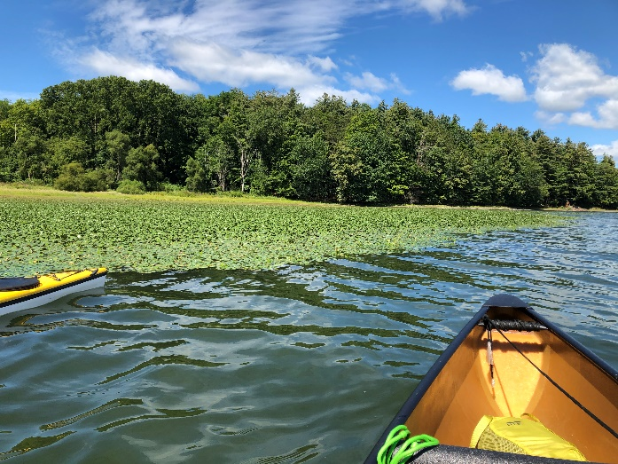
Map: Searched/Presence Areas: Tomhannock Reservoir (Entire Littoral Zone)
Water Chestnut (Trapa natans) Monoculture
Tomhannock Reservoir 2020

Section 2: Survey Result Summary

Common Name | Scientific Name | Location (GPS) | Growth Type | Phenology | Abundance
Brittle Naiad | Najas minor | 42.8198 -73.5181 | Floating |  | n/a
Curly-leaf pondweed | Potamogeton crispus | 42.8198 -73.5181 | Floating | Detritus | n/a
Eurasian Water-milfoil; European Water-milfoil | Myriophyllum spicatum | Intermittent through out | Submerged/Rooted | Growth | Sparse/Dense
Water Chestnut | Trapa natans | Note Seven Polygons | Surface/Rooted | In seed | Monoculture(s)
Suspected HAB Reported to DEC | n/a | 42.8163 -73.5209 | Surface/Water Column |  | n/a

Native species observed in Tomhannock Reservoir

Myriophyllum sibiricum - Northern watermilfoil
Najas flexilis - Slender/bushy naiad
Elodea sp. (E. canadensis, E. nuttallii) - Elodea, waterweed
Nymphaea odorata - White water lily
Ceratophyllum demersum - Coontail
Chara vulgaris - Chara, muskgrass
Potamogeton amplifolius - Large-leaf pondweed
Potamogeton perfoliatus - Clasping Pondweed

Areas of Concern:
The Presence polygons in green where dense monocultures of Water Chestnut (Trapa natans) are confirmed.

Polygon 1 iMap Invasives Presence Record ID: #1064700

Location: 42.86744 °-73.55809 °
Area: 52264.97 m² (12.91 Acres)

Polygon 2 iMap Invasives Presence Record ID #1064699
Location: 42.83815 ° -73.54509 °
Area: 8689.08 m² (2.14 Acres)

Polygon 3 iMap Invasives Presence Record ID #1064701
Location: 42.8368° -73.54286°
Area: 847.7 m² (0.21 Acre)

Polygon 4 iMap Invasive Presence Record ID #1064698
Location: 42.8395° -73.52187 °
Area: 48819.73 m² (12.1 Acres)

Polygon 5 iMap Invasives Presence Record ID #1064695
Location: 42.81579 °-73.52717 °
Area: 37388.06 m² (9.3 Acres)

Polygon 6 iMap Invasives Presence Record ID #1064696
Location: 42.81326 °-73.52247 °
Area: 47272.29 m² (11.7 Acres)

Polygon 7 iMap Invasives Presence Record ID #1064697
Location: 42.81709 °-73.51834 °
Area: 95075.53 m² (23.5 Acres)

*Upper left polygon in the North West is not a presence polygon from this survey and does not represent a monoculture, however water chestnut is found in this area in trace and sparse populations. iMap Invasives Presence Record ID #334979 David Newman - 4221 6.7.2012
Polygon data was delineated using ARC GIS Collector in the field.
Section 3: Summary of Recommendations

Treatment:
Chemical treatment is not an option for the public water supply.

Bio-Based mapping should possibly be considered to determine the possible extent in which soft sediments occur in the reservoir within the littoral zone. These areas can represent possible environments for future expansion of the plant into new un-established habitat.

Mechanical Harvesting:
- Newly introduced populations of T. natans. Early detection of introductions and a rapid control response are key to preventing high-impact infestations. Because T. natans is an annual plant, effective control can be achieved if seed formation is prevented. Small populations can be controlled by hand pulling working from canoes or kayaks.

- Established and large infestations usually require the use of mechanical harvesters.
- Regardless of treatment, ideally removal should take place before the fruit has ripened and dropped to the bottom forming a long-term seed bank.
- Water chestnut overwinters entirely by seeds that may remain viable in the sediment for up to 12 years, repeated annual control is critical to deplete the seed bank. Treatment generally is needed for five to twelve years.
-Shallow water aquatic weed harvesters maybe needed for control / eradication in sections of the littoral zone
in conjunction with larger harvesters. Some hand pulling maybe required.

Basic Primer(s) on Water Chestnut
- https://www.dec.ny.gov/docs/lands_forests_pdf/aiswatercfs.pdf
- http://nyis.info/invasive_species/water-chestnut/
- https://seagrant.sunysb.edu/ais/pdfs/WaterChestnutFactsheet.pdf

Post- Survey Monitoring:

The Capital Region PRISM will continue to monitor the infestation(s) of Water Chestnut (Trapa natans) on a triannual cycle and delineate their size using collector polygons. The PRISM will also monitor for other AIS.

Will post-treatment management be handled by another person/entity? Not Applicable at this time.
If yes- please provide the contact information:

Will an Invasive Species Management Plan be created? Not Applicable at this time.

The New York State Department of Environmental Conservation provides financial support to The Capital Region PRISM via the Environmental Protection Fund
