Capital Region PRISM AIS Treatment Report

Date: August 20th September 2nd 2020
Site Name: Delegan Pond Wilton Wildlife Preserve
Site Size: 4.1 acre(s) / Lake Perimeter: 0.4 Miles / Mean Depth: ?
GPS Location:43.154193 -73.698806
Physical Address: 80 Scout Road Parking Lot 1
County: Saratoga
Town: Gansevoort NY

Property Owner Contact: Wilton Wildlife Preserve & Park
80 Scout Road Gansevoort NY 12831

Primary Contact: Margo Bloom Olson mbolson@wiltonpreserve.org
Secondary Contact Erin McCabe emccabe@wiltonpreserve.org

Survey Leader: Kristopher Williams PRISM Coordinator
Phone: 518.321.0189
Email: kbw44@cornell.edu
iMapInvasives User ID:9274

Summary

On August 20th and two days in September 2nd and 11th the Capital Region PRISM conducted a Water Chestnut (Trapa natans) removal from Delegan Pond at the Wilton Wildlife Preserve and Park. The pond is approximately 4 acres in size and very manageable. Water chestnut was identified in the water body in 2019. The current infestation has a few small patches that are forming into dense monocultures with trace to sparse populations throughout the pond. The main monoculture to the back of the pond took a four person crew ten hours to remove 32 bags of water chestnut weighing in at approximately 2400 pounds. The monoculture was a tenth of an acer in size. The pull was the first at the location. Material was bagged and sent to a sanitary landfill.

Aquatic Invasive Species Present of Concern

- Water Chestnut (Trapa natans) is a very high threat species with a NEW YORK NON-NATIVE PLANT INVASIVENESS RANKING of 82. http://nyis.info/wp-content/uploads/2018/01/61a2d_Trapa-natans-NYS.pdf General Species Information http://nyis.info/invasive_species/water-chestnut/

Site Description:

Delegan pond is a small four acre pond in an ecologically sensitive area. The Wilton Wildlife Preserve and Park use the pond for outdoor educational purposes. The Town of Wilton Town Board, owners of property known as Camp Saratoga has stocked Scout Pond for resident fishing. The stocking program is for the Town of Wilton’s handicapped and youths under 16 only. The pond serves as a cultural/social component for area residents.

iMapInvasives Prioritization Model:
(https://www.arcgis.com/home/webmap/viewer.html?webmap=57d30ff9bff7426c8950d90b0ba43bba&extent=-81.0352,39.2503,-70.2686,45.8067)

The area surrounding Delegan Pond is ranked high on the prioritization model comprehensive score attribute with a strong coloring on the heat map due in part to the Karner Blue butterfly habitat. The pond is ranked moderately on the model.

Does this site contain previously treated infestations?
- No

Survey Techniques:
- Visual Inspection of Surface and Subsurface

Map:
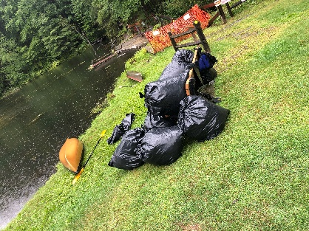
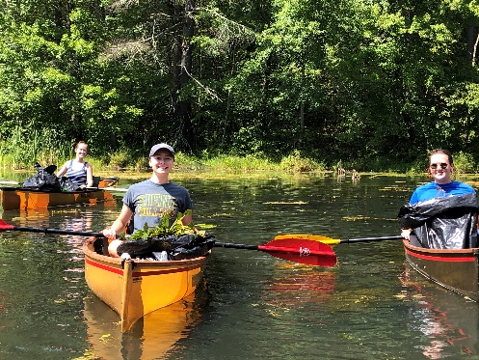
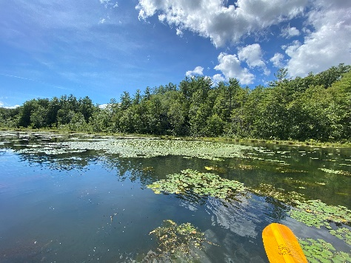

Section 2: Treatment Species

Common Name | Scientific Name | Location (GPS) | Growth Type | Phenology | Abundance
Water Chestnut | Trapa natans | Note Seven Polygons | Surface/Rooted | In seed | Monoculture(s)

Areas of Concern:
The Presence polygons in green where dense abundance of Water Chestnut (Trapa natans) where removed.
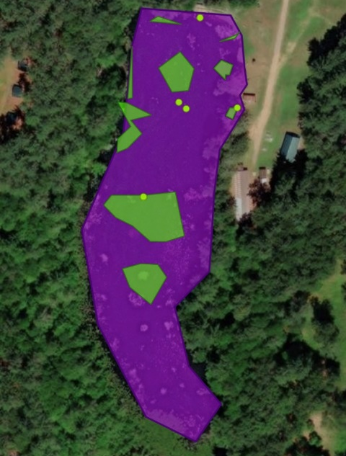
Polygon 1 iMap Invasives Searched Area Record ID: 18941

iMap Invasives Treatment Record Id 18941

Location: 43.15265 -73.69989
Area: (4.0 Acres)

Polygon 2 iMap Invasives Presence Record ID
Location:
Area: 4251 sq ft (0.1 Acre)

Removed
August 20th 8 bags /75lbs/ 4 person crew 6 hours / Large Search Area
Sept 2nd 24 bags /75lbs / 4 person crew 6 hours / Polygon 2
Sept 11th 8 bags/75lbs/ 3 person crew 4 hours / Polygon 2

- 4 person Crew 16 Hours
-40 Bags estimated 3000 pounds of water chestnut de-watered
(Polygon data was delineated using ARC GIS Collector in the field. )

Section 3: Summary of Recommendations

Treatment:

Hand Harvesting:
- Newly introduced populations of T. natans. Early detection of introductions and a rapid control response are key to preventing high-impact infestations. Because T. natans is an annual plant, effective control can be achieved if seed formation is prevented. Small populations can be controlled by hand pulling working from canoes or kayaks. As such Delegan Pond was cleared out with a small crew of 6 people over the course of three days. The staff from the Wilton Wildlife Preserve and Capital Region PRISM partnered on the event.

- Water chestnut overwinters entirely by seeds that may remain viable in the sediment for up to 12 years, repeated annual control is critical to deplete the seed bank. Treatment generally is needed for five to twelve years. A calendar for treatment should be adhered to for successful removal. The best time for coordinating a pull is in August.

- The Capital Region PRISM Recommends collaborating with the Wilton Wildlife to recruit volunteers for future removals.

- Disposal of material would be best if aloud to decompose on site and then buried on preserve property.

Basic Primer(s) on Water Chestnut
  - https://www.dec.ny.gov/docs/lands_forests_pdf/aiswatercfs.pdf
  - http://nyis.info/invasive_species/water-chestnut/
  - https://seagrant.sunysb.edu/ais/pdfs/WaterChestnutFactsheet.pdf

Post- Survey Monitoring:

The Capital Region PRISM will continue to monitor the infestation(s) of Water Chestnut (Trapa natans) on a triannual cycle and delineate their size using collector polygons. The PRISM will also monitor for other AIS.

Will post-treatment management be handled by another person/entity?
- Yes Wilton Wildlife and Capital Region PRISM

Will an Invasive Species Management Plan be created?
- Yes see associated document.

The New York State Department of Environmental Conservation provides financial support to The Capital Region PRISM via the Environmental Protection Fund

