FIVE RIVERS ENVIRONMENTAL EDUCATION CENTER INVASIVE SPECIES SURVEY 2019:

Anna Kuhne, Lauren Mercier, Kelsey Stevens, and Kristopher Williams

Introduction: In July of 2019, PRISM Coordinator, Kristopher Williams, the Terrestrial Invasive Species interns, from Siena College, and the education and outreach coordinator went to look for early detection invasive species throughout the Capital-Mohawk PRISM. The Siena interns, Anna Kuhne and Kelsey Stevens, focused on terrestrial invasive plant surveys at highly susceptible and valuable habitats throughout the PRISM region. The following is an abridged summary of some of the findings of the survey throughout Five Rivers Environmental Education Center. The PRISM works throughout 11 counties around the capital region to detect, prevent, and control invasive species.

Project Description: Surveying terrestrial invasive plants in the park
Dates: July 11th, 2019
Participants: Capital Mohawk Prism, Cornell Cooperative Extension, NYS DEC, Friends of Five Rivers, and Excelsior Conservation Corps.
Point of Contact: 5rivers@dec.ny.gov
County: Albany County

Locations and Species Identified:
Five Rivers Environmental Education Center (5rivers@dec.ny.gov): Scouting was done on the trails of the Five Rivers Environmental Education Center in partnership with the Excelsior Conservation Corps. Surveys were done around Skeeter Bowl, the Research Ponds, Recharge Pond, Fox Marsh, Wood Duck Marsh, and Goose Pond.
Invasive Species Present at Five Rivers Environmental Education Center:
Common Name | Scientific Name | Locations (GPS) | Growth Type | Phenology
Common Reed | Phragmites australis |  | Herbaceous
Norway Maple | Acer platanoides | 43.11285  -73.57717 | Tree | Vegetative
Japanese Barberry | Berberis thunbergii |  | Shrub
Oriental Bittersweet | Celastrus orbiculatus |  | Vine
Black Locust | Robinia pseudoacacia |  | Tree
Tartarian Honeysuckle | Lonicera tatarica |  | Shrub
Autumn Olive | Elaeagnus umbellata | 42.61632  -73.8916 | Shrub | Vegetative
Multiflora Rose | Rosa multiflora |  | Shrub
Ground Ivy | Glechoma hederacea | 42.61414  -73.89111 | Herbaceous | Vegetative
Birdfoot Deervetch | Lotus corniculatus | 42.61637  -73.89157 | Herbaceous | Flowering

Dominant Native Plants:
Native Community Types:
Treatment Method:

Summary of Work Completed:
  - Education and Outreach Events, Descriptions, and Total citizens reached
  - Miscellaneous Events such as SLF Trapping
  - Etc…

Recommendations for the Future:

Contact _____________ at emailgoes@here for any questions regarding this report.

((Insert pictures and captions at the end. Powerful examples include before and after pictures of management events, group photos, emerging species for stakeholders to be aware of, etc. This section should also include applicable maps.))
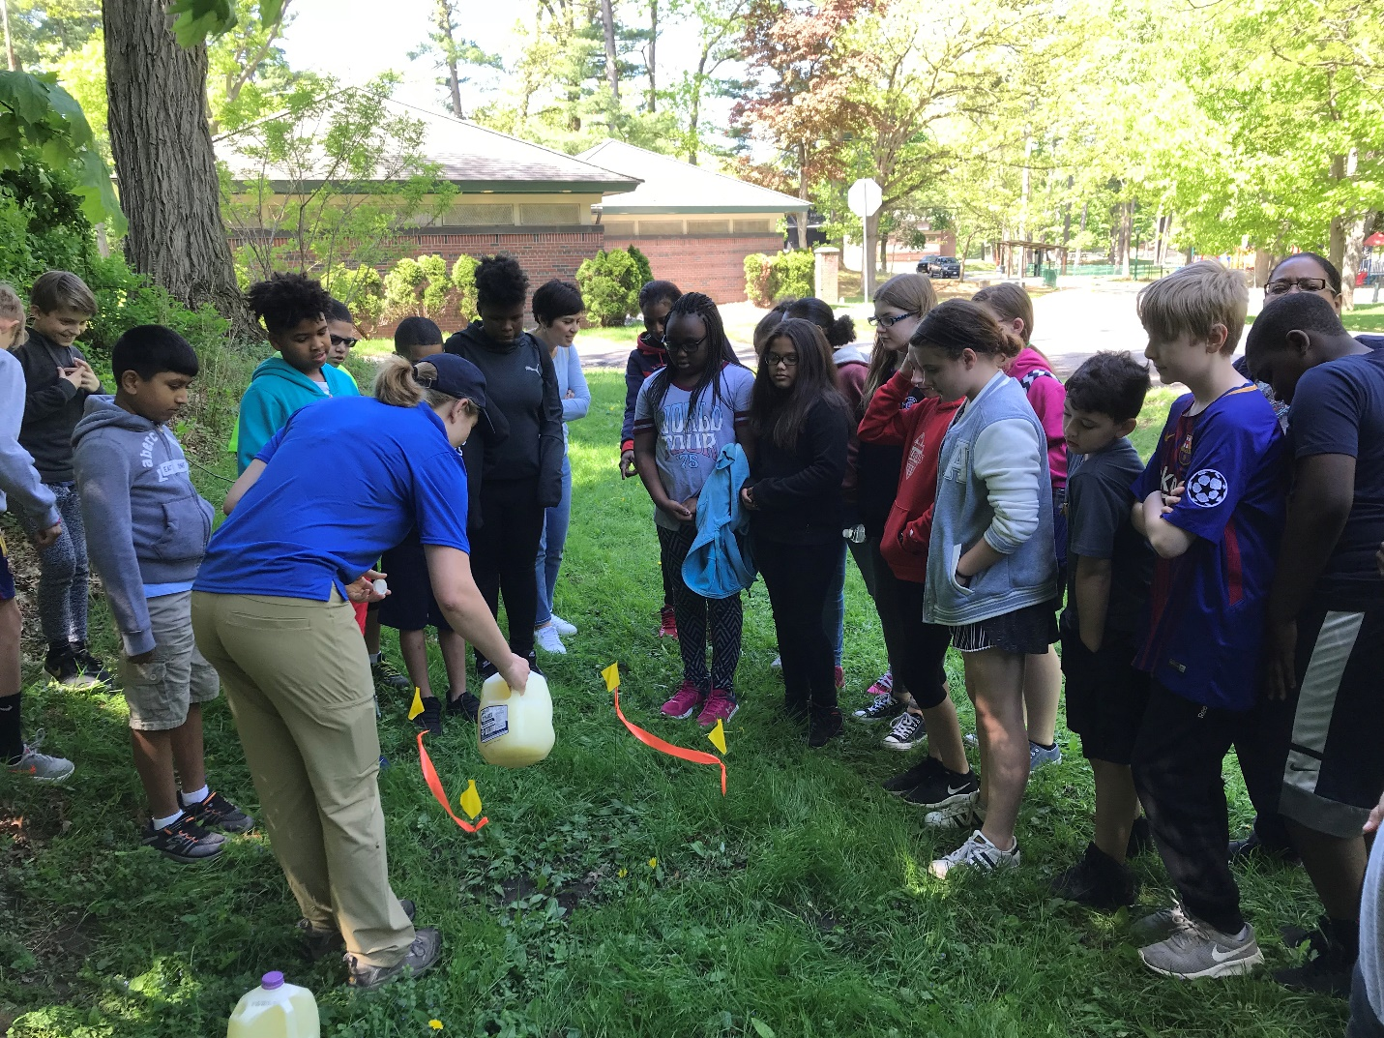
Figure 1: Elizabeth Jamison demonstrating mustard-seed’s effect on earthworms while checking Central Park in Schenectady for the invasive Amynthas earthworm during the 4H Environmental Field Day.

