FOUR MILE POINT WINEBERRY REMOVAL 2019:

Spencer Barrett, Anna Kuhne, and Kelsey Stevens

Introduction: In June of 2019, the Terrestrial Invasive Species Coordinator, Spencer Barrett, worked with two interns, from Siena College, to look for early detection invasive species throughout the Capital-Mohawk PRISM. The Siena interns, Anna Kuhne and Kelsey Stevens, focused on terrestrial invasive plant surveys at highly susceptible and valuable habitats throughout the PRISM region. The following is an abridged summary of some of the findings of the survey throughout Rockwood State Forest. The PRISM works throughout 11 counties around the capital region to detect, prevent, and control invasive species.
Project Description: Identification and removal of invasive terrestrial plant species such as Wineberry, Honeysuckle, Tree of Heaven, and Oriental Bittersweet.
Dates: June 6th, 2019
Participants: Spencer Barrett, Anna Kuhne, Kelsey Stevens, Scenic Hudson, and volunteers.
Point of Contact: Capital Mohawk PRISM, Scenic Hudson, and NYS Department of Environmental Conservation.
County: Greene

Locations and Species Identified:
Four Mile Point (Scenic Hudson): Removal efforts for Wineberry, with educating the public on other terrestrial invasive plant species such as Honeysuckle, Tree of Heaven, and Oriental Bittersweet.
Invasive Species Present at Four Mile Point:
Common Name | Scientific Name | Locations (GPS) | Growth Type | Phenology
European Barberry | Berberis thunbergii | 42.31726, -73.78644 | Shrub | Vegetative
Oriental Bittersweet | Celastrus orbiculatus | 42.31741, -73.78577 | Vine | Vegetative
Bishops Goutweed | Aegopodium podagraria | 42.31967, -73.78676 | Herbaceous | Vegetative
Tree of Heaven | Ailanthus altissima | 42.31739, -73.78583 | Tree | Vegetative
Black Swallowwort | Vincetoxicum louiseae | 42.31741, -73.78577 | Herbaceous | Vegetative
Wineberry | Rubus phoenicolasius | 42.31707, -73.78733 | Shrub | Vegetative

Dominant Native Plants: Walnut tree
Native Community Types: Swamp
Treatment Method: Manual removal of wineberry using weed wrenches, shovels, and pick axe.

Summary of Work Completed:
  - Identification and education on Wineberry and the effects on the surrounding ecosystem.
  - Manual removal of Wineberry where it was observed in the Four Mile Point trail.

Recommendations for the Future: Further surveying and removal efforts of Wineberry and other terrestrial invasive plant species. Other invasive plant species present served as a good indicator of what could take over in the case of Wineberry decline at Four Mile Point.

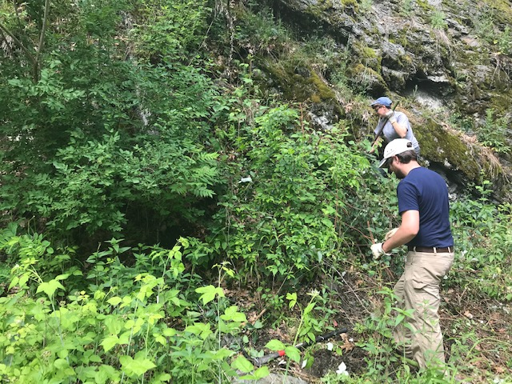

Figure 1. Scenic Hudson and volunteers taking part in removal of Wineberry and other associated invasive species located at Four Mile Point.

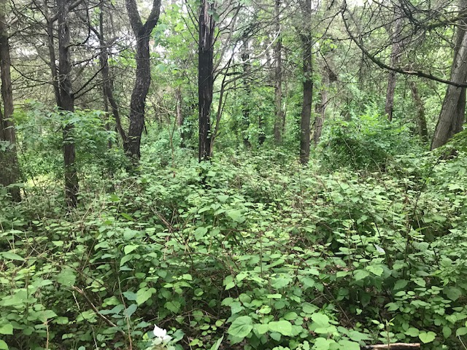

Figure 2. Before removal of very dense patch of Wineberry found less than ten feet off of beginning of trail.

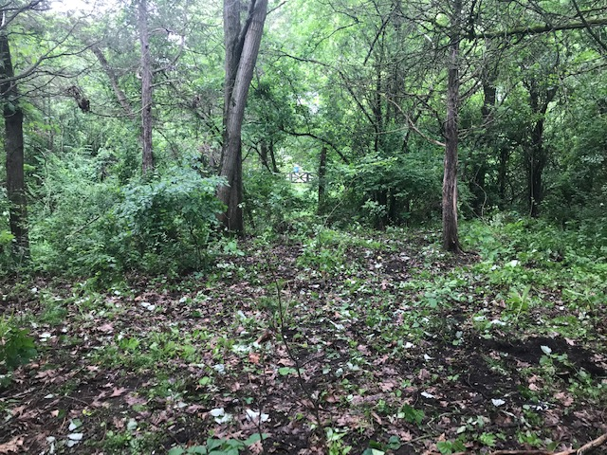

Figure 3. After removal of very dense patch of Wineberry found less than ten feet off of beginning of trail.

