HWA Lake Survey May/June 2019

Date: 5.31.2019
Survey Team: Kristopher Williams and Lauren Mercier
Project Description: As part of supporting the Cornell Hemlock Initiative the Capital Mohawk PRISM has surveyed the Hudson River between the Sherman Island Dam and the Spier Falls Dam along with other portions of Moreau State Park. The survey is part of the HWA Lake Survey program that Carri Marchner has coordinated with several partner agencies.
- https://blogs.cornell.edu/nyshemlockinitiative/
- Hemlock Initiative Boat Survey Protocol

Location: Sherman Island Boat Launch Saratoga County
DEC Hudson River Corinth, Spier Falls Rd, Gansevoort, NY 12831
43.249187, -73.738471

Point of Contact: Caroline (Carri) Marschner
NYS Hemlock Initiative Cornell University
cam369@cornell.edu 360-915-4778

Introduction: The Hemlock Initiative has designed a program to survey for HWA surrounding the southern portion of the Adirondack Blue Line in upstate New York. The program is in its pilot year and is seeking to slow the spread of HWA with early identification. The Capital Mohawk PRISM will conduct surveys at the following locations.
- Moreau State Park Lake, Lake Bonita, and Hudson River Corridor Saratoga County
- https://www.dec.ny.gov/outdoor/84524.html
- https://parks.ny.gov/parks/attachments/MoreauLakeMoreauLakeStateParkLakeBonitaTrailMap.pdf
- Butler and Rush Pond Warren County
- Butler Pond Watershed is located near Rush Pond
- https://www.queensbury.net/2015/11/rush-pond-trail/
- South Bay in Washington County
- https://www.dec.ny.gov/outdoor/53108.html
- Rockwood Lake State Forest
- https://www.dec.ny.gov/lands/107041.html

Invasive Species Survey: Moreau SP / Lake Bonita / Hudson River Corridor
Common Name | Scientific Name | Locations (GPS) | Survey Type | Status | Time/Survey
Hemlock Woolly Adelgid (HWA) | Adelges tsugae | 43.249187, -73.738471 | Early Detection  HWA Boat Survey | No Detection  No Damage | 120mins L.Moreau  100mins L.Bonita  240mins Hudson R

Findings and Recommendations: No detection as of May 26th May 31st 2019
The Hudson River Corridor from the Sherman Dam to the Spier Falls has no trail or road access on the Saratoga County Side of the river until you reach the Sherman Island Boat Launch. The hemlock stand density on the Saratoga County side of the river ranges from an approximate 40-60% along a 2.5 mile stretch from dam to dam. The stretch of river on the Warren County side has hemlock stand density of less than 15% for the majority of the distance. The round trip loop in this section is approximately 5 miles. The survey was completed in less than 4 hours. The Saratoga County portion of river above the Spier falls dam along route 24 (Spier falls road) has less than 5% hemlock along the road side which is not the case when entering the forest to the west of the road.
Lake Bonita part of Moreau State Park is accessible from Wilton Mountain Road has trail side access to a 2 mile loop surrounding the lake. The Hemlock stands in this are the dominate forest type with tree density reaching 80%. No HWA was detected.
Morea State Park Lake is a complex of glacial lakes in which the ground water aquifer breaches the surface. The complex is made of three lakes with a total shore line 4.24 miles. The hemlock stand density in this area depending on northern and southern slopes range between 35-55% compositions.
The area should be monitored into the foreseeable future. Segments of Moreau State Park are designated as a Bird Wildlife Management Area by the State. The potential risk for bird born vectors of HWA crawler transmission maybe greater in this region due to the nature of the habitat for migratory birds. The Hemlock Stands are part of the dominate matrix of trees in this region and protect stream and lakeside ecosystems. Moreau Lake State Park is designated by the Capital Mohawk PRISM as an Invasive Species Prevention Zone (ISPZ). Approximately 11.25 total miles of shore line in the Moreau State Park region were surveyed using HWA Lake Survey Protocol. Limited trees of poor health were observed and had tree trunk base damage from beaver activity.
The northern stretch of Hudson River above the Spire Falls Dam through the Townships of Corinth and Luzern should be considered for future surveys.
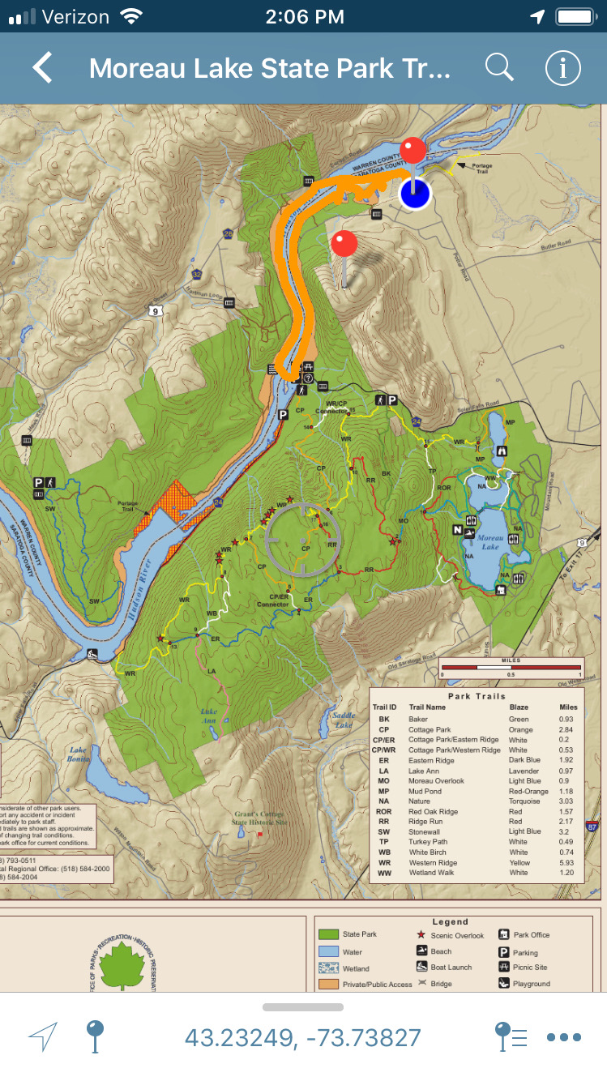

Lauren Mercier Conducting HWA Survey Hudson River Corridor Sherman Island to Spier Falls Dam 2019
