Moreau State Park ISPZ: I Love My Park Day (2019)

Field Manger Kristopher Williams:

Introduction:
I Love My Park Day (ILMPD) is a reoccurring event across the State of New York. On May 4th over 87 volunteers attended the Moreau State Park event. The volunteers are broken up into several groups to complete various tasks from planting flower beds, reconstructing rain gardens, painting and installing benches, and constructing canoe racks are a sampling of a few work projects. The Capital Mohawk PRISM in year two if the Invasive Species Prevention Zone (ISPZ) program will be attending ILMPD on a regular basis. In the park there are a few minor infestations that the PRISM can remove with a volunteer task force. The Friends of Moreau who host the event have designated a set group of volunteers to help the PRISM remove some of these minor infestations.
Project Description: Educational Removal of Invasive Species
Dates: May 4th 2019
Participants: Kristopher Williams / Park Volunteers
Point of Contact: Capital Mohawk PRISM / Friends of Moreau / Moreau State Park Manager Allen Trapper
County: Saratoga

Locations and Species Identified:
Site Name (Site Owner): Describe the primary actions taken at this site in a paragraph, most likely either giving a full account of the management actions at that location or describing the scouting efforts and how that took place. Try to include either an area or number of plants treated for a removal effort.
Invasive Species Present at (SITE NAME): ((One table per Site))
Common Name | Scientific Name | Locations (GPS) | Growth Type | Phenology | Target/Treatment
Burning Bush | winged euonymus | 43.2335 -73.7141 | Shrub | Monoecious  High Seed Production /  Bird Dispersal | Manual/Mechanical Removal
Burning Bush | winged euonymus | 43.23814 -73.7141 | Shrub | ‘’ “ | Manual/Mechanical Removal
Honeysuckle Spp. | Lonicera spp. | 43.2335 -73.7141 | Shrub | High Seed Production /  Bird Dispersal | Manual/Mechanical Removal

Dominant Native Plants: Hardwood Conifer Mixed woods
Native Community Types: Beech Maple Mosaic Forest / Which hazel / Maple Viburnum
Treatment Method: Mechanical/ Manual Removal
Summary of Work Completed:
  - Education and Outreach Events Mini Lecture with Kick-Off at the Start of the Event.
- Over 87 participants
  - Beach Area Invasive Species Removal 43.2335 -73.7141
- 13 Direct Contacts /Participants
    - 18 Burning Bush Stumps
    - 3 Honeysuckle (ssp.) Stumps
    - Enough Biomass to Fill a Full Sized Pick up

  - Upper Campground Shower House Removal by Propane Tank 43.23814 -73.7141
    - Park Staff Removed 12 Burning Bush Stumps

Recommendations for the Future:
- Restore the site with native forbs and sedges. Both Sites would do well with a native grass and are in sandy silt loams with well drained conditions dry conditions.
- Rebecca Walker is the park educator and has expressed interest in completing a restoration project with an educational group/class offering.
- Sites will be monitored each I love My Park Day in May for Regrowth.
- Transects into nearby areas should be conducted to find off shoots of burning bush

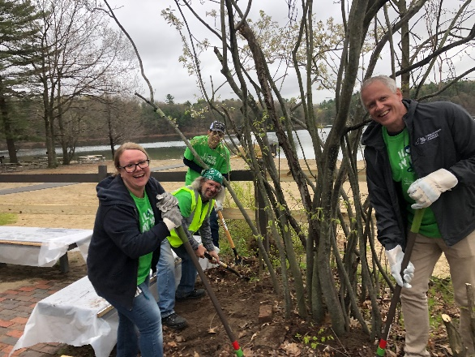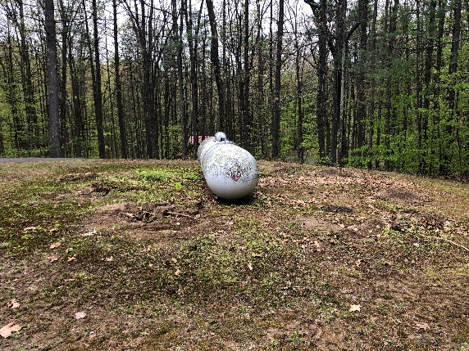
Beach Area MSP Upper Shower House in Camp Loop

