VOSBURGH SWAMP SCOUTING 2019:

Kelsey Stevens, Anna Kuhne, and Spencer Barrett

Introduction: In May of 2019, the Terrestrial Invasive Species Coordinator, Spencer Barrett, worked with two interns, from Siena College, to look for early detection invasive species throughout the Capital-Mohawk PRISM. The Siena interns, Anna Kuhne and Kelsey Stevens, focused on terrestrial invasive plant surveys at highly susceptible and valuable habitats throughout the PRISM region. The following is an abridged summary of some of the findings of the survey throughout Vosburgh Swamp as well as recommendations for future invasive species related endeavors for the various affected stakeholders. The PRISM works throughout 11 counties around the Capital Region to detect, prevent, and control invasive species.

Project Description: Invasive terrestrial plant survey conducted over the course of two years to track changes in species present and densities.
Dates: May 30th, 2019
Participants: Scenic Hudson, Capital/Mohawk PRISM
Point of Contact: Scenic Hudson, NYS DEC
County: Greene

Locations and Species Identified:
Vosburgh Swamp (New York State Department of Environmental Conservation): Terrestrial invasive plant species were surveyed throughout the site by foot. The records taken included plant species, GPS coordinates, surface area covered by the plant(s), and the percent cover of the identified plant(s). About 150 records were recorded at this site over the course of two days.
Invasive Species Present at Vosburgh Swamp (5/30/19):
Common Name | Scientific Name | Locations (GPS) | Growth Type | Phenology
Japanese Barberry | Berberis thunbergii | Lat: 42.30989  Long: -73.78702 | Shrub | Budding
Oriental Bittersweet | Celastrus orbiculatus | Lat: 42.30936  Long: -73.78742 | Vine | Budding
Black Locust | Robinia pseudoacacia | Lat: 42.3119  Long: -73.78624 | Tree | Vegetative
Honeysuckle  (Species Unknown) | Lonicera spp (species unknown) | Lat: 42.30873  Long: -73.78652 | Shrub | Immature Fruit
Autumn Olive | Elaeagnus umbellata | Lat: 42.30815  Long: -73.7851 | Shrub | Flowering
Multiflora Rose | Rosa multiflora | Lat: 42.31152  Long: -73.78632 | Shrub | Vegetative
European Barberry | Berberis vulgaris | Lat: 42.31086  Long: -73.78665 | Shrub | Vegetative
European Alder | Alnus glutinosa | Lat: 42.30987  Long: -73.78708 | Tree | Vegetative
Black Swallow-wort | Vincetoxicum louiseae | Lat: 42.30881  Long: -73.78642 | Herbaceous | Budding/Flowering
Ground Ivy | Glechoma hederacea | Lat: 42.30778  Long: -73.78641 | Vine | Flowering
Dame’s Rocket | Hesperis matronalis | Lat: 42.30932  Long: -73.78738 | Herbaceous | Flowering
Yellow Iris | Iris pseudacorus | Lat: 42.30979  Long: -73.78703 | Herbaceous | Flowering
Privet (Species Unknown) | Ligustrum spp. (species unknown) | Lat: 42.30932  Long: -73.78741 | Shrub | Vegetative
Moneywort | Lysimachia nummularia | Lat: 42.30934  Long: -73.78755 | Herbaceous | Vegetative
Purple Loosestrife | Lythrum salicaria | Lat: 42.30931  Long: -73.7876 | Herbaceous | Vegetative
Japanese Stiltgrass | Microstegium vimineum | Lat: 42.3069  Long: -73.78603 | Herbaceous | Vegetative
White Mulberry | Morus alba | Lat: 42.30809  Long: -73.78523 | Shrub | Vegetative
Norway Maple | Acer platanoides | Lat: 42.31029  Long: -73.78688 | Tree | Vegetative
Emerald Ash Borer | Agrilus planipennis | Lat: 42.30677  Long: -73.78687 | Insect | Unknown
Garlic Mustard | Alliaria petiolata | Lat: 42.30929  Long: -73.78758 | Herbaceous | Budding/Flowering
Mugwort | Artemisia vulgaris var. vulgaris | Lat: 42.31319  Long: -73.78606 | Herbaceous | Vegetative
Narrowleaf Bittercress | Cardamine impatiens | Lat: 42.30972  Long: -73.78703 | Herbaceous | Flowering
Canada Thistle | Cirsium arvense | Lat: 42.30808  Long: -73.78523 | Herbaceous | Vegetative
Pale Swallow-wort | Vincetoxicum rossicum | Lat: 42.30834  Long: -73.78645 | Herbaceous | Flowering
Swallowwort (species unknown) | Vincetoxicum spp. (species unknown) | Lat: 42.31227  Long: -73.78609 | Herbaceous | Flowering
Phragmites (Common Reed) | Phragmites australis ssp. australis | Lat: 42.31022  Long: -73.78695 | Herbaceous | Vegetative
Japanese Knotweed | Polygonum cuspidatum | Lat: 42.31225  Long: -73.78612 | Herbaceous | Vegetative
Common Buckthorn | Rhamnus cathartica | Lat: 42.30996  Long: -73.78698 | Shrub | Vegetative
Wineberry | Rubus pheonicolasius | Lat: 42.30789  Long: -73.78639 | Herbaceous | Flowering
Siberian Elm | Ulmus pumila | Lat: 42.31322  Long: -73.78614 | Tree | Flowering
Common Periwinkle | Vinca minor | Lat: 42.30942  Long: -73.78726 | Herbaceous | Flowering

Dominant Native Plants: Sugar Maple, Willow spp., Cattails, Oak spp.
Native Community Types: Swamp
Treatment Method: Not Applicable.

Summary of Work Completed:
- Terrestrial invasive plant identification and survey from southern entrance to boardwalk and bird blind both on marked paths and on roadsides.
Recommendations for the Future: Management and eradication of terrestrial invasive species such as yellow iris, black swallow-wart, and pale swallow-wart, with long-term monitoring of at least five years after removal.

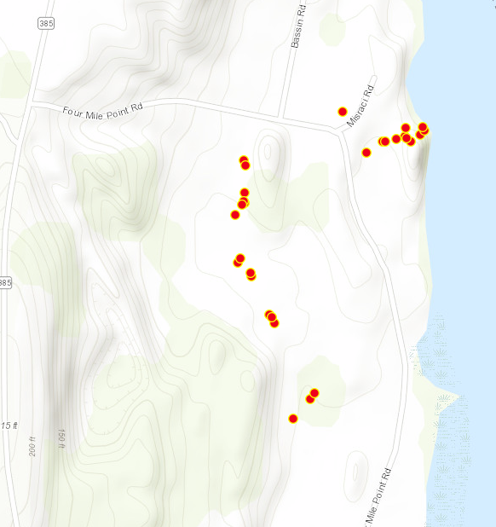
Figure 1: Invasive species identified in 2018 at the northernmost portion of Vossburgh Swamp. Similar species were found in the southern portion and along Four Mile Point Road.
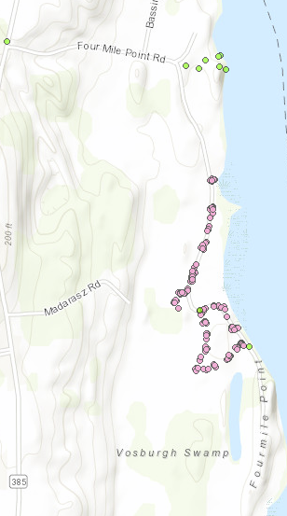
Figure 2: Invasive species identified in 2019 at Vossburgh Swamp. Surveying mostly was focused around the southern entrance to the property as well as on Four Mile Point road where it transects land owned by the state.

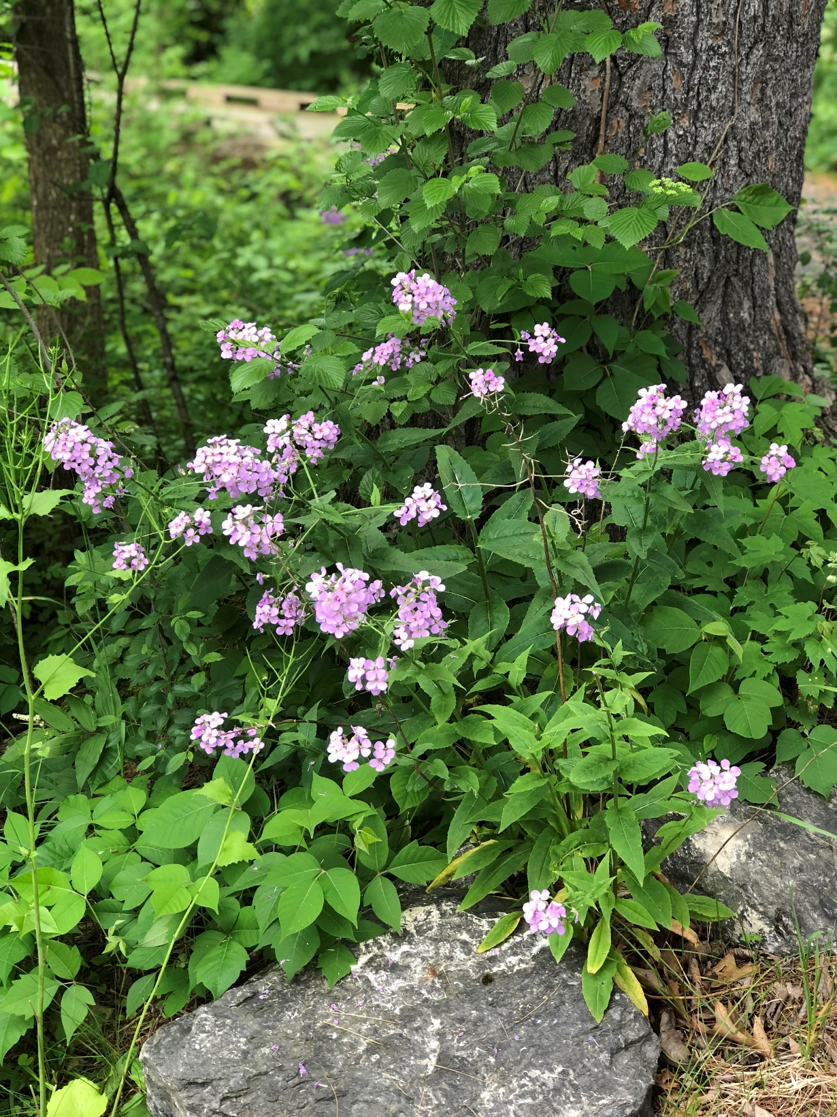
Fig 3. Dames Rocket at Vosburgh Swamp

