Capital Region (PRISM)
Partnership for Regional Invasive Species Management
2021 Annual Work Plan
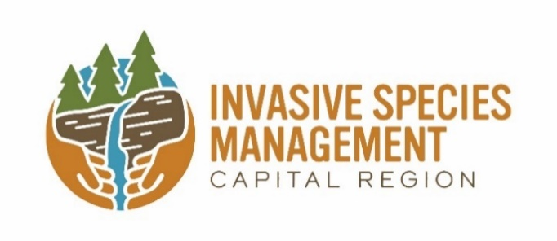

The Capital Region Partnership for Regional Invasive Species Management (PRISM), one of eight PRISMs across New York State, is hosted by the Cornell Cooperative Extension of Saratoga County. Through Cornell Cooperative Extension, the Capital Region PRISM proudly serves eleven counties, including Albany, Columbia, Montgomery, Rensselaer, Schenectady, and portions of Fulton, Greene, Herkimer, Saratoga, Warren, and Washington. More than three dozen cooperating organizations, partners, and volunteers support the Capital Region PRISM in its mission. To become a partner or volunteer please check out our website and contact a coordinator. Funding for the Capital Region PRISM is provided by the Environmental Protection Fund, administered through the New York State Department of Environmental Conservation.

Invasive species are defined by Environmental Conservation Law (9-1703 (1)) as non-native species that can cause harm to the environment, economy, or to human health. They are a form of biological pollution that comes from around the world. The rate of invasion of these species is growing due to increasing international trade and climate change. A wide variety of invasive species negatively impact many sectors of our world: our ecosystems, including all-natural systems and managed forests; our food supply, including agricultural products and harvested wildlife, fish and shellfish; our built environments, including landscaping, infrastructure, industry, gardens and pets; and our economy, recreation, and human health. Responding to this growing problem, New York State has implemented recommendations of the New York Invasive Species Task Force (ISTF) established under legislation passed in 2003. In 2008, Title 17 of ECL Article 9 established the New York Invasive Species Council and Invasive Species Advisory Committee. This Council of nine state agencies is co-led by the New York State Departments of Environmental Conservation (DEC) and Agriculture and Markets (DAM). Among the Council’s numerous statutory responsibilities is: “support(ing) within available funds and encourage(ing) Partnerships for Regional Invasive Species Management [PRISMs] in their efforts to address invasive species through coordination, recruitment, and training of volunteers, education, early detection, rapid response, eradication, research, and planning.”

A Special Thanks to: The New York State Department of Environmental Conservation, Invasive Species Coordination Section; the New York State Department of Agriculture and Markets; the New York State Invasive Species Council; Invasive Species Advisory Council; New York State Legislature; and the Capital Region PRISM Steering Committee.
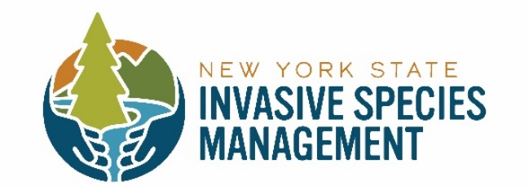
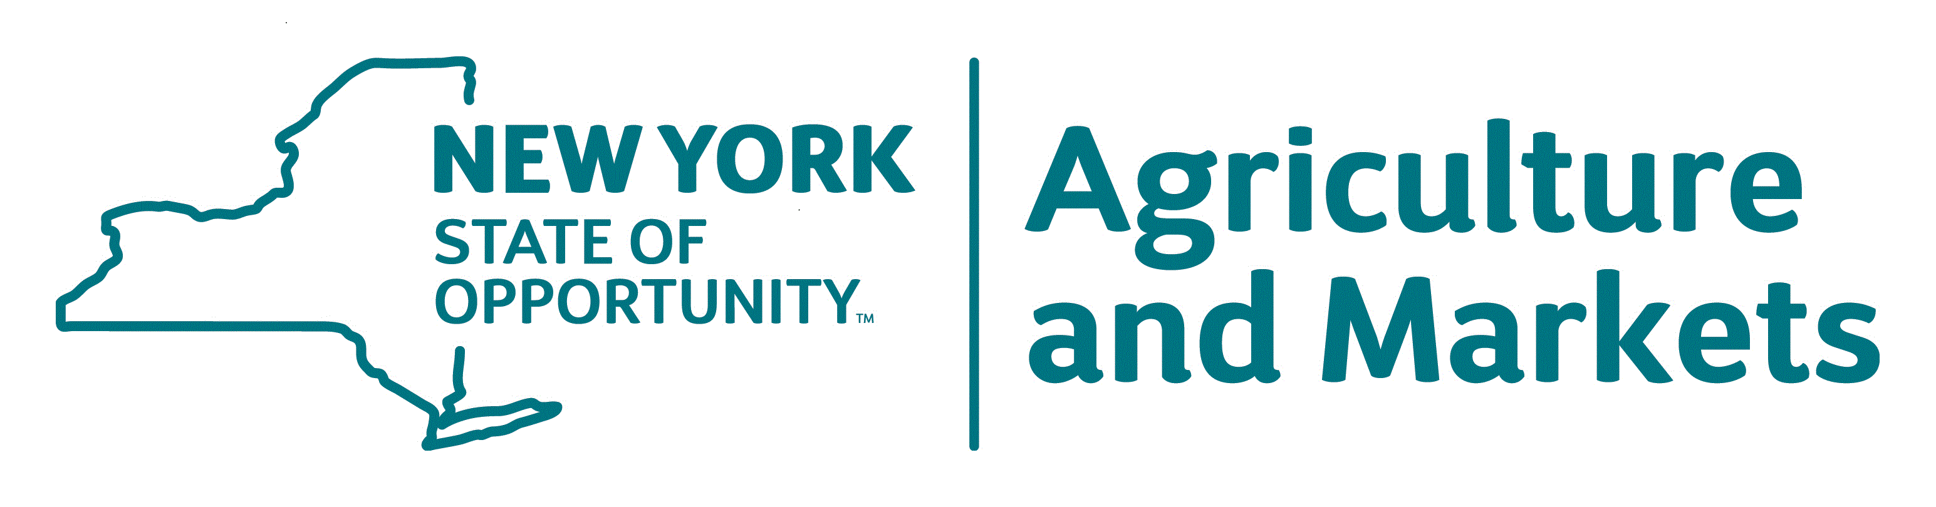
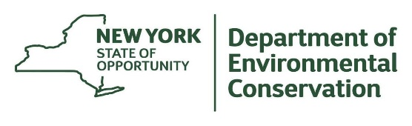

2021 Capital Region Steering Committee Members

Robert Cole NYS Department of Environmental Conservation Division of Lands and Forest: Forester
Linda White National Park Service: Biological Technician
Neil Gifford Albany Pine Bush Preserve: Conservation Director
Thomas Allgaier NYS Department of Agriculture and Markets: Invasive Species Coordinator
Loretta McNamee NYS Department of Transportation: Planning and Permitting Coordinator
Matthew Brincka NYS Office of Parks, Recreation, and Historic Preservation / Invasive Species Biologist
Dustin Lewis Saratoga County Soil and Water Conservation District: District Manager
Meg Wilkinson NYS Department of Environmental Conservation, Natural Heritage Program

The PRISM’s 2020 Workplan is aligned with the goals and objectives described in Capital Regions Five-year Strategic Plan and outlines specific actions the Capital Region PRISM staff will take in 2021 to advance the plan’s goals and objectives. The PRISM would like to thank our dedicated partners for their support and assistance in achieving our shared mission of reducing the impact of invasive species on our economy and ecology of the region.

The Mission of the Capital Region PRISM is to: “detect, prevent, and control invasive species through direct action and education to protect biodiversity, the natural environment, economy and quality of life.”

Capital Region PRISM Strategic Goals / Objectives
A. | Coordination/Partners. Cooperation
B. | Prevention
C. | Early Detection (ED) and Rapid Response (RR)
D. | Education and Outreach (E/O)
E. | Control / Management / Restoration
F. | Information Management and Communication
Capital Region PRISM Staff
KW | Kristopher Williams Team Leader /PRISM Coordinator
LH | Lauren Henderson Aquatic Invasive Species Coordinator
LM | Lauren Mercier Education and Outreach
NC | Nicole Campbell Terrestrial Invasive Species Coordinator

Capital Region PRISM: Goals, Objectives, Strategies and Work Plan Actions
Coordination/ Partners / Cooperation
– An essential part to achieving success of preventing the spread of invasive species is to - identify partners, and stakeholders to improve opportunities for sharing resources (human & financial), knowledge, and cooperation.

Objectives:
- Partners are the success to the Capital Region PRISM region in reaching a common goal to slowing the spread of invasive species.
- Collaborating with partners on projects, programs, and events.
- Sharing of resources, data and research will save time and efforts among partners in slowing the spread of invasive species.
- Continue to foster new partners to the Capital Region PRISM to increase capacity; especially with local colleges and universities.

Strategies: | 2021 Work Plan Actions | Target Quarter
- Provide opportunities for PRISM partners to give updates on projects, information, and materials at PRISM wide quarterly meetings. | Provide time at partners meeting for networking  Continue to promote Request for Proposals (RFPs) that address our goals, objectives, strategies and or outcomes in our work plan.  - Offer RFP’s under $2500 with easy qualification procedures no match  - Offer RFPs under $10,000 with justifications documented+  - Offer RFPs between $10,000 – 25,000 must have management plan+  Recruit RFPs that focus on E/O or ED/RR of emerging species  Report management and research executed from RFP at partner meetings | Q1/Q2/Q4
- Enable networking through PRISM partner meetings, working committees, listserv, and other avenues to improve aspects of the PRISM. | Distribute a form to partners to solicit outreach events on the listserv and website  Distribute survey and management plan forms to partners to encourage reporting  Increase PRISM participation with expertise, field work, or recruitment of resources  Post Partner works and PRISM work on web page  Create an e-blast to gather information on partner efforts for (annual report feature) | Q1-4
- Encourage participation of partners in Invasive Species Awareness Week (ISAW) and other events throughout the region. | Encourage partners to report on ISAW events throughout the region  Solicit partners to see what information and or needs they would like  Post to ISAW statewide report | Q1-3
- Promote the Capital/Mohawk PRISM throughout the region in order to recruit new partners, including but not limited to educational institutions (high schools, colleges, universities), professional trade organizations, public sector agencies, and non-governmental organizations. | Obtain approval for formal partners agreement / Implement  Recruit new partners via invitation strategies  Contact and renew existing partnerships /Prioritize relations with 2-3 partners per team member  Spread invitation to new partners by word of mouth/ preexisting partners or by attending functions such as board meetings and delivering invitation when possible  Provide a quarterly newsletter with updates on information such as regional roundups, new threats, bmp’s, Partner efforts and works, ISAW | Q1/Q4

Capital Region PRISM: Goals, Objectives, Strategies and Work Plan Actions
Prevention
– Although considered the first line of defense for invasive species moving into an area, often the best efforts and management practices will not stop invasive species from becoming established.
Objectives:
- Further develop to partners, communities, and municipal officials an awareness of pathways that will likely be corridors for introduction and/or spread of invasive species.
- Continue to develop a public awareness about the PRISM, invasive species, and the impact that invasive species can cause to the environment, economy, and human health.
- Sustain the efforts of awareness regarding early detection species to prevent the spread, and control methods to implement.

Strategies | 2021 Work Plan Actions | Target Quarter
- Strengthen the resource capacity of the Capital Region PRISM to further assist partners, communities, and volunteers in preventing the spread of new or existing invasive species. | Recruit 2-4 interns for aquatic and terrestrial program or survey assistance  Reach out to new partners and encourage them to apply for RFP  Reach out to other agencies, parks, or preserves who have available staff to provide holistic instruction on invasive identification, reporting in iMap and prioritization of removals w/BMP  Recruit citizen scientists through educational programing with lecture series | Q1/Q4
- Target pathway of movement areas to educate partners, stakeholders, volunteers for monitoring and early detection. | Create brochures, infographics, and trifolds on highly probable areas of transport including parking lots, roadways, bike paths, etc.  Include trainings in the field on how to conduct search to find invasive species  Establishing 1-2 training sites for in-person demonstration of successes and failures of invasive species management  Create, revise and implement documents on how to conduct surveys for terrestrial and aquatic environments i.e. transects and rake tosses  Post ecological significance, prioritization, comprehensive score, and heat map of risk of infestation to website  - Front page of website  - Embed to website or direct people to view it in iMap  - Utilize newsletter to disseminate information | Q1-4
- Continue to further develop citizen science projects throughout the region for both aquatic and terrestrial species. | RFP process  -Emphasize as research requirement / -Have partners create projects and conduct research based on needs and report back | Q1/Q4
- Within the Capital Region PRISM, identify and map high priority ecological areas that could be impacted by the treat of invasive species. | Utilize Lake Prioritization Model and Priority Conservation Areas based off the NHP prioritization model  Encourage partners and volunteers to adopt work in those areas | Q1-4
- Utilize knowledge of partners and surrounding PRISMs to provide better management practices (BMP’s) awareness to stakeholders and the public for slowing the introduction or spread of invasive species. | Share NYSDEC ISCU, NYSISRI, NEIPMC, NHP, Hudson River Estuary Program, Mohawk River Basin Program, NYSFOLA, NY Dept. of Ag. and the Hemlock Initiative resources  -Distribute information from the NYIS / -Collaborate and share info from partner PRISMs  Collaborative information with be share and distributed across listserv, social media, website, PRISM partner meetings and at request.  Statewide aquatic and terrestrial coordinator meeting to review BMPs | Q1/Q4
- Continue to develop educational outreach materials for targeted audiences, such as, but not limited to gardeners, recreationalist, lake associations, etc. on identification and pathways. | Promote factsheets for various groups  Posters for kiosks or professionally made signs  Identify target audiences | Q1/Q4
- Continue to provide workshops and trainings for public agencies and private businesses, such as, but not limited to highway departments, parks departments, cemetery associations, landscapers, developers, garden centers, etc. on the pathways that invasive species spread. | Reach out and rotate to all 11 counties  PRISM-led trainings  Continue to honor requests from the public for trainings (1-3 per month) | Q1-4 as appropriate w/ seasonal work
Capital Region PRISM: Goals, Objectives, Strategies and Work Plan Actions
Early Detection/Rapid Response (ED/RR)
– early detection is imperative to slowing the spread and further prevention of a harmful species. Prioritizing species, pathways, and high probable areas is necessary for reducing the spread.

Objectives:
- Species are identified in the Capital Region PRISM ‘invasive species priority ranking tier system’ as ED/RR species and to develop a protocol for responding.
- Keeping partners and the public informed as to those species that are deemed to be species of high or very high impact to the environment, economy, or human health.
- Continue to survey and monitor areas of high priority of risk from invasive species.

Strategies | 2021 Work Plan Actions | Target Quarter
- Continue to update and verify locations of those species in Tier 1 (ED/Prevention) of the Capital Region PRISM priority list – as to how proximity to the PRISM. | Update and review conservation priority areas  Continue surveying areas of higher significance more often and those with lower values less often on a 1-3 year cycle  Consider non-Priority Conservation Areas / or Nearby Parcels  Utilize a Framework of Response  Include partner research for early detection and management  -Gather additional resources for complete evaluation of BMPs/IPM  Continue development of survey protocol for aquatic/terrestrial locations  -Look at various protocol from separate agencies (park staff, fisheries, etc.)  Survey protocols for highly probable areas with transects should be developed (terrestrial) | Q1-4
- Establish an effective monitoring system with PRISM partners. | Look into the Lake Management Tracker Training program with iMap’s inclusion of map overlays (aquatic)  Implement and promote use of iMapInvasives via trainings
- Implement a monitoring system with partners and citizen science volunteers. | Share methodologies for surveying (ED/RR protocol)  Conduct trainings for identification of different tier species; include iMap mobile application and treatment reports  Send staff and seasonal workers to assist partners with identification and response  Have partners reporting back to use  Encourage monitoring through RFP process | 1/Qrt Each
- Determine procedures of communicating the need for a rapid response upon confirmation of finding a high impact species. | Encourage partners to use iMap for reporting and advanced partners to set alerts on iMap  -Ensure that PRISM staff have alerts set up for 11-county region  Provide a mechanism for reporting on Capital Region PRISM webpage  -Include mechanism in literature (factsheets, listserv, etc.) | Q1-4
- Continue to develop a communication protocol for notifying partners and the public. | Partner meeting updates and listserv updates  Use quarterly reporting and outreach to update partners/public  -Send through listserv twice a year or as needed | Q1-4
- Assist partners in finding funding sources to implement a rapid response program/project. | Listserv, RFP, MOU, Single source | Q1-4
- Acquire previous documented information from other PRISMs, agencies, and organizations on effective management practices. | Use clearinghouse and encourage partners to access it as well  Encourage partners to access our webpage as well as NYS Invasive Species Info  Utilize sharing of current research and practices | Q1-4

Capital Region PRISM: Goals, Objectives, Strategies and Work Plan Actions
Education / Outreach (E/O):
-To increase awareness and knowledge of invasive species that can cause significant harm to the environment, economy, and human health.

Objectives:
- Provide education/outreach to assorted entities in order to increase awareness of the PRISM, and to provide a better understanding of invasive species and their impacts.
- Collaborate with Capital Region PRISM partners and stakeholders to expand opportunities of providing information on identification, prevention, management, and restoration throughout the region.
- Maintain and further develop the Capital Region PRISM web site, and other social media avenues as resources regarding invasive species within the eleven-county area.
- Aid communities in developing educational materials when responding to a rapid response situation.

Strategies | 2021 Work Plan Actions | Target Quarter
- Continue to support to the Education/Outreach working committee in developing materials, lesson plans, exhibits, and other resources to be distributed throughout the Capital Region PRISM. | Distribute PRISM created ID cards, BMP’s, Factsheets, Survey Protocol, and Powerpoints for use throughout region  Post webinars and recordings to website  Develop and participate in committees that include partners and other PRISMs that can meet once or twice a year | Q1-4
- Continue to develop and provide trainings as needed and requested for communities, highway departments, educational institutions, organizations, and other stakeholders. | Target/Select specific stakeholders from the list below  -SWCDs  -Master Gardner’s  -Municipalities  -Conservation Boards  -DOT  -Aquatic organizations (Scenic Hudson, Riverkeeper, etc.)  -Local colleges (Skidmore, Siena, ACC, UAlbany, Saint Rose, RPI, Union)  -Local middle/high schools -BOCES Programs  -Library series across the Capital Region (Guilderland, Saratoga, Malta, Burden Lake, etc.)  -Park staff (maintenance, educators, etc.)  -Future Farmers of America / 4H | Q1,2/4
- Continue to utilize iMapInvasives as an approach to involve citizen scientist volunteers throughout the region. | Offer different levels of training with different targets  -Mobile app training for reporting  -iMap Desktop version (Making survey/treatment reports) | Q1-4
- Provide invasive species trainings/workshops that include both terrestrial and aquatic invasive species information. Disseminate brochures, fact sheets, and educational materials throughout the Capital Region PRISM that have been developed by partners and statewide support. | Using contract service dollars, develop in-house resource guidebooks to print | Q1
- Promote the PRISM website as a location for educational resources. | Set team updates quarterly by posting newsletter (emerging species, research, reports, photos)  - hyperlinking Instagram/Facebook current feed to website  2021 will include launch of updated website
- Develop a Capital Region PRISM communiqué that is shared quarterly with partners via the listserv, and posted on website. | Newsletter (quarterly)  -Updates on tier species, relevant research, general PRISM Partner updates (Listserv, e-blasts) | Q1-4
- Continue to attend events and locations that can promote the mission and purpose of the Capital Region PRISM.

Capital Region PRISM: Goals, Objectives, Strategies and Work Plan Actions
Control / Management / Restoration:
-Three contemporaneous efforts in the reduction, impact, and manipulation of areas compromised by invasive species; especially high priority ecological areas.

Objectives:
- Identify, map, and prioritize high priority ecological areas.
- Work with PRISM partners to respond to early detection species; especially near probable high-risk areas within the PRISM.
- Make use of proven control and management methods of partners and other PRISMs in order to best accomplish containment, and to slow the spread of infestation.
- Procure funding sources to provide effective response and control measures within the PRISM.

Strategies | 2021 Work Plan Actions | Target Quarter
Frequently review Capital Region PRISM priority species ranking tiers, and update as needed. | Post updates to website, listserv, biannual newsletter, and share with partners  Solicit updates from partners at partner meetings and through the listserv  Have individual/new species reviewed by both conservation and aquatic working committees for tier list recommendation(s) | Q1/4
Working with the conservation/terrestrial working committee of the Capital Region PRISM, prioritize species using the invasive plant management decision analysis tool (IPMDat). | Use a Framework of response in guiding management practice | Q1/4
Utilize iMapInvasive data, maps developed by PRISM partners, and GIS to estimate pathways and corridors of potential spread. | Continue to utilize Prioritization Models to determine PCA’s, priority waterways, and highly probable areas  Focus efforts based on tier 1 & 2 presence and proximity data
Develop with the Capital Region steering committee an annual work plan. |  | Q3
Provide an annual request for proposals (RFP) to Capital Region PRISM partners to provide collaborative efforts in controlling, managing, and restoring critical habitats within the region | Request for Proposals  -General RFP’s: under $2,500  -General RFPs: more than $2500 and up to $10,000  -Targeted RFPs: $10,000 - $25,000  Explore use of single-source contracting | Q3/Q4
Utilizing volunteers, partner agencies, and strike teams to respond to high risk/low abundance infestations within the PRISM | Utilize 1-4 seasonal interns as technicians for control and management  Use volunteer networks  Partner agencies and staffing | Q2-3
Develop a resource list of key individuals throughout the PRISM, including but not limited to, pesticide applicators, volunteers, and species-specific experts. | Provide up-to-date resources as requested
Highlight key success projects; especially those that show response to restoration efforts. | Add to website when reports come in; add to annual work plan as well  Highlight 2nd,3rd year successful post-treatment monitoring/management  Promote restoration through RFP

.

Capital Region PRISM: Goals, Objectives, Strategies and Work Plan Actions

Information Management/Communication:
-Bringing together all goals and objectives in order to advance collaboration of the Capital Region PRISM for sharing information involving surveys, monitoring, early detection, management approaches, restoration, and research.

Objectives:
- Encourage the use of the Capital Region PRISM website and use it as a platform to disseminate information to PRISM partners, stakeholders, and volunteers.
- Continue to develop and promote educational fact sheets, brochures, and research-based information regarding invasive species identification, management, control, and restoration.
- Support quarterly meetings, and partner involvement in working committees as opportunities to share and report updates.
- Establish and maintain a system for collecting data from PRISM partners regarding early detection of new species, management techniques, control options, and applied research.
- Support PRISM partners, stakeholders, and communities during early detection/rapid response actions, including priority contacts to communicate efforts.

Strategies | 2021 Work Plan Actions | Target Quarter
Provide a guest presenter at each Capital Region PRISM partner meeting, and provide a forum for partners to share at these meetings. | Maintain required Partners meeting biannual with one more as need on partner demand. | Q1/4
Encourage PRISM partners to utilize Capital PRISM website for linking pertinent reports, management techniques, control methods, and research regarding invasive species. | Disseminate information through website, listserv, etc. as outlined in other goals  Encourage use of survey and management templates found on website for work done on behalf of our partners to report back to the PRISM (put into our annual work plan and upload to the website under Partner Reports)  Reach out to partners via e-blasts and listserv to gather information on management, research, and control and provide link to website  Link to partner reports page of our website
Continue to support and increase capacity of the Capital Region PRISM working committees to strengthen partner collaboration. | Activate aquatics committee to strengthen community relationships and acquire additional insights  Initiate education committee  Maintain 1-3 steering committee meetings  Continue to maintain 1-3 meetings with Conservation Committee | Q1/4
Encourage PRISM partners to share data, control methods, and research in the Capital Region PRISM annual report each year. | Encourage use of survey and management templates found on website for work done on behalf of our partners to report back to the PRISM  Survey partners
Provide a systematic checklist to be used as partners, stakeholders, and communities work through an early detection/rapid response framework. | Implement Survey and Management templates  Encourage use of reports through website, listserv, newsletter  Require reporting for ED/RR

