Capital Region PRISM Treatment Report

Site Information
Date: (9/9/2020)
Site Name & Address: Daketown State Forest Daketown Rd. Greenfield Center, NY 12833
Property Owner: NYS
Latitude: 43.10569 ° Longitude: -73.92506 °
Project Leader: Nicole Cambell Email: nlc64@cornell.edu
Team Members: Rich McDermott, Lauren Mercier, Kristopher Williams
iMapInvasives User ID: 7176

Project Information
(Copy this section and fill out for each species)

Target Species: Shrubby Bushclover (Lespedeza bicolor)
First year of treatment? Yes
Size of infestation: 901.13 m²
Treatment Method (please be specific):Loppers, pruners, and weed-wrench to cut all plants down and piled on site.
% Completed: 100%
Time spent on removal: 3 hours
Is follow-up needed? Yes- 2-3x a year
Were treatments uploaded to iMapInvasives? Yes
Photos and maps of the project:
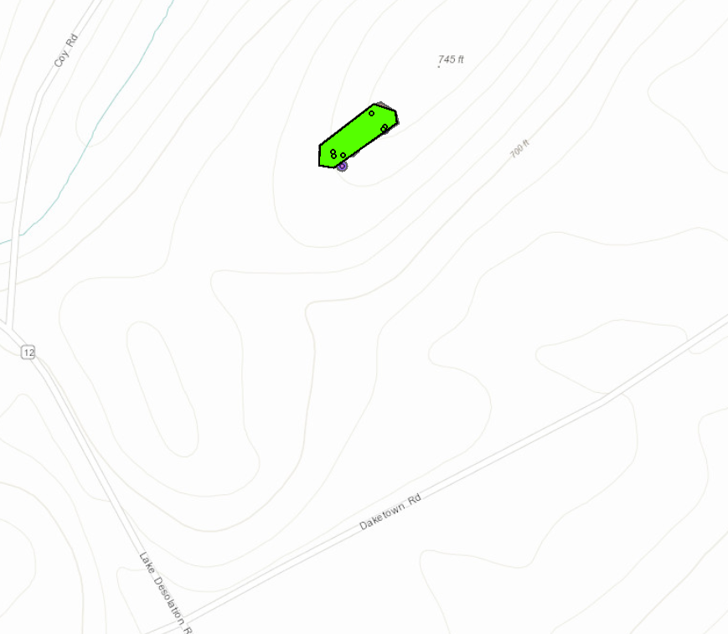
Map of the Shrubby bushclover infestation
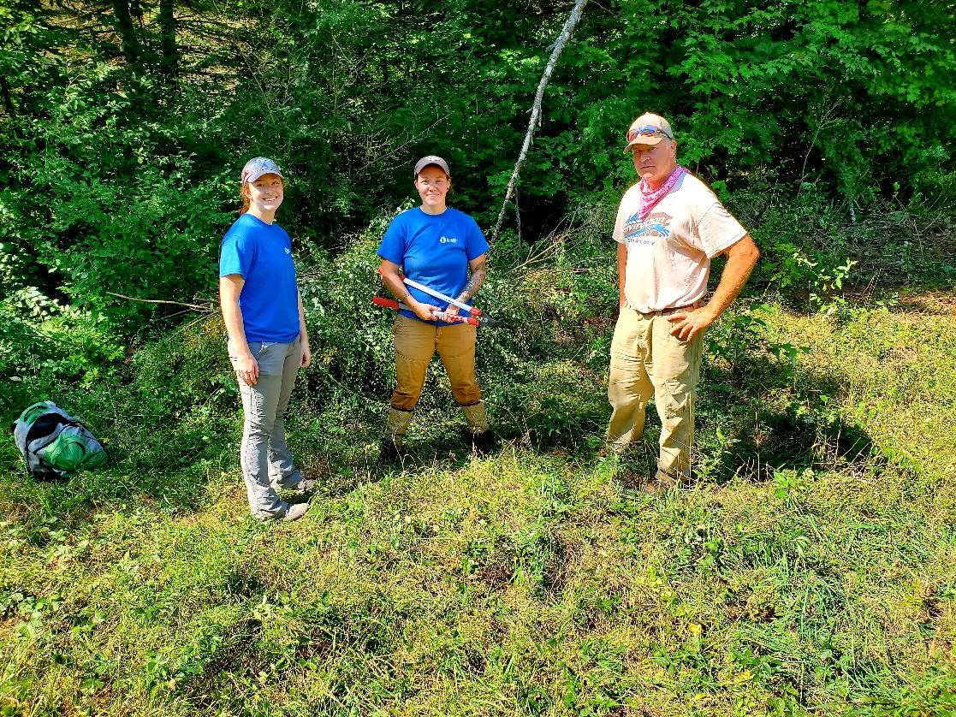
Capital Region PRISM staff Lauren Mercier, Nicole Campbell, and State Forester Rich McDermott on site following removal
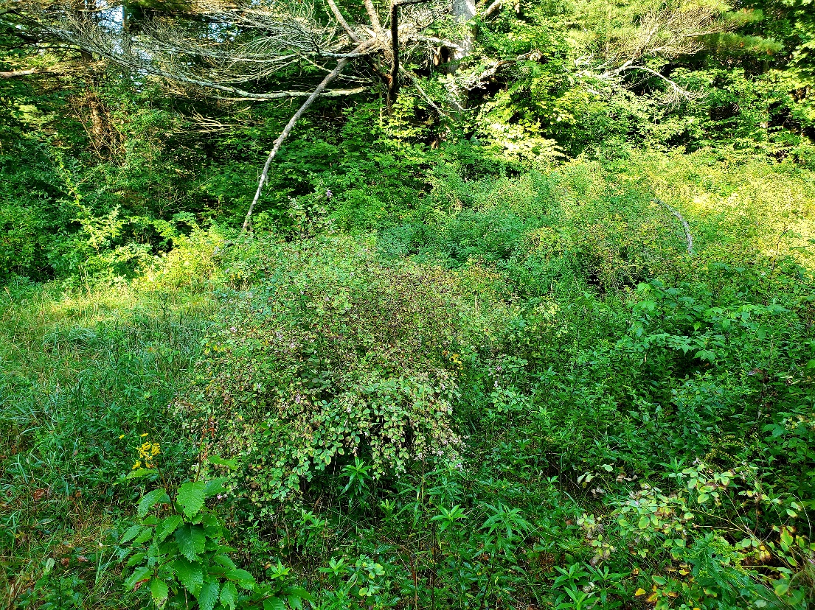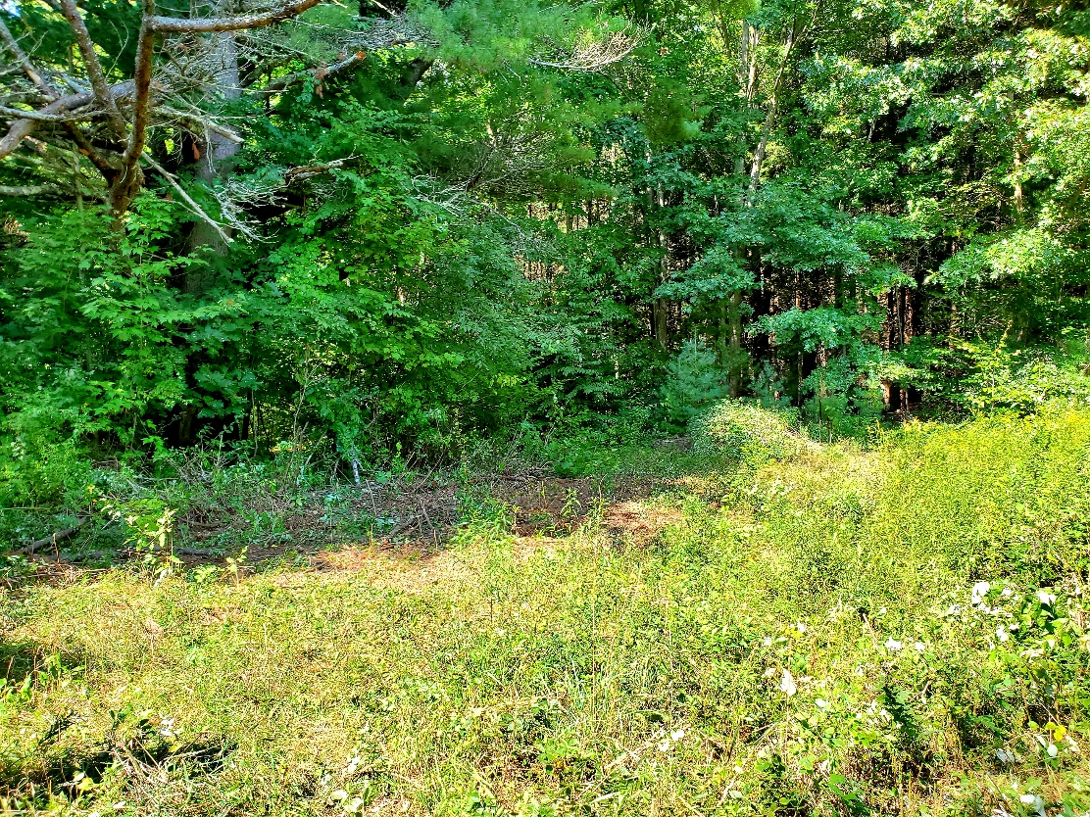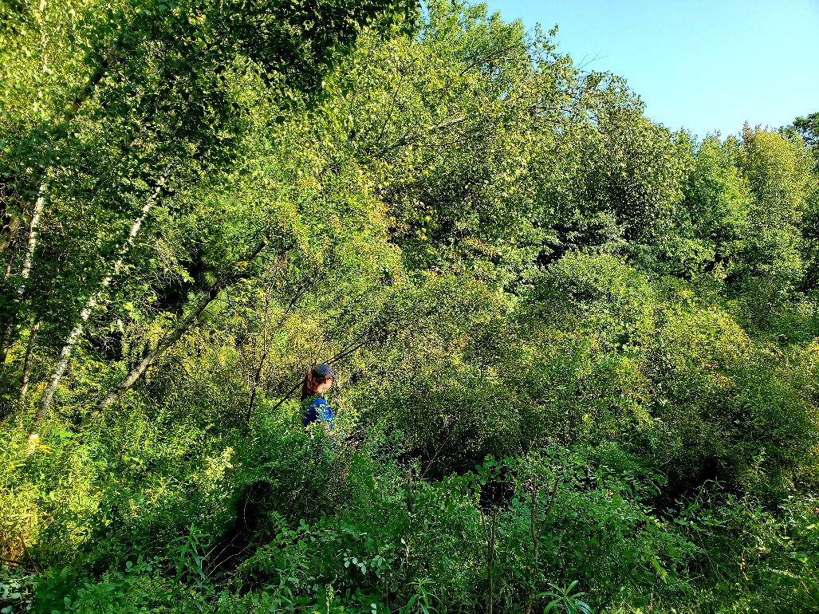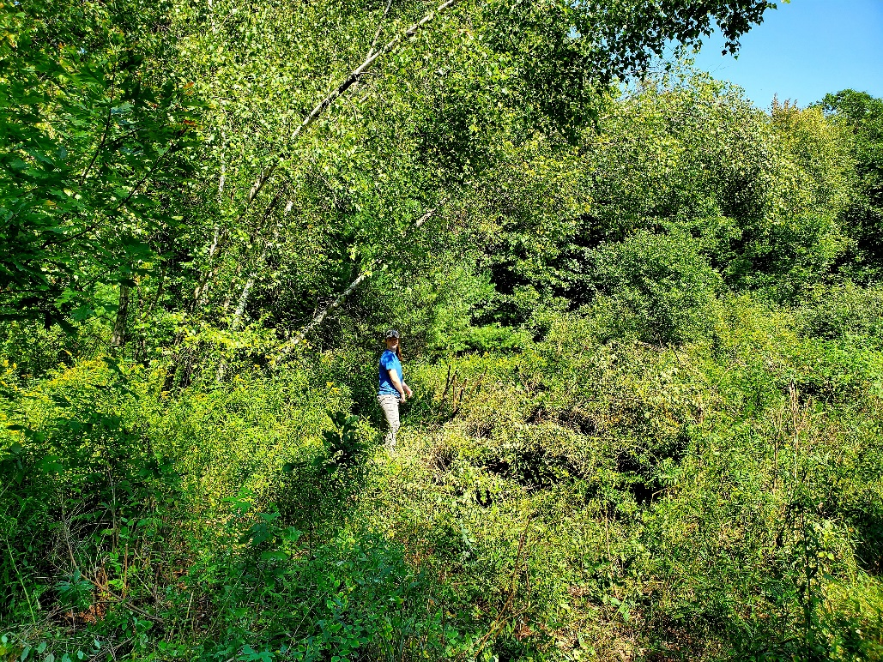
Before and after photo of the Southwestern edge of the infestation.
PRISM staff member Lauren Mercier is pictured in the same location in the middle of the infestation before and after the removal

