ALBANY PINE BUSH PRESERVE INVASIVE SPECIES SURVEY 2019:

Emily Caboot, Anna Kuhne, Lauren Mercier, and Kelsey Stevens

Introduction: In July of 2019, the Terrestrial Invasive Species interns, from Siena College, and the education and outreach coordinator went to look for early detection invasive species throughout the Capital-Mohawk PRISM. The Siena interns, Anna Kuhne and Kelsey Stevens, focused on terrestrial invasive plant surveys at highly susceptible and valuable habitats throughout the PRISM region. The following is an abridged summary of some of the findings of the survey throughout the Albany Pine Bush. The PRISM works throughout 11 counties around the capital region to detect, prevent, and control invasive species.

Project Description: Surveying terrestrial invasive plants in the park in a Highly Probable Areas
Dates: July 17th, 2019
Participants: Capital Mohawk Prism, Cornell Cooperative Extension, NYS DEC, and Albany Pine Bush Preserve
Point of Contact: info@albnaypinebush.org
County: Albany County

Locations and Species Identified:
Albany Pine Bush Preserve (infor@albnaypinebush.org): Surveying was done around the parking lots and main entrance of the Albany Pine Bush Preserve Discovery Center.
Invasive Species Present at Albany Pine Bush Preserve: This table presents species that have been identified in the area in the past and present including both terrestrial and aquatic invasive species.
Common Name | Scientific Name | Locations (GPS) | Growth Type | Phenology
Common Reed | Phragmites australis | 42.71918  -73.86483 | Herbaceous | Vegetative
Oriental Bittersweet | Celastrus orbiculatus | 42.71877  -73.86506 | Vine | In Seed
Black Locust | Robinia pseudoacacia | 42.71827  -73.86447 | Tree | Vegetative
Honeysuckle | Lonicera spp | 42.71893  -73.86533 | Shrub | In Seed
Multiflora Rose | Rosa multiflora | 42.71816  -73.86481 | Shrub | Vegetative
Spotted Knapweed | Centurea stoebe | 42.71863  -73.86436 | Herbaceous | Flowering
Mugwort | Artemisia vulgaris | 42.71851  -73.86399 | Herbaceous | Vegetative
Wild Carrot, Queen Anne’s Lace | Daucus carota | 42.71856  -73.86464 | Herbaceous | Flowering
Birdfoot Deervetch | Lotus corniculatus | 42.71852  -73.86444 | Herbaceous | Flowering
Great Mullein | Verbascum Thapsus | 42.71931  -73.86417 | Herbaceous | Flowering
Garlic Mustard | Allaria petiolata | 42.7186  -73.8648 | Herbaceous | In Seed
WhiteSweet – clover | Melilotus albus | 42.71896  -73.86457 | Herbaceous | In Flower
Wild Parsnip | Pastinaca sativa | 42.7186  -73.8648 | Herbaceous | Flowering

Dominant Native Plants: Butterfly weed, wild blue lupine, pitch pine, scrub oak
Native Community Types: Scrub oak barrens, scrub oak forest
Treatment Method: N/A

Summary of Work Completed:
  - Surveying for invasive terrestrial species
Recommendations for the Future:

Contact Emily Caboot at ecc238@cornell.edu, Anna Kuhne at av13kuhn@siena.edu, Lauren Mercier at lnm47@cornell.edu, or Kelsey Stevens at kao04stev@siena.edu for any questions regarding this report.

Figure 1: Map of the Albany Pine Bush Preserve. The pink dots surrounding the Discovery Center were the points taken by the CAPMO team on July 17th 2019.
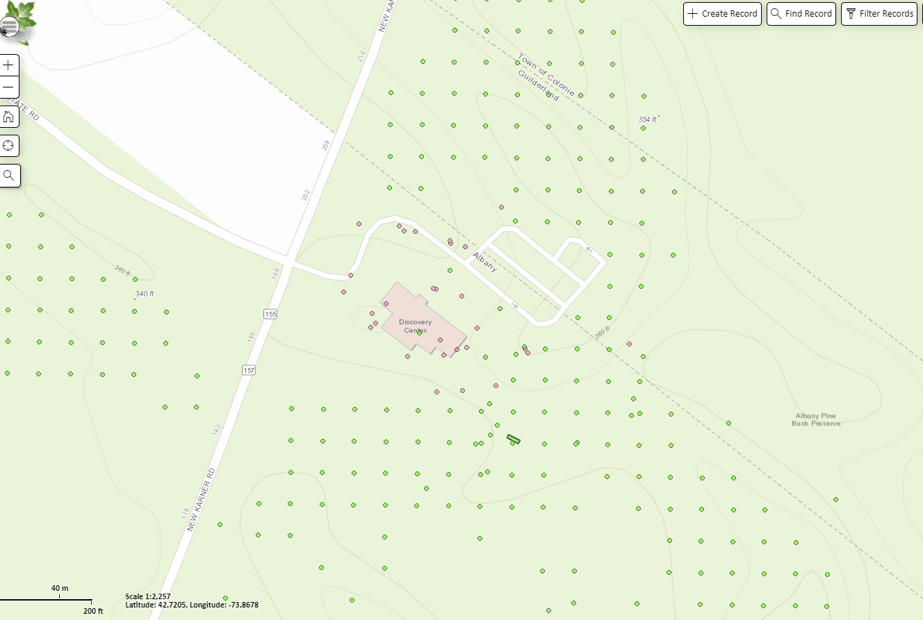

Figure 2. Mugwort (Artemisia vulgaris) outside the Discovery Center of the Albany Pine Bush Preserve.
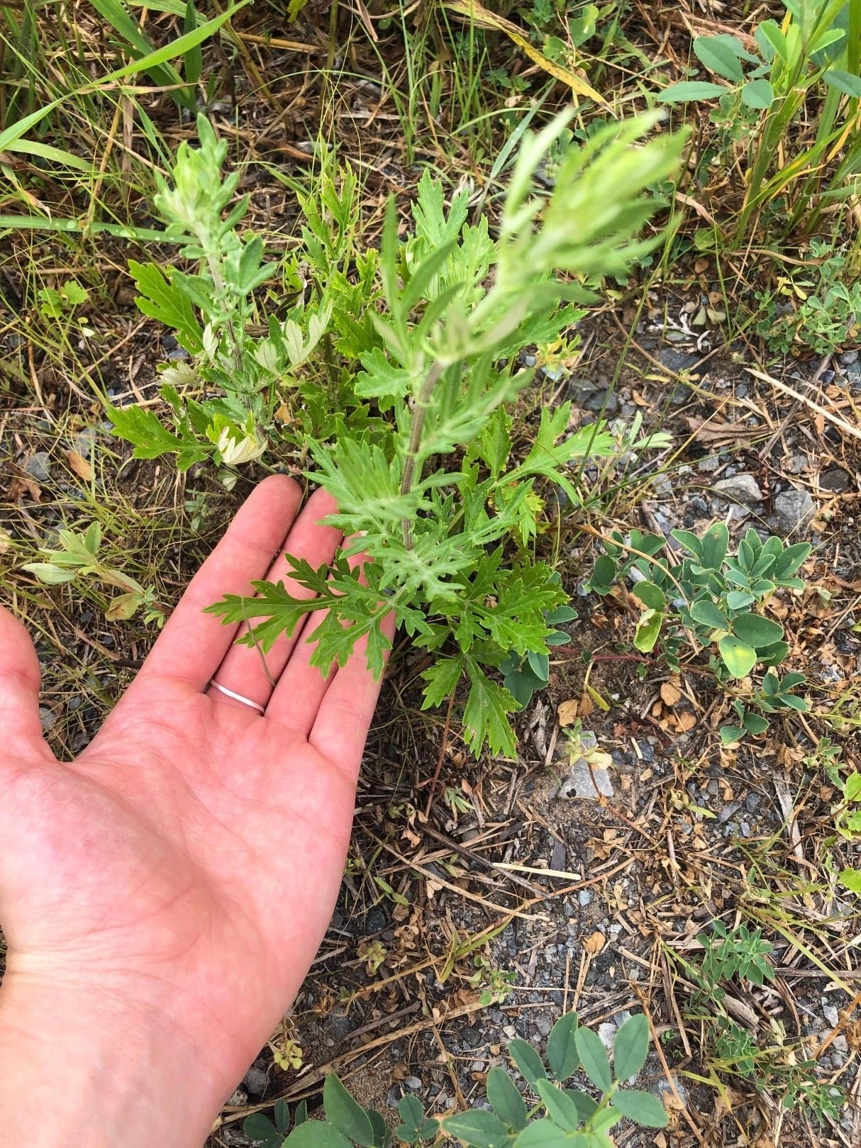

Figure 3. Wild Carrot, Queen Anne’s Lace directly adjacent to the Discovery Center at the Albany Pine Bush Preserve.
