Anchor Diamond Park Hemlock Woolly Adelgid Treatment 2019:

Spencer Barrett, Terrestrial Invasive Species Coordinator

Introduction: This past summer, the Terrestrial Invasive Species Coordinator worked with two interns, one from SUNY Environmental Science and Forestry and one from Cornell, to look for Early Detection invasive species throughout the Capital-Mohawk PRISM. The ESF Intern, Elizabeth-Anne Jamison, focused on terrestrial plant species, while the Cornell Intern, Lilly-Anne Trainor, worked for the New York State Hemlock Initiative to determine the spread of Hemlock Woolly Adelgid throughout the Capital region. One of the places surveyed was Anchor Diamond Park in the town of Ballston where the (then) northernmost untreated population of Hemlock Woolly Adelgid was discovered. Working with the Forest Health division of the New York Department of Environmental Conservation, the PRISM planned a response strategy over several months, and DEC applicators came to treat the site in April 2019. The following report summarizes the PRISM’s activities with DEC from the discovery of the population to the treatment.

Project Description: The Capital-Mohawk PRISM partnered with DEC and the town of Ballston to address the Hemlock Woolly Adelgid at Anchor Diamond Park through a pesticide treatment of both imadicloperid and dinotefuran. Hemlock Woolly Adelgid is a destructive tree pest and when left unchecked, would cause tree decline and death, resulting in a complete ecosystem shift in that portion of the park.
Dates: The Hemlock Woolly Adelgid population at Anchor Diamond was found in June 2018. Original treatment of the site was planned for fall 2018, but was later rescheduled to spring 2019. The treatment date occurred on 4/25/19.
Participants: Lily-Anne Jamison, Elizabeth Jamison and Spencer Barrett, Capital-Mohawk PRISM. Jason Denham, Jessica Cancilliere and Liam Somers, DEC Forest Health. DEC Statewide Giant Hogweed Team. Mary Alice Nyhan, Town of Ballston Parks Committee Representative. Cliff Samson, Michael Gaige, Amy Jones and Ralph Keating, Town of Ballston Residents. Loretta McNamee and Eric Sage, Schenectady County Invasive Species Committee.
County: Saratoga County
Associated iMap Invasive Records: Presence: 531088, 525748. Treatment: 14197.

Summary of Work Completed:
  - Detection: Lily-Anne Trainor was the original discoverer of HWA at Anchor Diamond Park. The Terrestrial Field team of the PRISM had gone to Anchor Diamond for a half-day to train on identification features and methods of scouting for HWA, and Lily discovered adelgid presence on two trees next to the fireplace on the yellow (or hemlock) trail. The team continued to survey for adelgid during the afternoon, as well as doing traditional invasive plant trail surveying of the hemlock loop. At this point, Anchor Diamond was the only new point discovered during the field season in the target area between Prospect Mountain, the northernmost point of HWA in New York, and Indian Kill Preserve in Glenville, the next closest population.

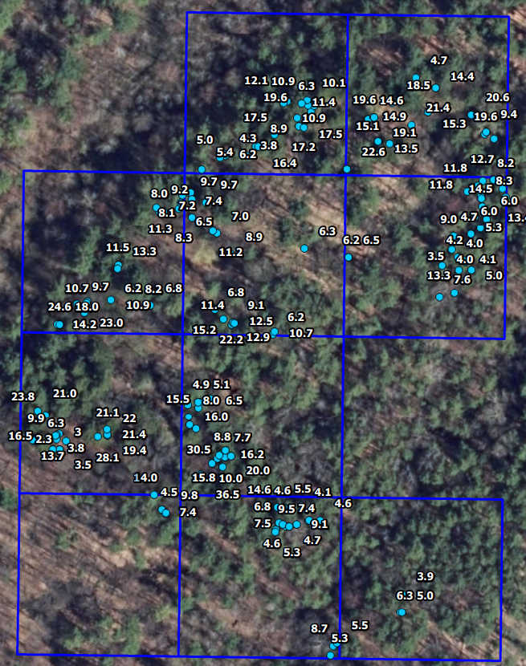
  - Collaboration: After the field season had ended, Spencer Barrett met with the Town of Ballston Parks Committee to discuss the discovery of HWA as well as treatment options. After that first meeting, a second meeting was set with Jason Denham, the HWA lead for DEC. It was at that meeting when Jason offered to perform treatment with DEC applicators. On September 17th, a team of five people (Michael Gaige, Spencer Barrett, Amy Jones, Jason Denham, and Mary Alice Nyhan) went to Anchor Diamond Park to prioritize trees for treatment. Michael Gaige, who has extensive site knowledge of Anchor Diamond, categorizes the hemlocks in the park as belonging to three major stands; the Confluence, Fireplace, and Cathedral Groves. The infested trees were all in the Fireplace grove, and Jason set a ten acre grid around the known infested trees. The ten acres were selected based upon permitting requirements as well as pesticide label restrictions, which allow for 256 inches of trunk diameter to be treated per acre. The selected trees, as well as their respective DBH, can be seen on the map below, which roughly follows the bend at the furthest point of the yellow trail. Trees are located on both sides of the trail. The approximate location of the fireplace is represented with a yellow star. During prioritization, one more tree was found to be infested, represented with the red circle on the map.

  - Education and Outreach: After it was clear that the treatment would have to wait until spring, Spencer Barrett worked with the Town of Ballston Parks Committee to set up an educational seminar at the Ballston Town hall to cover Hemlock Woolly Adelgid. When the date was set, Jessica Cancelliere from the DEC Forest Health Research lab agreed to speak as well, discussing the statewide treatments spearheaded by DEC, of which Anchor Diamond would be the latest. There were 15 attendees at the seminar, mostly residents from the town of Ballston and surrounding areas in the county.
Yellow Star- Fireplace/First Detection Point. Red Circle- Second detection point.

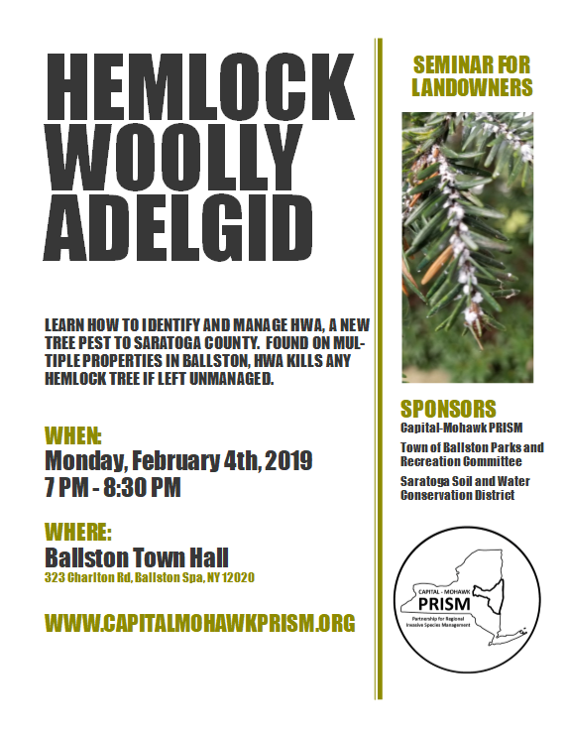
  - Re-flagging and Tagging: Early that spring, Jason Denham and Spencer Barrett met on site on two separate occasions to establish how many flagged trees had lost their tape over the winter, flag them again, and tag them with the metal tags, similar to the process at Plotterkill. Tagging only the treated trees was a massive improvement in the process, as now the town will be able to tell which trees were part of the first treatment and track results without the use of the original dataset. Tagging only the 159 trees that were treated also left no opportunity for duplicate tags. Tags are all located on the north side of each tree that was treated. After the trees were verified, the treatment dates were set with the DEC Giant Hogweed Team through communication with Naja Kraus and local press coverage was arranged to notify hikers of the trail closure.

  - Treatment: (4/25/19) Five applicators from the DEC Giant Hogweed Team arrived at 12:30 P.M. on the date of treatment and mixed their packs to the label rates for Hemlock Woolly Adelgid. They were joined on-site by Spencer, Jessica, town of Ballston residents, two members of the Schenectady County Invasive Species Committee, and additional helpers from the DEC research lab and the Giant Hogweed team. After mixing pesticide and running through safety measures and treatment procedures, the group walked back to the hemlock loop and familiarized themselves with the treatment area. Groups of helpers and applicators were divided and given one page of tagged trees (an amount ranging from 26 to 36 trees) over two or three blocks. Applicators found that they could apply in the range of 170-200 inches of insecticide before refilling their packs, so one refill was needed to cover the 159 trees tagged for treatment. The calibration for this treatment required 7.5 seconds of continued spraying per inch of dbh for each tree.

Recommendations for the Future:
- The Confluence and Cathedral groves require additional surveying efforts. One landowner in the town of Ballston reported HWA on a single tree, which was then removed. This landowner is located a few miles north of Ballston and assisted with the treatment, but has not seen HWA on his property since. Resurveying of his property is recommended as well. Yearly monitoring of Anchor Diamond should be a priority at times when HWA is visible such as May or October-November.
- If the town is interested in additional treatments, the Schenectady County Invasive Species Committee is looking into contracting out a treatment of the Indian Kill Preserve, so may be able to share quotes from contractors who could potentially treat untreated trees at Anchor Diamond Park or other town properties. A very cost-effective area to contract treatment would be the three trees surrounding the manor, all of which are old and would present a possible hazard to hikers were their health to decline. Naturally, points where new HWA is detected should also be a focus for new treatments.
- There are a number of other invasive species issues at the park, of which HWA was the most concerning. Other invasive species not covered in the above sections of the report are listed briefly below, of which a few are located in the treatment area. It is recommended that the Forsythia next to the fireplace is removed as soon as possible due to the low levels of other invasive species in the Fireplace stand, and then invasive species removed from the park moving out from the relatively pristine areas to protect the ecological health of the property, which is home to a wide variety of plants and provides habitat to barred owls, coyotes, porcupines, etc.
Common Name | Scientific Name | Growth Type
Common Reed | Phragmites australis | Herbaceous
Purple Loosestrife | Lythrum salicaria | Herbaceous
Oriental Bittersweet | Celastrus orbiculatus | Vine
Black Locust | Robinia pseudoacacia | Tree
Honeysuckle | Lonicera spp. | Shrub
Colt’s Foot | Tussilago farfara | Herbaceous
Multiflora Rose | Rosa multiflora | Shrub
Bishop’s Goutweed | Aegopodium podagraria | Herbaceous
Forsythia | Forsythia spp. | Shrub
Norway Maple | Acer platanoides | Tree
Garlic Mustard | Alliaria petiolate | Herbaceous
Japanese Barberry | Berberis thunbergii | Shrub
February Daphne | Daphne mezereum | Shrub
Burning Bush | Euonymus alatus | Shrub
Privet | Ligustrum spp. | Shrub
Common Buckthorn | Rhamnus cathartica | Shrub
European Spindle | Euonymus europeus | Shrub
Glossy Buckthorn | Frangula alnus | Shrub

Secondary Invasive Species Identified:

Native Plants Present: Eastern Hemlock (Tsuga canadensis), American Fly Honeysuckle (Lonicera canadensis), Green False Helebore (Veratrum viride), Marsh Marigold (Caltha palustris), Canada Mayflower (Maianthemum canadense), Yellow Trout Lily (Erythronium americanum), American Beech (Fagus grandifolia), Eastern White Pine (Pinus ), Northern Spicebush (Lindera benzoin), Red Trillum (Trillium erectum), Prickly Ash (Zanthoxylum americanum), Large White Trillium (Trillium grandiflorum), Sessile Bellwort (Uvularia sessifolia)

Contact Spencer Barrett at spncrbrrtt@gmail.com for any questions regarding this report.

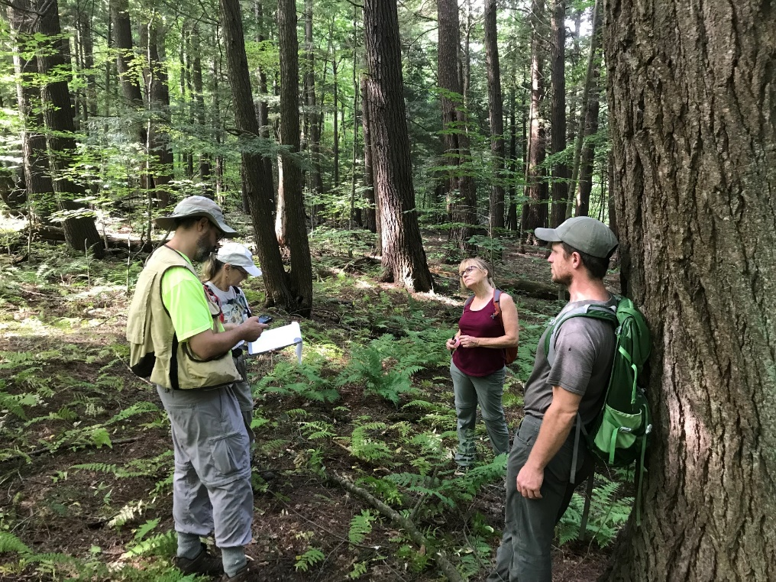
Figure 1: (From left to right) Michael Gaige, Amy Jones, Mary Alice Nyhan, and Jason Denham work to prioritize and take GPS points for chosen trees in the fireplace stand. Those points were later turned into the map earlier in this report.

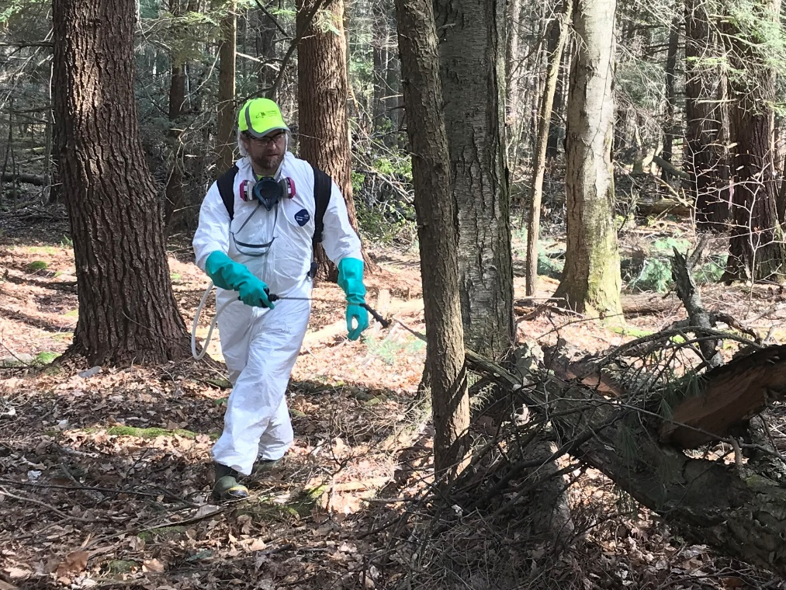
Figure 2: Andy of the DEC Giant Hogweed Team treats one of the smaller hemlock trees of the day. Smaller trees were primarily chosen based upon their proximity to infested trees as well as when there was excess dbh available in an acre. Larger, older trees were primarily given precedence due to the amount of canopy they provide, presumed genetic suitability to the climate and site, and greater effect on the overall microclimate and water quality.

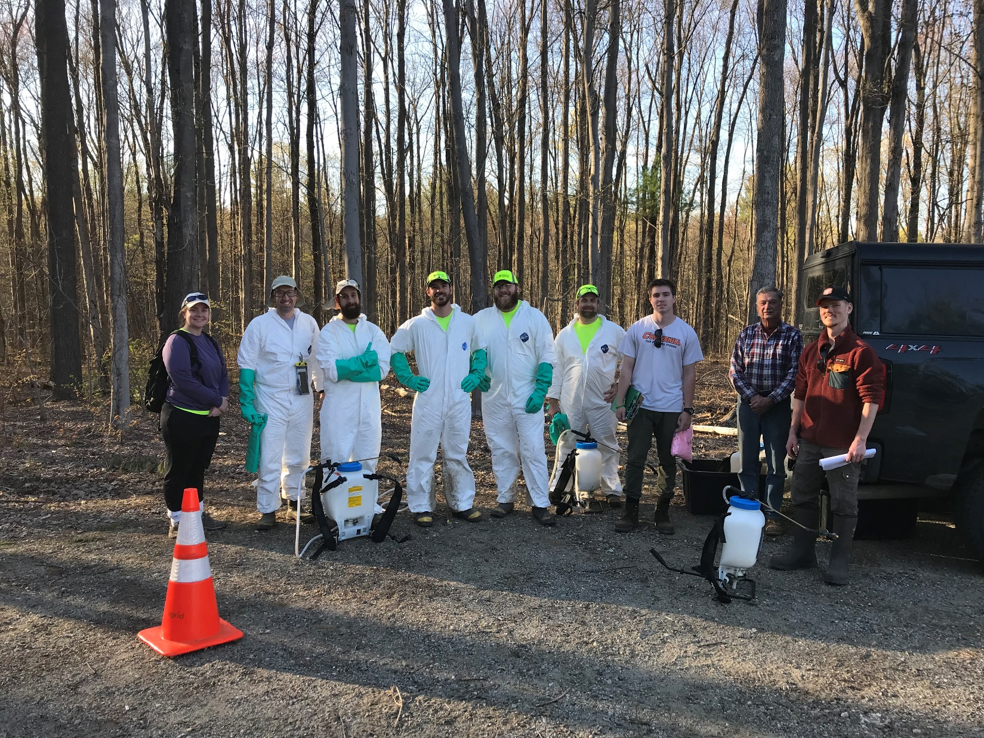
Figure 3: Group photo taken at the end of the day of treatment. Due to others having to leave early, we ended up with five helpers and five applicators, which is the minimum staffing ratio one should have going into these treatments. This project could not happen without community support from the town and residents of Ballston, support from the various levels of the DEC, as well as help from the Schenectady County Invasives Committee.

