ANCHOR DIAMOND INVASIVE SPECIES SURVEY 2019:
Anna Kuhne and Lauren Mercier
Type of Work Performed: Terrestrial invasive species surveying and scoping for training sights

Date: July 31st, 2019

Address: 1 – 17 Middleline Rd
County: Saratoga County
Latitude and Longitude: 42.937313, -73.874097
Website: https://www.alltrails.com/trail/us/new-york/anchor-diamond-ballston-spa--2
Lead Contact Information for Project: Kristopher Williams, Capital Mohawk PRISM

Site Owner Contact Information: Town of Ballston Spa

Project Description: Surveying for terrestrial invasive species was done and points for the species were uploaded on to iMapInvasives.

Invasive Species Present at Anchor Diamond Park:
Common Name | Scientific Name | Locations (GPS) | Growth Type | Phenology | Distribution/ Abundance
Norway Maple | Acer platanoides | 42.93925  -73.87541 | Tree | Vegetative | Dense
Hemlock Wooly Adelgid | Adelges tsugae | 42.93784  -73.89081 | Pest | N/A | Record from 2018
Tree of Heaven | Ailanthus altissma | 42.93768  -73.8875 | Tree | Vegetative | Record from 2018
Garlic Mustard | Alliaria petiolate | 42.93925  -73.87547 | Herbaceous | In seed | Dense
Japanese Barberry | Berberis thunbergii | 42.93796  -73.88318 | Shrub | Vegetative | Sparse
Daphne | Daphne mezereum | 42.93952  -73.8776 | Herbaceous | Vegetative | Record from 2018
Burning Bush | Euonmys alatus | 42.93726  -73.89063 | Shrub | Vegetative | Record from 2018
Privet | Ligustrum spp | 42.93904  -73.88137 | Shrub | Vegetative | Record from 2018
Honeysuckle | Lonicera spp | 42.93929  -73.87505 | Shrub | In seed | Dense
Common Buckthorn | Rhamnus cathartica | 42.9387  -73.87812 | Tree | Vegetative | Dense
Multiflroa Rose | Rosa multifora | 42.93885  -73.87745 | Shrub | Vegetative | Dense
Glossy Buckthorn | Frangula alnus | 42.93852  -73.88087 | Tree | In seed | Record from 2017
Oriental Bittersweet | Celastrus orbiculatus | 42.93821  -73.88245 | Vine | Vegetative | Sparse
Gypsy Moth | Lymantria dispar | 42.93933  -73.87505 | Pest | Moth | Single individual with eggs
Black Locust | Robinia pseudoacacia | 42.93844  -73.87973 | Tree | Vegetative | Dense

Capital Mohawk PRISM Strongly Recommends Uploading Points into https://www.imapinvasives.org/
Native Community Types: Wetland and forest
Dominant Native Plants Present: Sugar Maple, black cherry, and hemlock
Summary of Work Completed:
  - Surveying for terrestrial invasive plant species
  - Scoping out the area for possible training sessions
Recommendations for the Future: Continue surveying the site
Contact the Capital Mohawk Prism http://www.capitalmohawkprism.org/
Figure 1. Map of points taken in Anchor Diamond Park in Saratoga County.
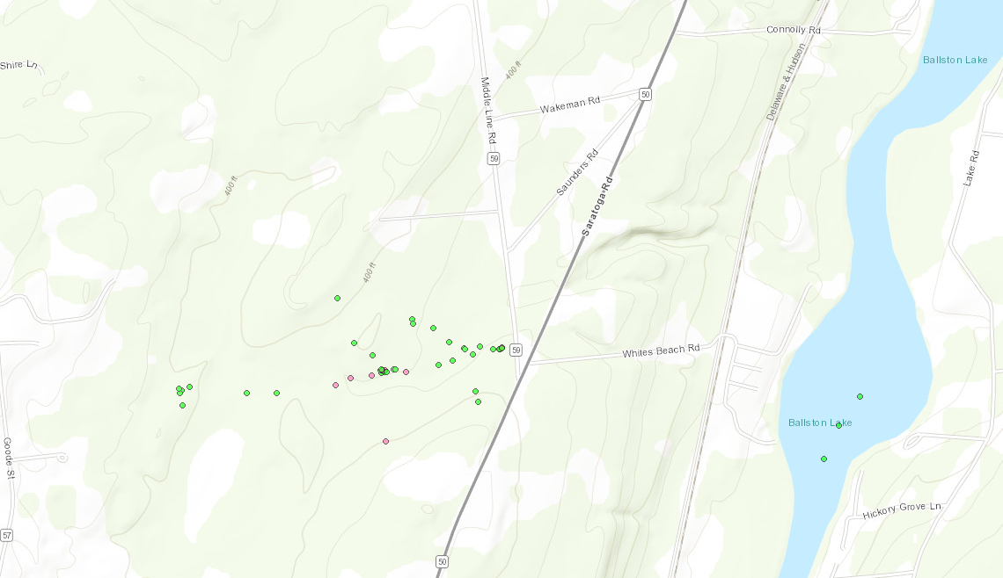

Figure 2. Japanese Barberry in Anchor Diamond Park in Saratoga County.
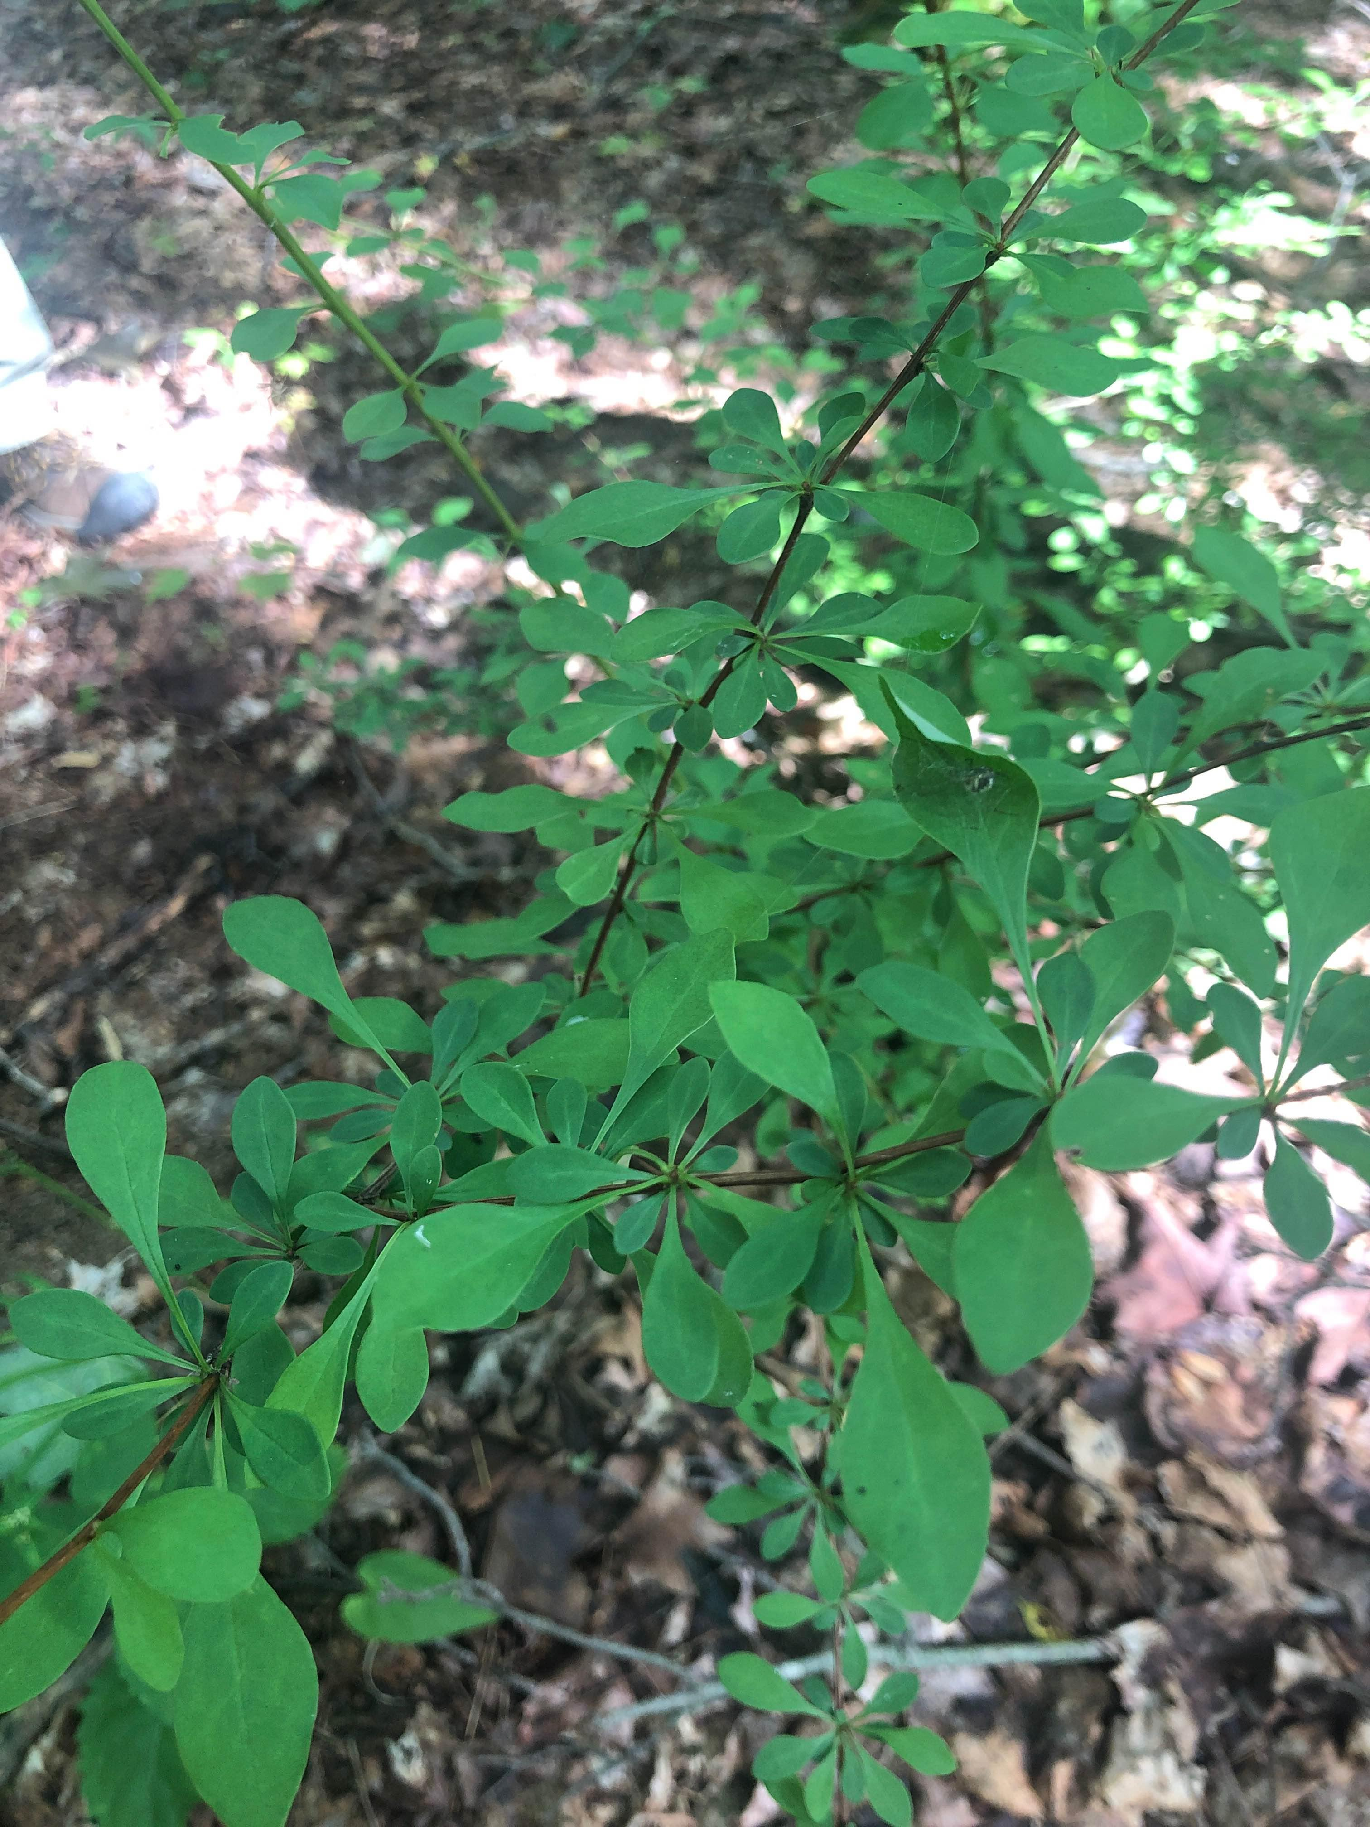

The New York State Department of Environmental Conservation provides financial
support to The Capital Mohawk PRISM via the Environmental Protection Fund.

