Capital Region PRISM Cornell Cooperative Extension Saratoga County
Partnership for Regional 50 West High St. Invasive Species Management Ballston Spa, NY 12020
www.capitalregionprism.org (518) 885-8995

Capital Region PRISM Treatment Report

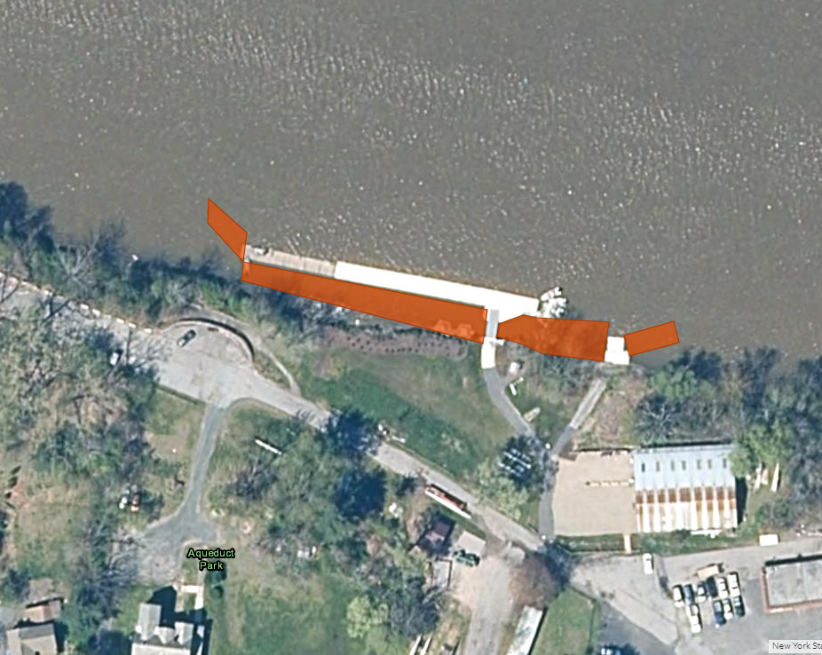
Site Information
Date: July 29th, 2022
Site Name & Address: Aqueduct Park
2757 Aqueduct Road, Schenectady, NY, 12309
Property Owner: Town of Niskayuna
Contact Info: aqueductrowingclub@gmail.com

Coordinates: 42°50'55.9"N 73°54'04.4"W
Project Leader: Hannah Coppola (AIS Program Manager)
Email: hwe22@cornell.edu
iMapInvasives User ID: 21052
Team Members: Hannah Coppola, Kristopher Williams (PRISM Coordinator), Pamela Aprilliano (AIS Watercraft Steward Supervisor), Bianca Gonzalez and Caleb Lines (AIS Watercraft Stewards), Addison Kubik (Invasive Species Outreach Educator), Alex Paonessa and Connor Mears (DEC Interns), 3 additional volunteers.

Project Information
Target Species: Water chestnut (Trapa natans)
First year of treatment? No. Last year was the first participation of the CR-PRISM. Aqueduct Rowing Club performs maintenance removals throughout the growing season to maintain access to docks.
Size of infestation: 12+ acres
Size of area treated: 0.17acres
Treatment Method (please be specific): Hand Pulling, removing two feet of stems then cutting
% Completed: 90%
Amount removed: (# bags, # plants, # mature, # seedlings): Fifty-eight contractor bags estimated at 40lbs each. A conservative estimate of 2,320lbs total.
Time spent on removal: 3 hours
Is follow-up needed? Yes. August 10th
Were treatments uploaded to IS Tracker and Field Maps? Yes
Field Maps Object ID: 2846

Photos of the project:
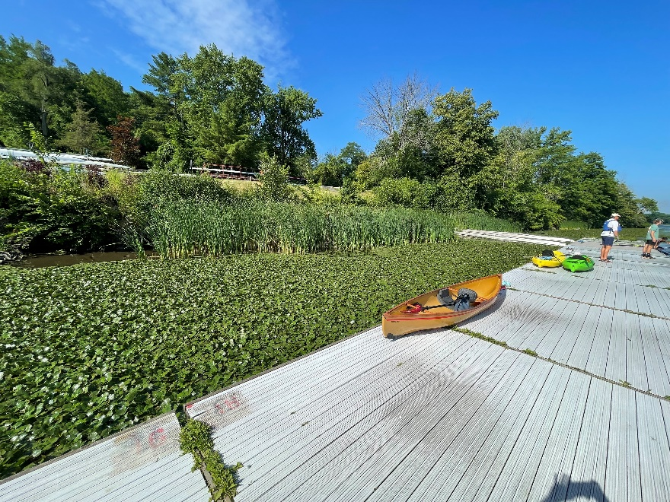
After
Before

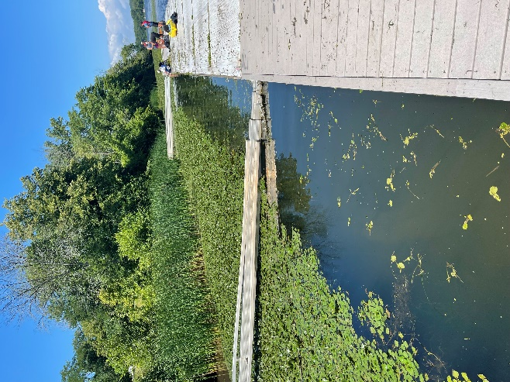
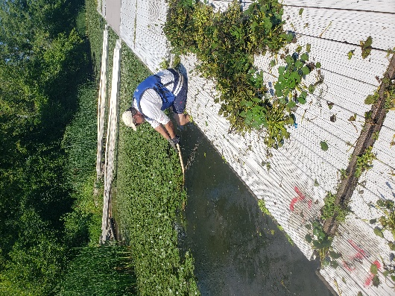
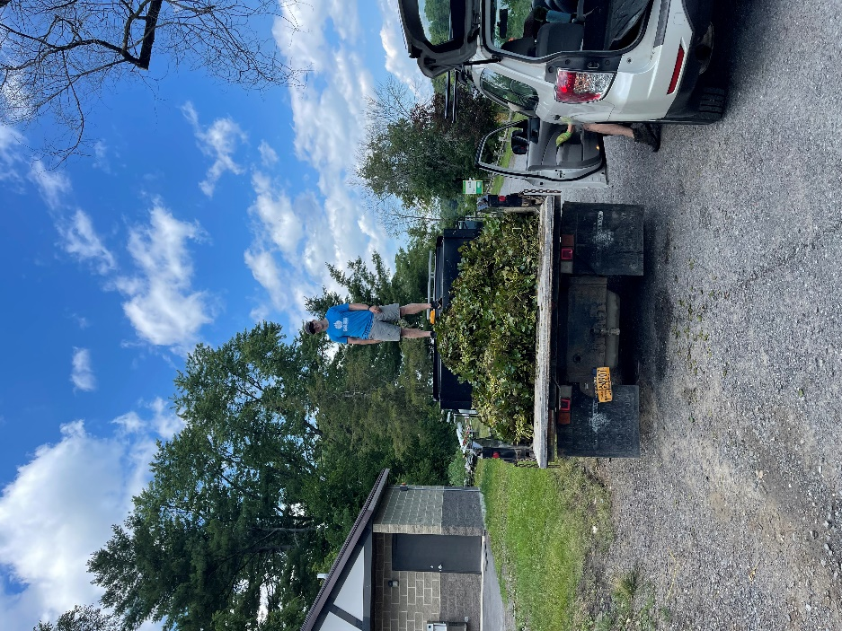
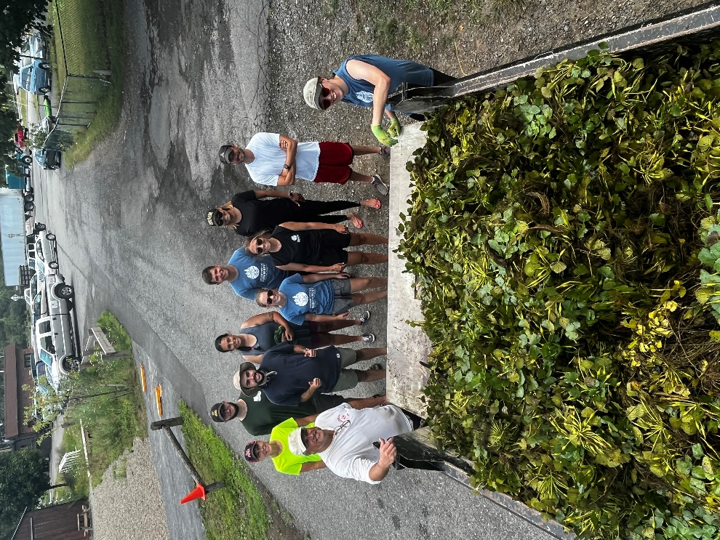
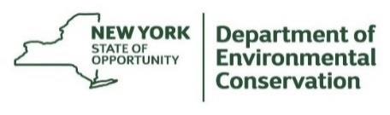
The New York State Department of Environmental Conservation provides financial support to The Capital Region PRISM via the Environmental Protection Fund

