Capital Region PRISM Cornell Cooperative Extension Saratoga County
Partnership for Regional 50 West High St. Invasive Species Management Ballston Spa, NY 12020
www.capitalregionprism.org (518) 885-8995

Capital Region PRISM Treatment Report

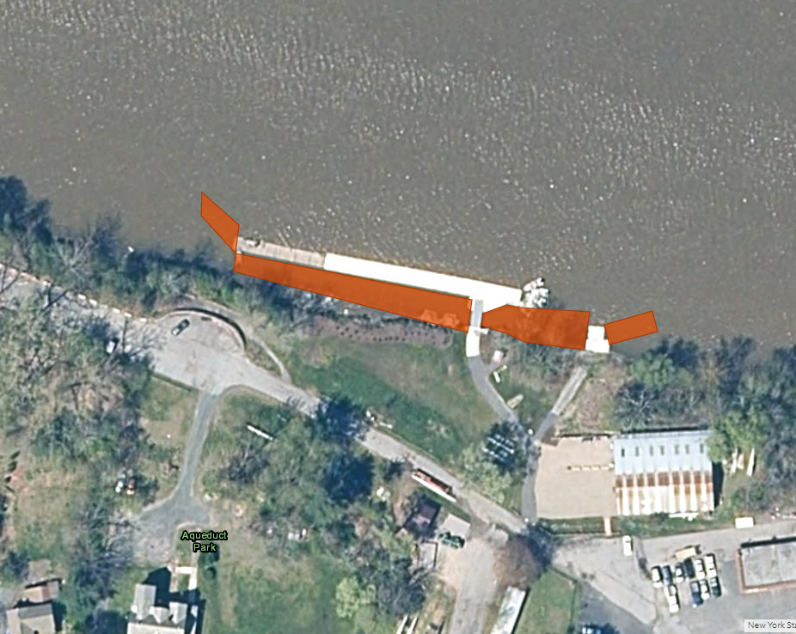
Site Information
Date: August 10th, 2022
Site Name & Address: Aqueduct Park
2757 Aqueduct Road, Schenectady, NY, 12309
Property Owner: Town of Niskayuna
Contact Info: aqueductrowingclub@gmail.com

Coordinates: 42°50'55.9"N 73°54'04.4"W
Project Leader: Hannah Coppola (AIS Program Manager)
Email: hwe22@cornell.edu
iMapInvasives User ID: 21052
Team Members: Hannah Coppola, Ben Caligiuri (PRISM Technician), Mal Provost (Adirondack Mountain Club, Schenectady Chapter), Gabe Zahn (Volunteer), Rowing Club Instructor (Volunteer)

Project Information
Target Species: Water chestnut (Trapa natans)
First year of treatment? No
Size of infestation: 12+ acres
Size of area treated: 0.06
Treatment Method (please be specific): Hand Pulling, removing two feet of stems then cutting
% Completed: 100%
Amount removed: (# bags, # plants, # mature, # seedlings): 26 Contractor bags estimated at 45lbs each. A conservative estimate of 1,170lbs of plant material removed.
Time spent on removal: 2.5 hours
Is follow-up needed? No
Were treatments uploaded to IS Tracker and Field Maps? Yes
Field Maps Object ID: 2847

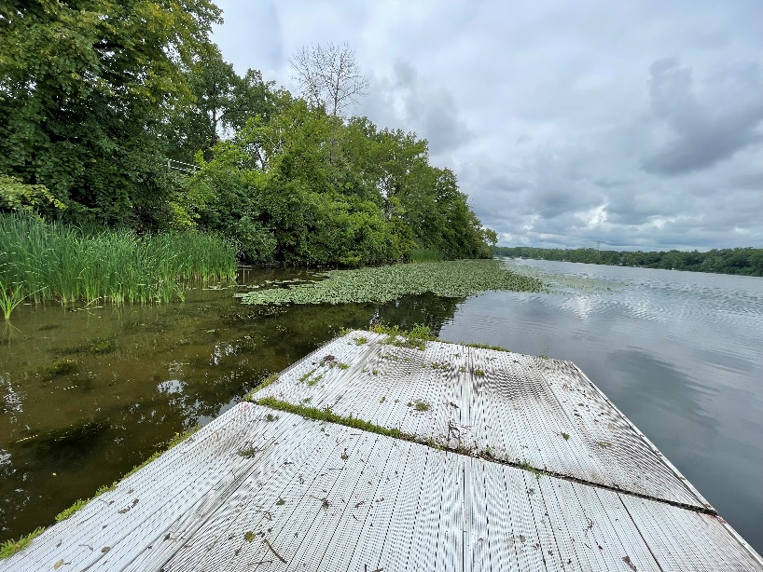
Photos of the project:
After
Before
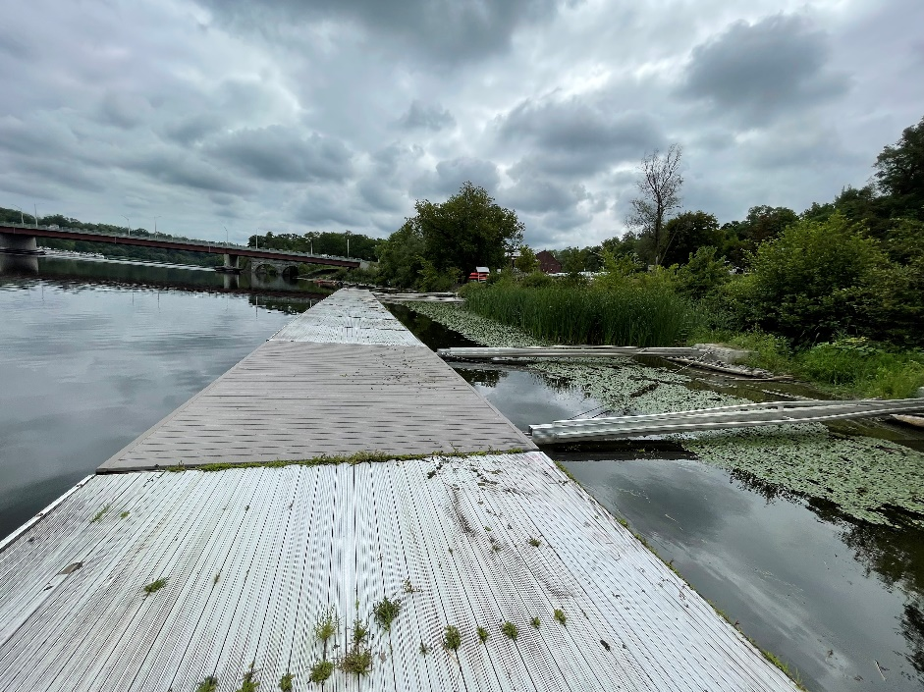
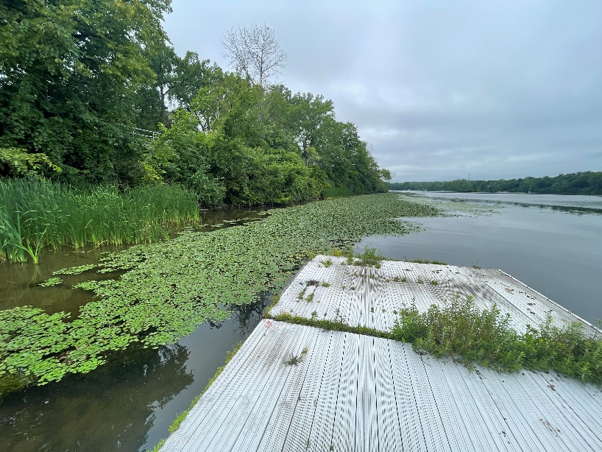
After
Before

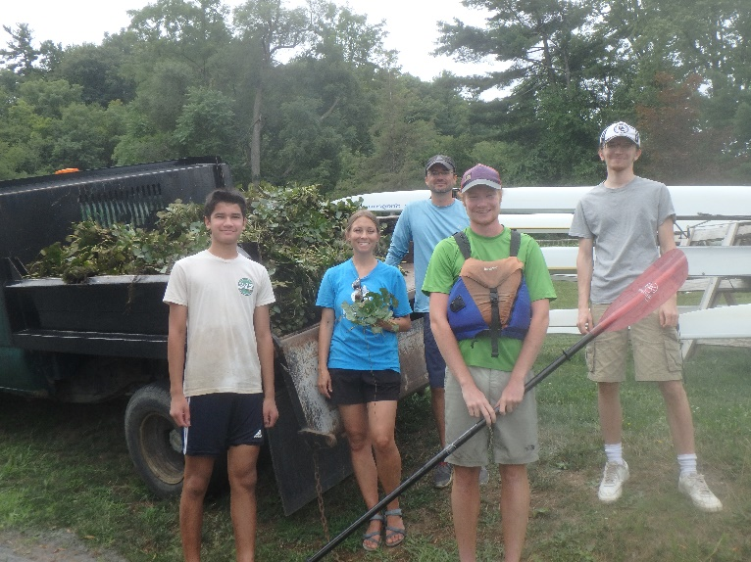
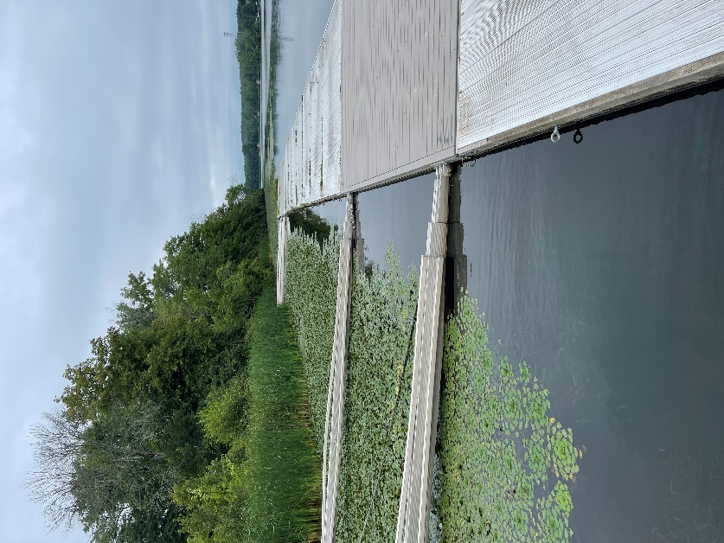
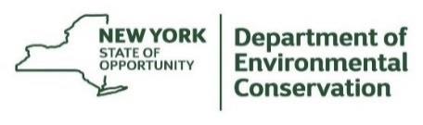
The New York State Department of Environmental Conservation provides financial support to The Capital Region PRISM via the Environmental Protection Fund

