Bush Honeysuckle Spp.

Lonicera spp.

Identification
The invasive bush honeysuckles are a group of deciduous shrubs. There are three main species, Lonicera maackii, L. morrowii, and L. tatarica. All three species have simple, oval, and opposite leaves that have smooth edges. The leaves bud out earlier than most other plants and stay longer throughout the season. The stems are woody and hollow, while the roots are fibrous and very shallow. In comparison to the native bush honeysuckle, the invasive honeysuckles have shaggy bark while the native have very smooth bark.

Reproduction
Between May and June the invasive bush honeysuckles form tubular white flowers. L.tatarica flowers can also be pinkish in color but are most commonly white. By June or July, L. tatarica and L.morrowii will form clusters of small red berries very close to the stem. L.maackii does not form berries until October or November, but they are very similar in appearance. The berries contain between 2 and 6 seeds, which are typically dispensed by birds or deer.

Habitat
Invasive bush honeysuckles are found in a variety of environments including forest edges, fields, woodlands, and roadsides. They are tolerant of moist soils but require lots of light.

Threat
Invasive bush honeysuckles grow very quickly and can form dense thickets that outcompete native species for space, light, and other resources. Their shallow root system also increases erosion and they are a poor habitat for birds.
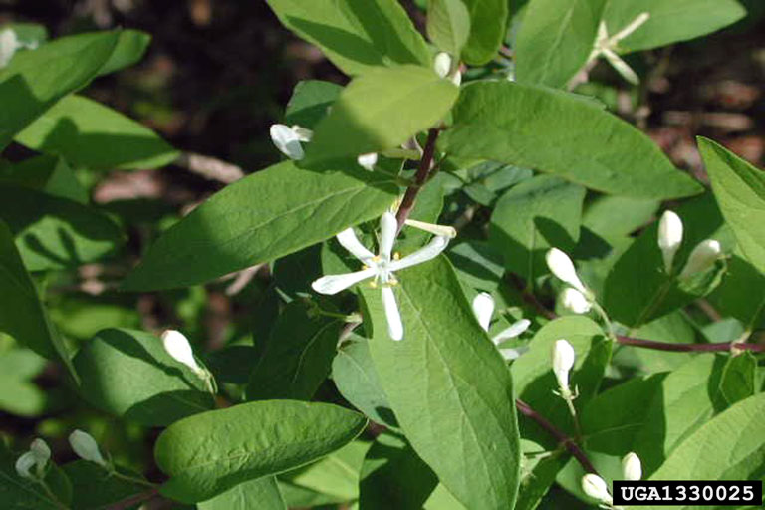
L. morrowii

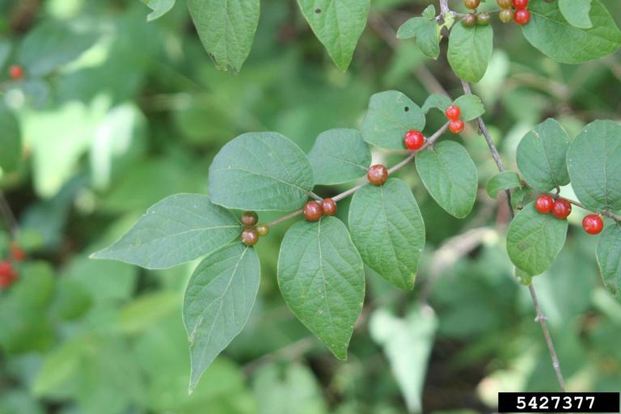
L. maackii

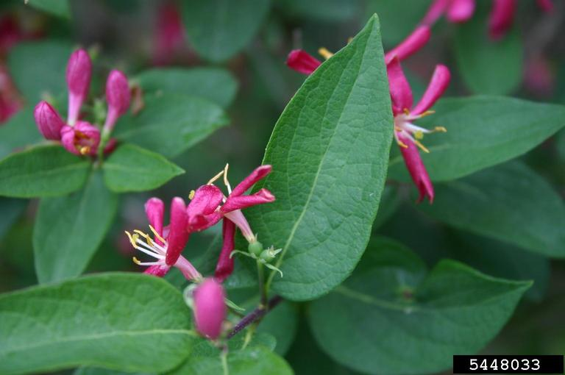
L. tatarian

Integrated Pest Management for

Bush Honeysuckle Spp.
Due to the threat of bush honeysuckle to local ecosystems, it is important to reduce the size and limit the spread of existing populations. Invasive species are controlled through prevention, eradication, containment and suppression. An integrated pest management (IPM) approach should be adopted to control unwanted species. The integrated approach is a combination of manual, mechanical, biological and chemical controls. IPM requires post treatment monitoring and treatment over a period of several years, leading to more successful outcomes (https://nysipm.cornell.edu/about/defining-ipm/).

Practices to Avoid
- DO NOT LEAVE BARE GROUND. When excavating or pulling Asian bush honeysuckle, it is important to plant new ground cover to prevent erosion and re-infestation by other invasive species.

Manual and Mechanical Control
Small and young infestations of invasive bush honeysuckle can be easily removed by hand or with an excavating machine. The roots are fairly shallow and pull up when the soil is moist. It is important to remove the entire root system when the plant is larger because the plant is able to re-sprout from fragments.

Biological Control
There are currently no approved methods for biological control in the United States.
Herbicide Control
Herbicide treatment(s) are to be used when mechanical control methods are not enough to combat the infestation. The best management practices when applying chemical herbicides to treat an infestation should be followed to limit the effects on the environment Please consult an expert or certified applicator when applying herbicides. Read and follow herbicide products labels as required by law. Seek out proper local, state, and federal permitting when applying herbicides.
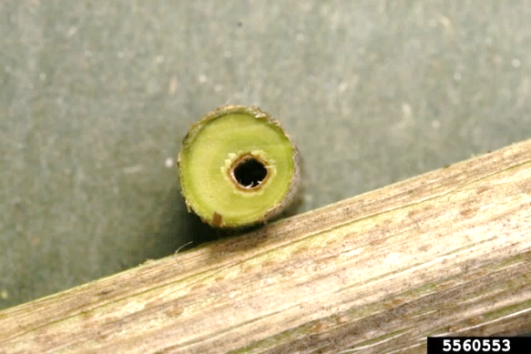
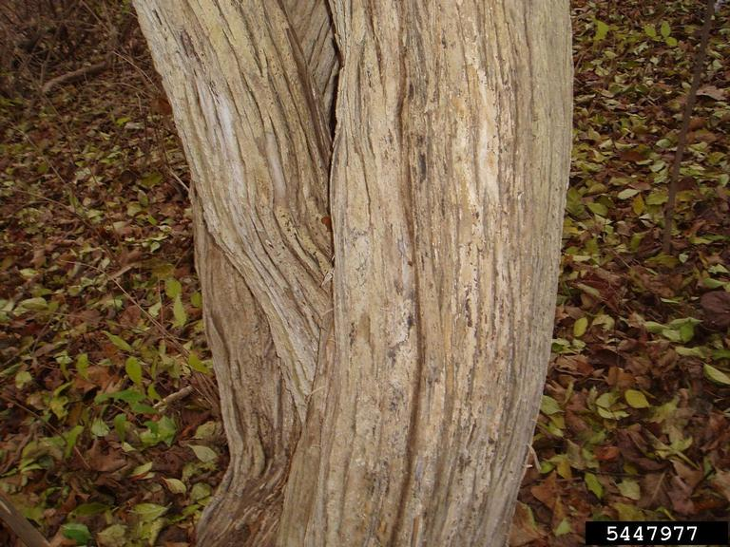

Herbicide Treatment for Homeowners/Private landowners

Time of Year: June to October (flowering to foliage color change)

Example Chemical(s) to Use: Read all Product Labels as Required By Law
Product names are listed as examples, and not as endorsement or recommendation. The suitability and details for specific use of these products are provided through their labels.
Chemical  (Products containing) | Time of Year | Application Technique | Notes
Glyphosate (Roundup, Rodeo, Glyphomate 41) | June to October | - Cut-stump  - Foliar Spray | - Non-selective so not good for high quality habitat  - Best to spray in fall when native species have died back and invasive honeysuckles still green
Triclopyr (Garlon 3A, Garlon 4) | June to October | - Stem-injection  - Cut stump  - Foliar Spray | - Selective
If there is water present near the infestation, a permit from the DEC is required. For more information regarding aquatic pesticide permitting, please contact the nearest DEC Regional Office: Division of Environmental Permits at (518) 357-2069 or visit: http://www.dec.ny.gov/permits/209.html.

Timeline of Action

For More Information Seek out the Cornell Guidelines for Pesticide Use:
The Cornell Guidelines offer the latest information on topics such as pest management, crop production, and landscape plant maintenance. Each title in the series is updated by Cornell University researchers and Extension specialists and is designed as a practical guides. https://www.cornellstore.com/books/cornell-cooperative-ext-pmep-guidelines

Native Replacements
After removing or treating Asian bush honeysuckle, it is important to reseed or plant the disturbed soils with native species common in the geographic area. Replanting will help restore the ecosystem and prevent old infestations from re-establishing. Consider using stress tolerant plants in harsh environments that are best suited to a given site. If pre-existing native plants are present on site, protect these species from harm, during management. The surrounding native species can then be used to aid in the heathy reestablishment of the area. More information about native plants, shrubs and trees can be found:
Alternatives to Ornamental Invasive Plants “A Sustainable Solution for New York State”
- https://nysipm.cornell.edu/sites/nysipm.cornell.edu/files/shared/documents/NYSIPM-alt-inv.pdf

NYSDEC Native Plant Factsheets
- https://www.dec.ny.gov/docs/lands_forests_pdf/factnatives.pdf

Lady Bird Johnson Native Flower Database
- https://www.wildflower.org/plants/

Westchester Community College Native Plant Center
- https://www.sunywcc.edu/about/npc/

Definitions:
Manual Control: a technique to remove small infestations. Some examples of manual control is hand-pulling, mulching, burning, digging, and removal of the entire plant, portions of a plant, nests, egg masses, or other life stages. This type of control is only economically feasible for small infestations.
Herbicide Control: a technique which uses chemicals to remove or decrease the population of a species. Herbicides are usually one of the last choices for control as they are usually expensive and have adverse effects to the environment. There are different methods to apply an herbicide. Some examples are: foliar spray, basal bark, bundle and cut, and cut-stump treatment.
Biological Control: a technique where an animal, insect, fungi or disease is used to manage a large invasive species population. This control species is studied intensively to see if there could be any negative effects for native species.
Foliar Spray: method of herbicide control where the chemical is sprayed directly on the leaves. Sprayers can be hand held, on a backpack or mounted on a vehicle. If a plant has a waxy surface, a surfactant may be needed to allow the herbicide to work.
Cut-stump treatment: method of herbicide control where the stem is cut, near the base of the plant, and an herbicide is applied. Water-based herbicides should be applied immediately following the stem cut while oil-based can be applied later. The herbicide can be applied use a sprayer or sponge/paint brush.
Selective herbicides: a type of herbicide which kills specific groups of plants but not others. For examples, a selective herbicide may kill broadleaf plants, like dandelions, but not grasses.
Non-selective herbicides: a type of herbicide which kills all types of plants. When using this herbicide, any plant that is sprayed will be effected.
DISCLAIMER
Please note that neither Cornell Cooperative Extension of Saratoga County nor any representative thereof makes any representation of any warranty, express or implied, of any particular result or application of the information provided by us or regarding any product. If a product is involved it is the sole responsibility of the User to read and follow all product labeling instructions and to check with the manufacturer or supplier for the most recent information. Nothing contained in this information should be interpreted as an express or implied endorsement of any particular product or criticism of unnamed products. With respect to any information on pest management the User is responsible for obtaining the most up-to-date pest management information. The information we provide is no substitute for pesticide labeling. The User is solely responsible for reading and following manufacturer’s labeling and instructions.

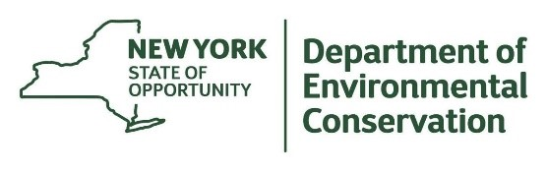
The New York State Department of Environmental Conservation provides financial support
to The Capital Mohawk PRISM via the Environmental Protection Fund.

