Autumn Olive
Elaeagnus umbellata

Identification
Autumn olive is a deciduous shrub/small tree with grey speckled bark. Young branches have thorns that can grow up to 2 in. long. The leaves are elongated oval shaped and grow opposite on the stem. The leaves are a muted green color on top and have a silvery appearance underneath.

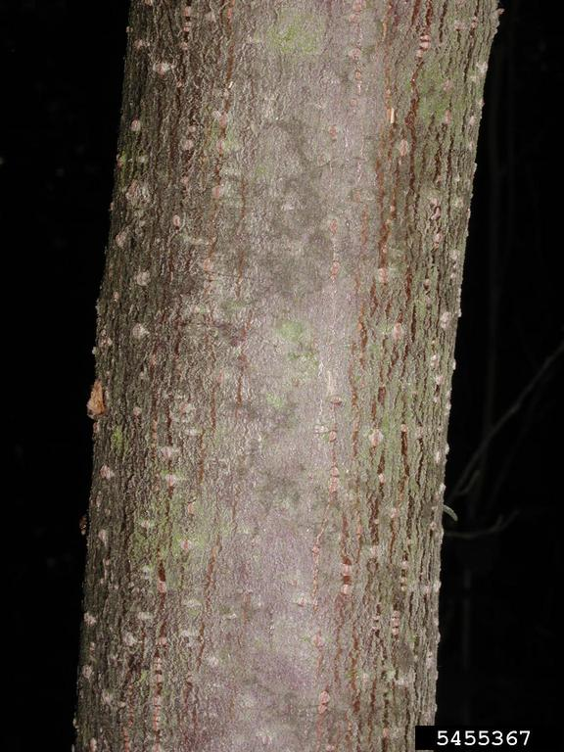
Leslie J. Mehrhoff, University of Connecticut, Bugwood.org

Reproduction
Between April and June, fragrant, tubular, yellowish flowers develop in clusters of 1-8. By September or October, brown fruit will ripen and turn bright red. The fruit is speckled at all stages. The fruit are eaten by wildlife which disperses the seeds.

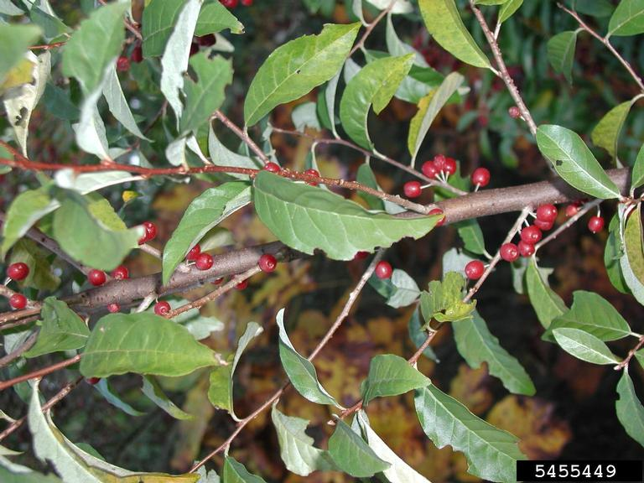

Leslie J. Mehrhoff, University of Connecticut, Bugwood.org

Habitat
Typically found in old agricultural fields, along forest edges, roadsides, and in other disturbed areas. Autumn olive is tolerant of many soil types and moderate shade.

Threat
Autumn olive is easily spread which can lead to large populations that can outcompete native shrubs and trees. The fruit are also a poor nutrient source for wildlife.
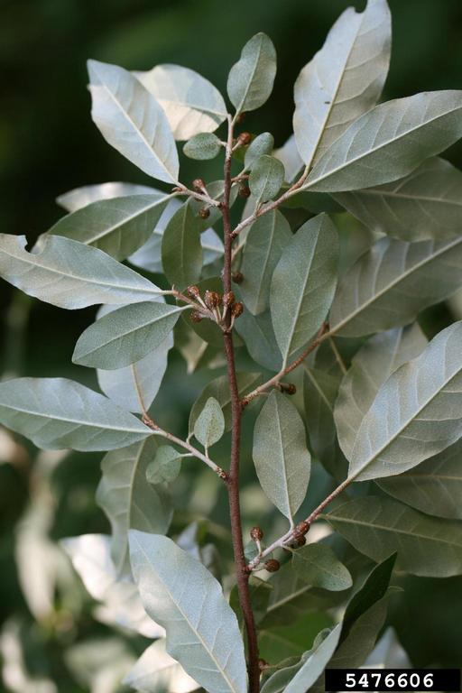
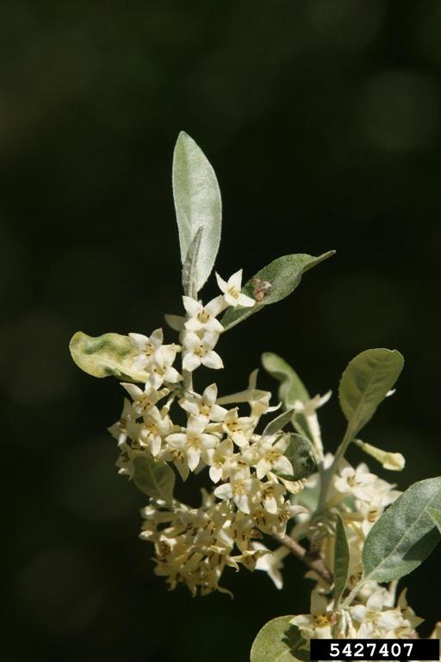

Chris Evans, University of Illinois, Bugwood.org
Chris Evans, University of Illinois, Bugwood.org

Integrated Pest Management for

Autumn Olive
Due to the threat of autumn olive to local ecosystems, it is important to reduce the size and limit the spread of existing populations. Invasive species are controlled through prevention, eradication, containment and suppression. An integrated pest management (IPM) approach should be adopted to control unwanted species. The integrated approach is a combination of manual, mechanical, biological and chemical controls. IPM requires post treatment monitoring and treatment over a period of several years, leading to more successful outcomes (https://nysipm.cornell.edu/about/defining-ipm/).

Practices to Avoid
- Avoid just cutting or mowing due to likelihood of re-sprouting. Pair with herbicide treatment to limit growth.
- Avoid leaving bare soil after treatment. This can allow seeds hiding in the seed bank to sprout.

Manual and Mechanical Control
Small individuals are easily pulled when the soil is damp. Weed wrenches can be used for larger individuals, but be sure to remove all of the root to prevent re-sprouting. Mowing can be used to prevent individuals from going into seed, but they will re-sprout if not treated with herbicide after.

Biological Control
Goats graze on autumn olive foliage and bark, which can cause the plant to die. Avoid overgrazing due to the threat of erosion and loss of native plant seedlings.

Herbicide Control
Herbicide is the last resort control method and is reserved for widespread, large infestations. For more information about which herbicide to use, see “Herbicide Treatment for Homeowners/Private Landowners.” Please consult an expert or certified applicator when applying herbicides. Read and follow herbicide product labels as required by law. Seek out proper local, state, and federal permitting when applying herbicides.

Herbicide Treatment for Homeowners/Private landowners

Time of Year: May to October

Example Chemical(s) to Use: Read all Product Labels as Required By Law
Product names are listed as examples, and not as endorsement or recommendation. The suitability and details for specific use of these products are provided through their labels.
Chemical  (Products containing) | Timing | Application Technique | Notes
Glyphosate  (Aquaneat, Round-Up, Rodeo) | May-October | - Foliar  - Cut Stump | - Mixing with triclopyr amine can reduce non-target effects  - Monitor for several years after initial treatment to evaluate need for repeat treatment
Triclopyr  -Amine (Vastlan, Garlon 3A)  -Ester (Garlon 4) | May-October* | - Foliar  - Cut-Stump  - Basal Bark | - Basal bark treatments are best performed during the dormant season (winter)*
Terrestrial invasive species disclaimer:
If there is water present near the infestation, a permit from the DEC is required. For more information regarding aquatic pesticide permitting, please contact the nearest DEC Regional Office: Division of Environmental Permits at (518) 357-2069 or visit: http://www.dec.ny.gov/permits/209.html.
Aquatic invasive species disclaimer:
For aquatic infestations, a permit from the DEC is required. For more information regarding aquatic pesticide permitting, please contact the nearest DEC Regional Office: Division of Environmental Permits at (518) 357-2069 or visit: http://www.dec.ny.gov/permits/209.html

Timeline of Action

For More Information Seek out the Cornell Guidelines for Pesticide Use:
The Cornell Guidelines offer the latest information on topics such as pest management, crop production, and landscape plant maintenance. Each title in the series is updated by Cornell University researchers and Extension specialists and is designed as a practical guides. https://www.cornellstore.com/books/cornell-cooperative-ext-pmep-guidelines

Native Replacements
After removing or treating Autumn Olive, it is important to reseed or plant the disturbed soils with native species common in the geographic area. Replanting will help restore the ecosystem and prevent old infestations from re-establishing. Consider using stress tolerant plants in harsh environments that are best suited to a given site. If pre-existing native plants are present on site, protect these species from harm, during management. The surrounding native species can then be used to aid in the heathy reestablishment of the area. More information about native plants, shrubs and trees can be found:

Alternatives to Ornamental Invasive Plants “A Sustainable Solution for New York State”
- https://nysipm.cornell.edu/sites/nysipm.cornell.edu/files/shared/documents/NYSIPM-alt-inv.pdf

NYSDEC Native Plant Factsheets
- https://www.dec.ny.gov/docs/lands_forests_pdf/factnatives.pdf

Lady Bird Johnson Native Flower Database
- https://www.wildflower.org/plants/

Westchester Community College Native Plant Center
- https://www.sunywcc.edu/about/npc/

Definitions:
Manual Control: a technique to remove small infestations. Some examples of manual control is hand-pulling, mulching, burning, digging, and removal of the entire plant, portions of a plant, nests, egg masses, or other life stages. This type of control is only economically feasible for small infestations.
Herbicide Control: a technique which uses chemicals to remove or decrease the population of a species. Herbicides are usually one of the last choices for control as they are usually expensive and have adverse effects to the environment. There are different methods to apply an herbicide. Some examples are: foliar spray, basal bark, bundle and cut, and cut-stump treatment.
Biological Control: a technique where an animal, insect, fungi or disease is used to manage a large invasive species population. This control species is studied intensively to see if there could be any negative effects for native species.
Foliar Spray: method of herbicide control where the chemical is sprayed directly on the leaves. Sprayers can be hand held, on a backpack or mounted on a vehicle. If a plant has a waxy surface, a surfactant may be needed to allow the herbicide to work.
Cut-stump treatment: method of herbicide control where the stem is cut, near the base of the plant, and an herbicide is applied. Water-based herbicides should be applied immediately following the stem cut while oil-based can be applied later. The herbicide can be applied use a sprayer or sponge/paint brush.
Selective herbicides: a type of herbicide which kills specific groups of plants but not others. For examples, a selective herbicide may kill broadleaf plants, like dandelions, but not grasses.
Non-selective herbicides: a type of herbicide which kills all types of plants. When using this herbicide, any plant that is sprayed will be effected.
DISCLAIMER
Please note that neither Cornell Cooperative Extension of Saratoga County nor any representative thereof makes any representation of any warranty, express or implied, of any particular result or application of the information provided by us or regarding any product. If a product is involved it is the sole responsibility of the User to read and follow all product labeling instructions and to check with the manufacturer or supplier for the most recent information. Nothing contained in this information should be interpreted as an express or implied endorsement of any particular product or criticism of unnamed products. With respect to any information on pest management the User is responsible for obtaining the most up-to-date pest management information. The information we provide is no substitute for pesticide labeling. The User is solely responsible for reading and following manufacturer’s labeling and instructions.

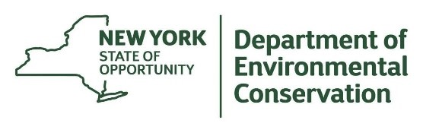
The New York State Department of Environmental Conservation provides financial support
to The Capital Mohawk PRISM via the Environmental Protection Fund.

