BETAR BYWAY / SOUTH GLENS FALLS HISTORICAL PARK INVASIVE SPECIES SURVEY 2019:
Anna Kuhne and Lauren Mercier
Type of Work Performed: Terrestrial invasive species surveying, with an emphasis on looking for porcelain berry

Date: July 31st, 2019

Address: South Glens Falls, NY 12803
County: Saratoga County
Latitude and Longitude: 43.301786, -73.641516
Website: Southern Adirondack Audubon Society

Lead Contact Information for Project: Lauren Mercier, Capital Mohawk PRISM

Site Owner Contact Information: Southern Adirondack Audubon Society President, John Loz

Project Description: Surveying for terrestrial invasive species was done and points for the species were uploaded on to iMapInvasives.

Invasive Species Present at South Glens Falls Historical Park, Betar Byway Bike Path:
Common Name | Scientific Name | Locations (GPS) | Growth Type | Phenology | Distribution/ Abundance
Common Reed | Phragmites australis | 43.30039  -73.64181 | Herbaceous | Vegetative | Sparse (only 2 sitings)
Japanese Barberry | Berberis thunbergii | 43.29631  -73.64088 | Shrub | Vegetative | Sparse
Oriental Bittersweet | Celastrus orbiculatus | 43.29837  -73.64118 | Vine | In seed | Dense
Garlic Mustard | Alliaria petiolate | 43.30087  -73.6414 | Herbaceous | In seed | Sparse
Porcelain Berry | Ampelopsis brevipedunculata | 43.29893  -73.64143 | Vine | Vegetative | Dense (throughout Park)
Common Barberry | Berberis vulgaris | 43.29437  -73.64022 | Shrub | Vegetative | Sparse
Spotted Starthistle | Centaurea stoebe spp | 43.29612  -73.64079 | Herbaceous | Flowering | Sparse
Chicory | Cichorium intybus | 43.29665  -73.64093 | Herbaceous | Flowering | Sparse
Field Bindweed | Convolvulus arvensis | 43.29654  -73.64072 | Vine | Flowering | Dense
Wild Carrot | Daucus carota | 43.29512  -73.64061 | Herbaceous | Flowering | Dense
Cypress Spurge | Euphorbia cyparissias | 43.29611  -73.64078 | Herbaceous | Vegetative | Sparse (found in one area)
Glossy Buckthorn | Frangula alnus | 43.29628  -73.64089 | Tree | In seed | Dense
Ground Ivy | Glechoma hederacea | 43.29815  -73.64123 | Herbaceous | Vegetative | Dense
Common St. Johnswort | Hypericum perforatum | 43.29723  -73.64096 | Herbaceous | Flowering | Sparse
Privet | Ligustrum spp | 43.29738  -73.64104 | Shrub | Vegetative | Sparse
Honeysuckle | Lonicera spp | 43.29429  -73.64017 | Shrub | In seed | Dense
Birdfoot Deervetch | Lotus coriculatus | 43.29611  -73.64079 | Herbaceous | Vegetative | Sparse
Creeping Jenny | Lysimachia nummularia | 43.30062  -73.64178 | Herbaceous | Vegetative | Dense
Purple Loosestrife | Lythrum Salicaria | 43.29504  -73.64069 | Herbaceous | Flowering | Sparse
Japanese Knotweed | Reynooutria japonica | 43.29394  -73.63977 | Herbaceous | Vegetative | Dense
Common Buckthorn | Rhamnus cathartica | 43.29964  -73.64123 | Tree | Vegetative | Sparse
Multiflora Rose | Rosa multiflora | 43.29901  -73.64131 | Shrub | Vegetative | Dense
Climbing Nightshade | Solanum sulcamara | 43.29997
Great Mullein | Verbascum Thapsus | 43.29247  -73.63957 | Herbaceous | Vegetative | Sparse
Japanese Snowball | Viburnum plicatum | 43.03185  -73.64113 | Shrub | Flowering | Sparse

Capital Mohawk PRISM Strongly Recommends Uploading Points into https://www.imapinvasives.org/
Native Community Types: Wetland and forested
Dominant Native Plants Present: Sugar Maple
Summary of Work Completed:
  - Surveying for terrestrial invasive plant species
Recommendations for the Future: Continue surveying the site and do removals on the buckthorn, honey suckle, and rose if possible.
Contact the Capital Mohawk Prism http://www.capitalmohawkprism.org/

Figure 1. Map of points taken in South Glens Falls Historic Park Betar Byway Bike Path in Saratoga County.
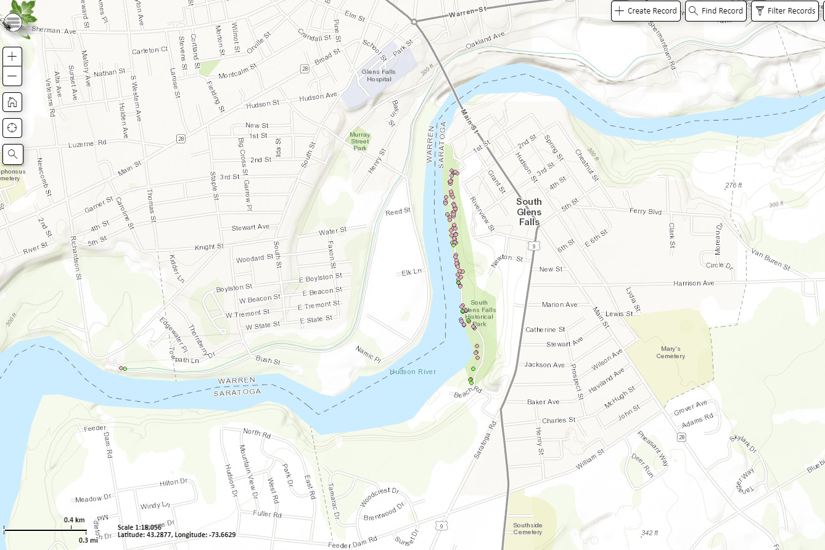

Figure 2. Japanese Knotweed in in South Glens Falls Historic Park Betar Byway Bike Path in Saratoga County.
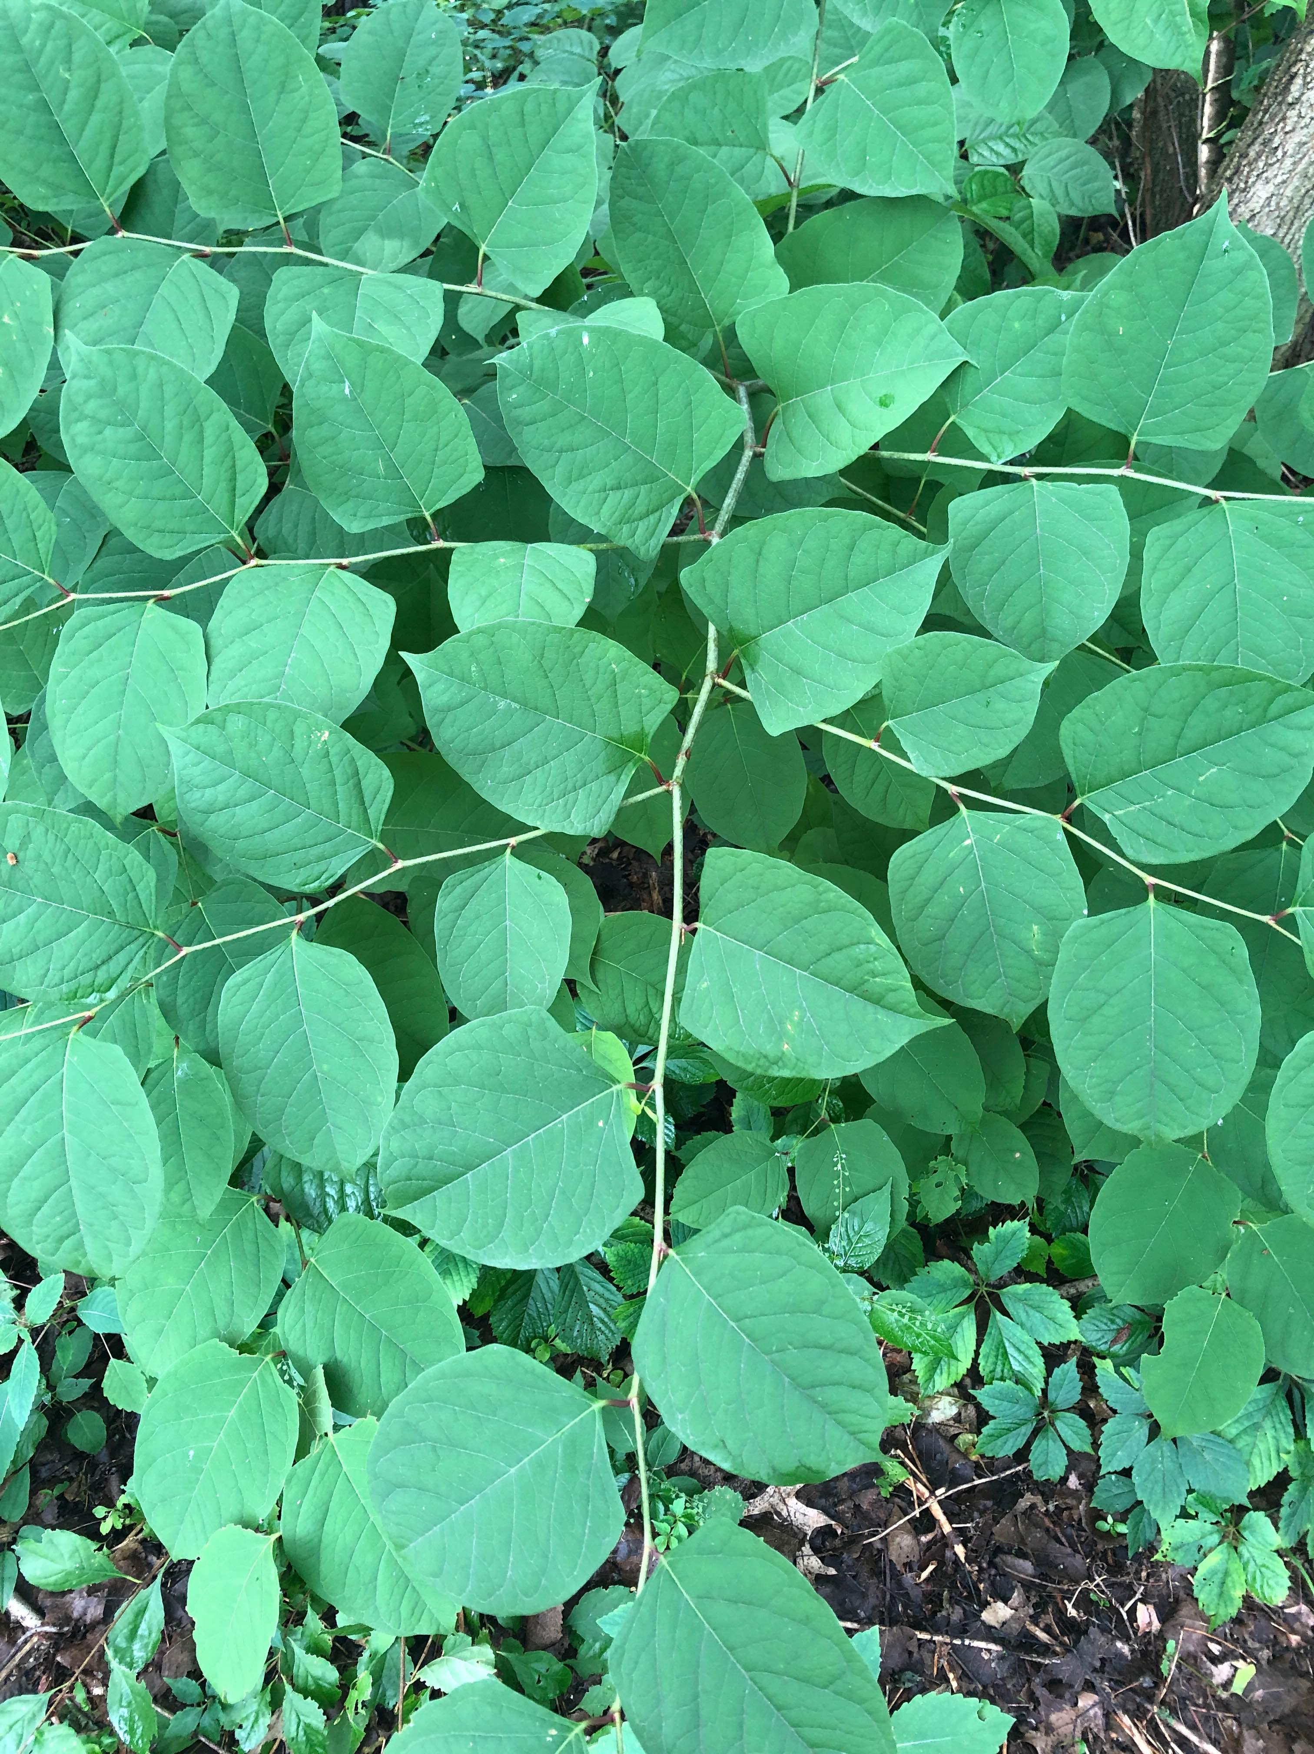

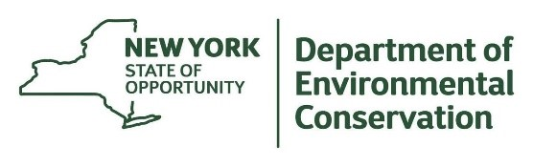
The New York State Department of Environmental Conservation provides financial
support to The Capital Mohawk PRISM via the Environmental Protection Fund.

