Winged Burning Bush
Euonymus alatus

Identification
Winged burning bush is a shrub which normally grows up to 5 -10 ft. tall however an older plant can grow up to 20 ft. The stem has woody wings that come off the sides. Leaves are about 1-3 in. long, are toothed, grow alternately along the winged stem and are a dark green in the summer then turn a red-purple in the fall. This ornamental plant is a common in landscaping however it is regulated by the New York State Department of Environmental Conservation.

Reproduction
Winged burning bush is able to spread by seeds and producing buds. The shrub develops a small, green flower in the spring which creates a red-purple, oval fruit in the summer months. The fruit is consumed by birds and spread to other locations. Winged burning bush is also able to produce buds from the root-system.
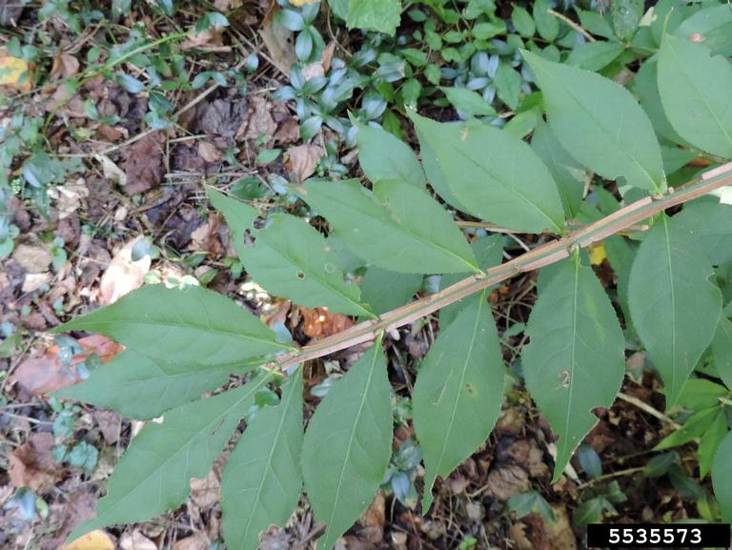

Habitat
Winged burning bush is an adaptable shrub. It can tolerate full sun to almost full shade environments as well as soils that have elevated methane levels. It has been found to escape captivity, moving from home gardens into nearby forests.

Threat
This species is creating dense stands which are out-competing native species changing the local ecosystem. Hundreds of seedlings can be found in the “seed shadow” of a parent plant.
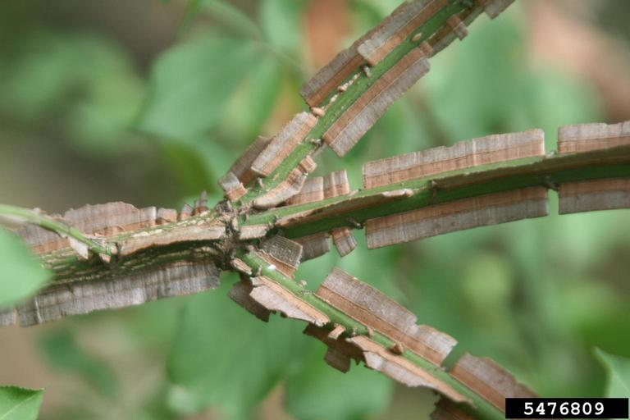

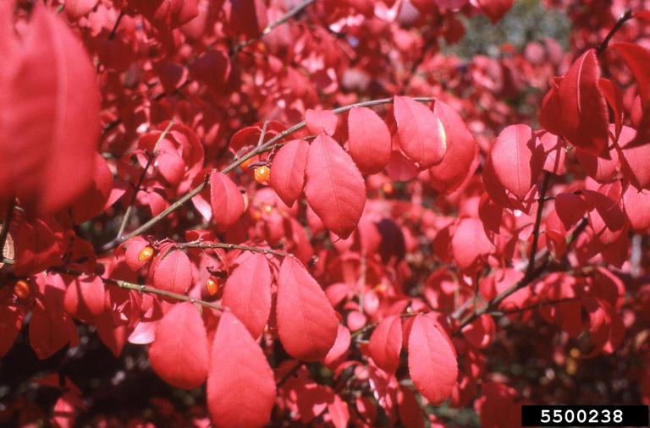

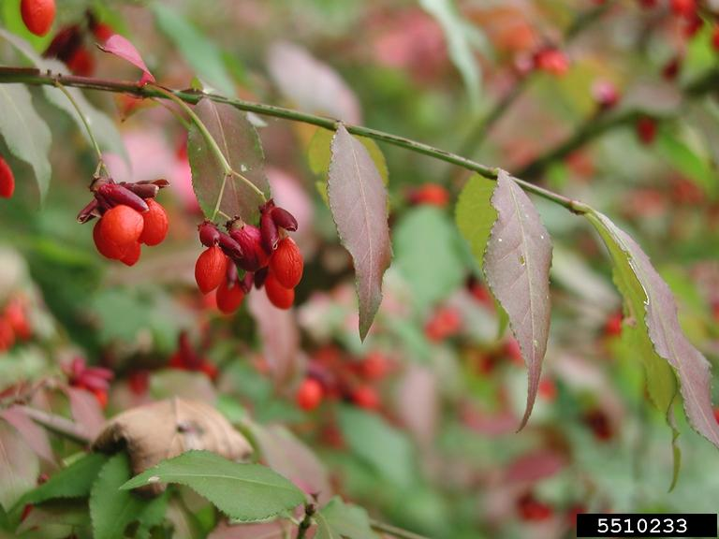

Integrated Pest Management for

Winged Burning Bush
Due to the threat of winged burning bush to local ecosystems, it is important to reduce the size and limit the spread of existing populations. Invasive species are controlled through prevention, eradication, containment and suppression. An integrated pest management (IPM) approach should be adopted to control unwanted species. The integrated approach is a combination of manual, mechanical, biological and chemical controls. IPM requires post treatment monitoring and treatment over a period of several years, leading to more successful outcomes (https://nysipm.cornell.edu/about/defining-ipm/).

Prevention
The most successful management strategy is preventing an infestation from establishing. An easy way to do this, for winged burning bush, is to use native alternatives in landscaping. Native alternative information is found on the last page of this packet.

Manual and Mechanical Control
For small infestations or locations where herbicides cannot be used, manual pulling is effective with monitoring and follow up. For manual control, pulling of mature shrubs and seedlings, as well as repeated clippings, should be done at least twice a year for three to five years. If the entire root system is not removed when pulling, or when using the clipping method, new growth can occur from the remaining root system.

Biological Control
There is currently no biocontrol for the winged burning bush.

Herbicide Control
Herbicide control is a last resort strategy and used for large infestations. For more information about which herbicide to use, see “Herbicide Treatment for Homeowners/Private Landowners.” Please consult an expert or certified applicator when applying herbicides. Read and follow herbicide product labels as required by law. Seek out proper local, state, and federal permitting when applying herbicides.

HERBICIDE TREATMENT FOR HOMEOWNERS/PRIVATE LANDOWNERS

Time of Year: May to October

Example Chemical(s) to Use: Read all Product Labels as Required By Law
Product names are listed as examples, and not as endorsement or recommendation. The suitability and details for specific use of these products are provided through their labels.
Chemical  (Products containing) | Timing | Application Technique | Notes
Glyphosate  (Roundup, Rodeo) | August to October | - Foliar | - Do not cut the shrub down for a full growing season following treatment
Triclopyr  (Garlon, Pathfinder) | August to October | - Cut-stump  - Foliar  - Basal bark | - Basal bark treatments can be applied year round under the right conditions.
If there is water present near the infestation, a permit from the DEC is required. For more information regarding aquatic pesticide permitting, please contact the nearest DEC Regional Office: Division of Environmental Permits at (518) 357-2069 or visit: http://www.dec.ny.gov/permits/209.html.

Timeline of Action

For More Information Seek out the Cornell Guidelines for Pesticide Use:
The Cornell Guidelines offer the latest information on topics such as pest management, crop production, and landscape plant maintenance. Each title in the series is updated by Cornell University researchers and Extension specialists and is designed as a practical guides. https://www.cornellstore.com/books/cornell-cooperative-ext-pmep-guidelines

Native Replacements
After removing or treating winged burning bush, it is important to reseed or plant the disturbed soils with native species common in the geographic area. Replanting will help restore the ecosystem and prevent old infestations from re-establishing. Consider using stress tolerant plants in harsh environments that are best suited to a given site. If pre-existing native plants are present on site, protect these species from harm, during management. The surrounding native species can then be used to aid in the heathy reestablishment of the area. More information about native plants, shrubs and trees can be found:

Alternatives to Ornamental Invasive Plants “A Sustainable Solution for New York State”
- https://nysipm.cornell.edu/sites/nysipm.cornell.edu/files/shared/documents/NYSIPM-alt-inv.pdf

NYSDEC Native Plant Factsheets
- https://www.dec.ny.gov/docs/lands_forests_pdf/factnatives.pdf

Lady Bird Johnson Native Flower Database
- https://www.wildflower.org/plants/

Westchester Community College Native Plant Center
- https://www.sunywcc.edu/about/npc/

Definitions:
Manual Control: a technique to remove small infestations. Some examples of manual control is hand-pulling, mulching, burning, digging, and removal of the entire plant, portions of a plant, nests, egg masses, or other life stages. This type of control is only economically feasible for small infestations.
Herbicide Control: a technique which uses chemicals to remove or decrease the population of a species. Herbicides are usually one of the last choices for control as they are usually expensive and have adverse effects to the environment. There are different methods to apply an herbicide. Some examples are: foliar spray, basal bark, bundle and cut, and cut-stump treatment.
Biological Control: a technique where an animal, insect, fungi or disease is used to manage a large invasive species population. This control species is studied intensively to see if there could be any negative effects for native species.
Foliar Spray: method of herbicide control where the chemical is sprayed directly on the leaves. Sprayers can be hand held, on a backpack or mounted on a vehicle. If a plant has a waxy surface, a surfactant may be needed to allow the herbicide to work.
Cut-stump treatment: method of herbicide control where the stem is cut, near the base of the plant, and an herbicide is applied. Water-based herbicides should be applied immediately following the stem cut while oil-based can be applied later. The herbicide can be applied use a sprayer or sponge/paint brush.
Selective herbicides: a type of herbicide which kills specific groups of plants but not others. For examples, a selective herbicide may kill broadleaf plants, like dandelions, but not grasses.
Non-selective herbicides: a type of herbicide which kills all types of plants. When using this herbicide, any plant that is sprayed will be effected.
DISCLAIMER
Please note that neither Cornell Cooperative Extension of Saratoga County nor any representative thereof makes any representation of any warranty, express or implied, of any particular result or application of the information provided by us or regarding any product. If a product is involved it is the sole responsibility of the User to read and follow all product labeling instructions and to check with the manufacturer or supplier for the most recent information. Nothing contained in this information should be interpreted as an express or implied endorsement of any particular product or criticism of unnamed products. With respect to any information on pest management the User is responsible for obtaining the most up-to-date pest management information. The information we provide is no substitute for pesticide labeling. The User is solely responsible for reading and following manufacturer’s labeling and instructions.

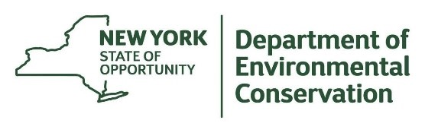
The New York State Department of Environmental Conservation provides financial support
to The Capital Mohawk PRISM via the Environmental Protection Fund.

