Rusty Crayfish Sampling at Five Rivers Environmental Education Center (2019)

Prepared by Chelsea Moore, Environmental Educator Assistant for Five Rivers Environmental Education Center

This survey was performed with 6 staff members from Five Rivers Environmental Education Center, 1 staff member from Capital Mohawk PRISM, and 1 staff member from the Department of Environmental Conservation.

Type of Work Performed: Identification and removal of Rusty Crayfish (Orconectes rusticus)

Date: October 8, 2019

Address: 56 Game Farm Rd. Delmar, NY 12054
County: Albany
Latitude and Longitude: 42.608676°N, 73.889757°W
Website: https://www.dec.ny.gov/education/1835.html

Lead Contact Information for Project: Gina Jack, Nancy Conway, Liz Wagner

Site Owner Contact Information: Five Rivers Environmental Education Center

Project Description:
Identification of O. rusticus in the Vlomankill.
8 person crew removed ~30 O. rusticus
Captured one native species (unidentified)

Invasive Species Present at (SITE NAME): Five Rivers - Vlomankill
Common Name | Scientific Name | Locations (GPS) | Growth Type | Phenology | Distribution/ Abundance
Rusty Crayfish | Orconectes rusticus | Vlomankill

Capital Mohawk PRISM Strongly Recommends Uploading Points into https://www.imapinvasives.org/
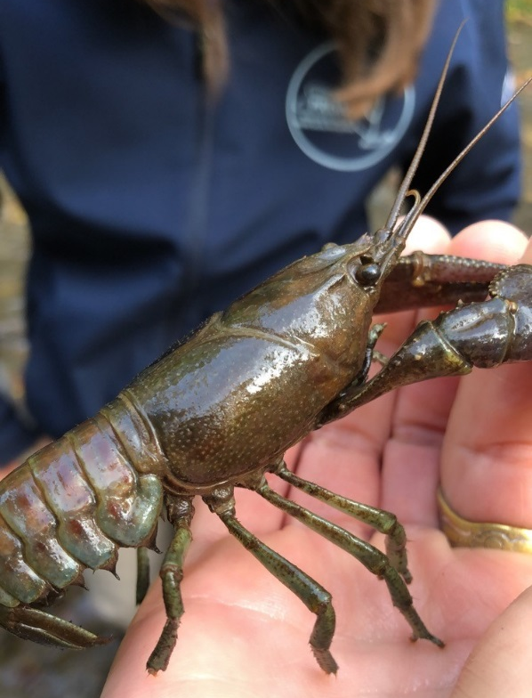
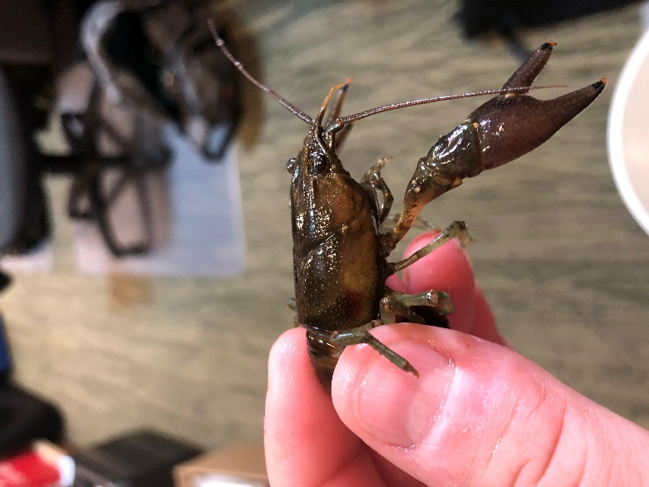

Figure 1. Rusty Crayfish – two individuals

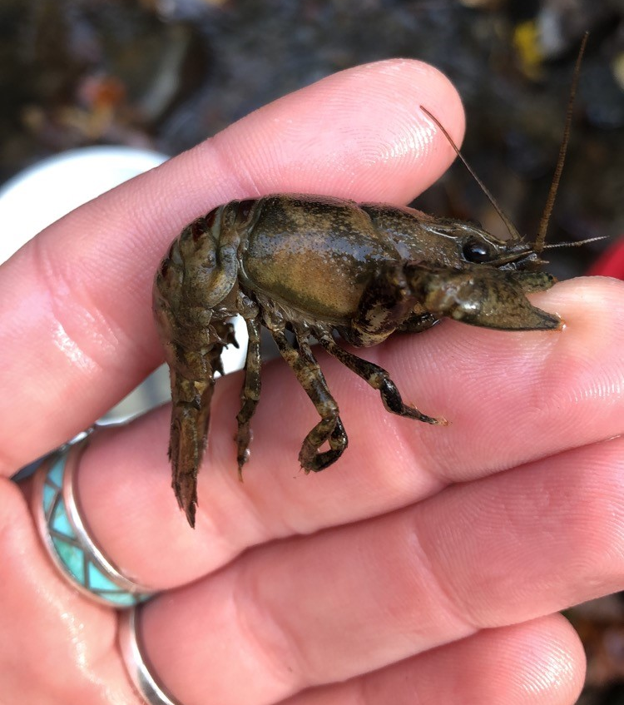

Figure 2. Native species – only individual found

Summary of Work Completed:
  - Identification
  - Removal of ~30 Orconectes rusticus

Recommendations for the Future:
Crayfish hitch every year to remove invasive rusty crayfish. Focus on stream sites where the presence of macroinvertebrates is necessary for stream lessons.

“Five Rivers IS Surveying Project” on iMapInvasives
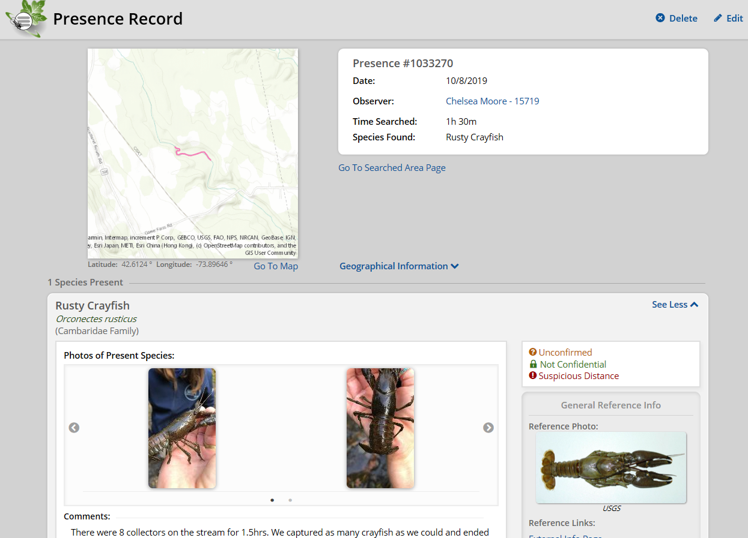

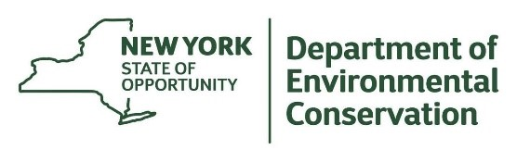
The New York State Department of Environmental Conservation provides financial
support to The Capital Mohawk PRISM via the Environmental Protection Fund.

