Capital Region PRISM Cornell Cooperative Extension Saratoga County
Partnership for Regional 50 West High St. Invasive Species Management Ballston Spa, NY 12020
www.capitalregionprism.org (518) 885-8995

Page 1

Capital Region PRISM Survey Report

Purpose:
The Invasive Species Survey Report will provide an overview and help guide invasive species treatments, baseline site composition, post-monitoring, and restoration at a specific site over time. A single survey report should not be written for an entire site, but a specific project. A site could have multiple reports. If there are multiple reports within a site, consult with the Capital Region PRISM about potentially preparing a more robust survey report.

To be submitted to Capital Region PRISM following the completion of partner, individual, or PRISM-led survey for review. This form can be found online as "Field Survey Report Template" at https://www.capitalregionprism.org or with a request. Please consult the Capital Region PRISM if there are any questions at (518)-885-8995. Please capture and collect data using iMap Invasives. The online software platform and associated mobile application are free and open sourced.

Section 1: Survey Summary
This section provides an overview of the site, contact information, etc. Once complete, save your report and submit the form via email to a member of the Capital Region PRISM team. Feel free to include supporting documents in your submission.

To determine site value, we recommend using the iMap Invasives Prioritization Model which can be found on the PRISM Prioritization webpage. The prioritization model will allow you to assess your sites ecologic value based on a few factors. Evaluate the comprehensive score or the ecological score to determine if your site is a high priority site that will help us determine if the location and infestation falls into our priority objectives for future management. If it is not a high priority site, we still encourage you to complete invasive species surveying as the site maybe culturally and socially of value to the public.

Section 2: Survey Result Summary
The survey summary section will contain the tables and maps generated from your survey efforts. The biological surveys will assist the Capital Region PRISM in our efforts to identify emerging species to be able to more effectively manage infestations and the spread of populations. Please fill out the provided table and insert screen shots of iMap Invasives maps.

Section 3: Summary of Recommendations
The recommendation section contains treatment calendars and post-season summaries. Most sites need to be revisited annually to document successes/failures, identify any changes needed, and update future treatment calendars.

Section 1: Survey Summary

Date: 05/27/2022, 06/06/2022 | Property Owner Name: DEC
Site Name: Charleston State Forest | Property Owner Contact: DEC Region 4 Stamford Office (M-F, 8:30 AM - 4:30 PM), (607) 652-7365; r4.ump@dec.ny.gov
Site Address (if different): Fultonville, NY 12072 | Survey Leader Name and Title: Sam Schultz, TIS Coordinator
County: Montgomery | Survey Leader Contact: ss986@cornell.edu
Latitude/Longitude: 42.820762288434985, -74.32673746141928 | Team Member Name(s): N/A
Site Size: 4,026 acres | Team Member Contact(s): N/A

Site Description: Provide existing conditions of the site, current land use, landscape elements, etc.
The 4,026-acre Charleston State Forest features more than 22 miles of cross-country ski trails in the winter. The property also contains 11 wildlife marshes, providing premium waterfowl viewing opportunities. It is also used for primitive camping, hunting and trapping, snowmobiling as well as hiking.

Survey Techniques: Provide a clear and concise description of the work to be conducted, target species, and any survey methods used (i.e. Highly probable area search, rake toss, transect, etc.).
Surveying conducted occurred along highly probable trail areas using a visual survey looking for tier 1 and tier 2 species while recording any invasive species found on site.

Did you identify this site through the iMap Invasives Prioritization Model? If yes- Did it score high in either ecological or comprehensive value? What other reason is present for conducting the survey?
Yes, this site scores highly in the comprehensive value due to its protected area status. There are multiple state regulated wetlands within the forest and it is in the vicinity of Rare Dragonflies and Damselflies. It is a Priority Conservation Area for the PRISM.

Section 2: Survey Result Summary
Common Name | Scientific Name | GPS Location | Growth Form | Phenology | Distribution/ Abundance | # of Stems | Area Infested (acres/miles if linear)
Garlic Mustard | Alliaria petiolata | See iMap | Herbaceous | In seed | Dense plants/clumps | N/A | 0.21 acres
Honeysuckle sp. | Loniceria spp. | See iMap | Shrub | Vegetative; Flowering | Dense plants/clumps | N/A | 0.47 acres
Multiflora rose | Rosa multiflora | See iMap | Shrub | Vegetative | Sparse | N/A | 0.21 acres
Common buckthorn | Rhamnus cathartica | See iMap | Shrub | Vegetative | Sparse | N/A | 0.23 acres
Common reed | Phragmites australis | 42.803116, -74.321267 | Herbaceous | Vegetative | Trace | N/A | 0.02 acres
Wild parsnip | Pastinaca sativa | 42.801814, -74.320524 | Herbaceous | Vegetative | Trace | N/A | 0.02 acres
Oriental bittersweet | Celastrus orbiculatus | 42.801642, -74.320261 | Vine | Vegetative | Sparse | N/A | 0.04 acres
Periwinkle | Vinca minor | See iMap | Ground Cover | Flowering | Monoculture | N/A | 0.64 acres
Forget-me-not | Myosotis scorpioides | 42.8070208, -74.318848 | Herbaceous | Flowering | Sparse | N/A | 0.04 acres
Autumn Olive | Elaeagnus umbellata | 42.799657, -74.312962 | Shrub | Flowering | Trace | N/A | 0.02 acres

Growth Form:
Terrestrial: Ground Cover, Herbaceous, Vine, Shrub, Tree, Insect, Animal
Aquatic: Submerged, Floating, Emergent, Riparian, Animal

Phenology:
Plants: Vegetative, Flowering, Fruit/In Seed, Dormant, Dead
Insects: Emergence, Swarming, Spawning
Animals: Spawning, Swarming, Migrating

Distribution/Abundance:
Trace (single plant/clump), Sparse (scattered plants/clumps), Dense plants/clumps, Monoculture, Linearly scattered

Map: Develop a map of the survey area that has any iMap Invasives points and/or searched, polygons to delineate infestation extent. Multiple maps may be added for multiple species or locations. Different mapping formats are welcome but iMap Invasive delineations are preferred.

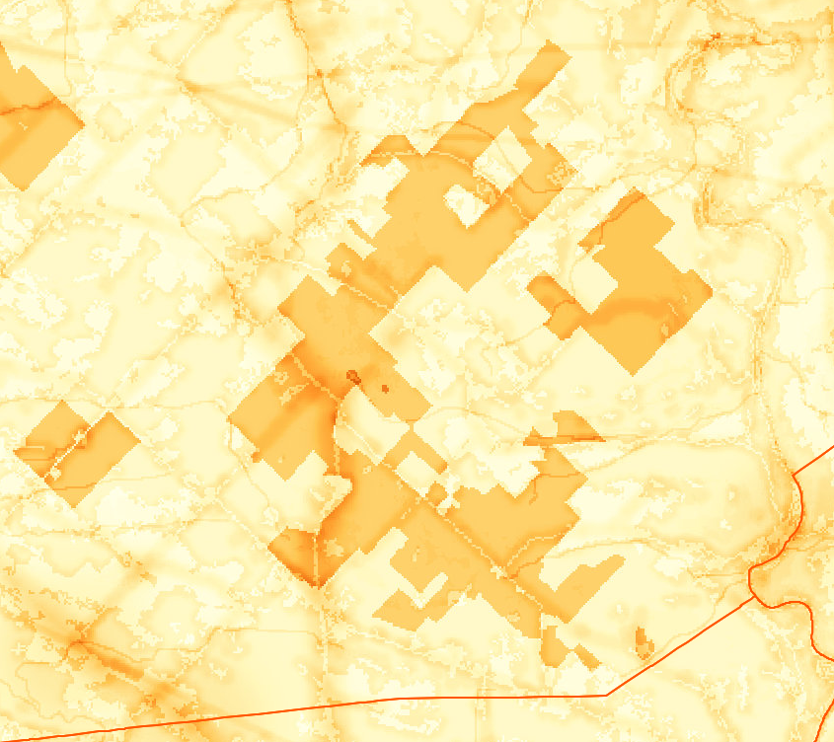
- Insert Survey Map(s):
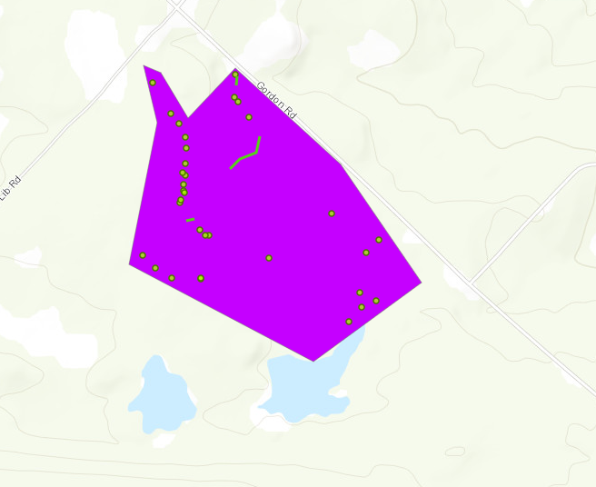
Searched Area #: 1285935

Section 3: Summary of Recommendations
This section provides recommendations of any treatment methods, monitoring methods, and restoration efforts based on the survey.

Additional Notes: Describe any barriers or issues that arose before or during the survey. Issues arising before completing the survey could include: trouble contacting owner, extended time to obtain permission, trouble accessing the property, etc. Barriers arising during the survey could include: downed trees, trail is closed off, hazards on site, unforeseen injury, inclement weather, etc. Provide any advice that could limit barriers or issues in the future.
This survey went smoothly. Trails are well marked within the forest but there is no known map of the trails. Trails are relatively well maintained at this site but be prepared for wet swampy areas before trailing here.

Treatment: Describe briefly any recommendations for future treatment methods, why they are recommended, and any alternatives to consider. Please use abundance and site-specific factors in your treatment recommendation. Optional: Attach or reference BMP guidance document. Consider state and local permitting requirements.
Currently, there are no treatments recommended for this site.

Post-Survey Monitoring: Briefly explain the monitoring procedure, when it will occur, and who will complete it. Consider the phenology of species when suggesting time-lines. If a control such as eradication, suppression, and exclusion is selected, will a management plan be drafted? If a plan is needed, please contact the CR-PRISM Office for a template of our Invasive Species Management Plan.
The Capital Region PRISM will continue to survey this area as it is one of the PCAs of the PRISM. More trails need to be surveyed to determine highest priorities on site for surveying. A hemlock woolly adelgid survey should be conducted around the wetlands as they seem to have hemlocks lining the shoreline and a high presence of waterfowl.

