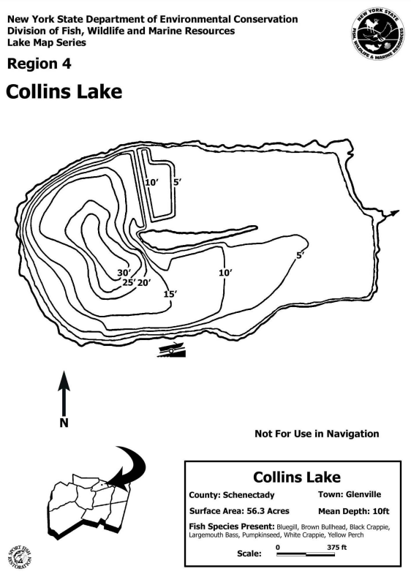
Capital Region PRISM AIS Survey Report
Date(s): September 19th, 2022
Site Name: Collins Lake
Site Size: 56.3 acres
Waterbody Perimeter: 1.5 miles
Mean Depth: 10 ft.
GPS Location: 42.826220, -73.954051
Physical Address: Kiwanis Way, Scotia, NY 12302
Town: Glenville
County: Schenectady

Property Owner Contact:
Primary Contact: NYSDEC | 65561 State Highway 10, Suite 1
Stamford, NY 12167 | 607-652-7366 | fwfish4@dec.ny.gov
Secondary Contact: Village of Scotia Parks & Recreation Department | 518-374-8611

Survey Leader: Hannah Coppola – AIS Program Manager
Phone: 518. 885-8995 Ext. 2215 / Email: hwe22@cornell.edu
Team Members: N/A
iMapInvasives User ID: 21052

Section 1: Survey Summary
On September 19th, 2022 the Capital Region PRISM conducted an aquatic survey on Collins Lake in Schenectady County for Tier 1 and 2 aquatic invasive species. Upon completion of the aquatic survey it was determined that water chestnut, curly-leaf pondweed and brittle naiad are present in Collins Lake. A large 10-acre water chestnut monoculture is present on the eastern shore of the waterbody. There is a strong presence of native elodea throughout the waterbody.

Site Description
Collins Lake is a 56.3-acre waterbody located within Collins Park in the Village of Scotia. The lakes substrate is comprised of muck and sand with a bottom cover of macrophytes, leaf pack, woody debris and benthic algae.
A small island, Scotia Island Preserve, is located in the center of the waterbody. Access to the island is not permitted to the public. The island has a heavy population of Canada Geese surrounding the island.
Collins Lake is a popular fishing spot for locals. A boat launch is located on the southern shore of the waterbody in Collins Park. A cartop boat launch is also present on the eastern shore with limited access to the water due to the water chestnut monoculture.
There is limited visibility within the waterbody due to poor water quality. The waterbody has multiple aerators between the shoreline and island, and has waterflow into the Mohawk River.

Survey Techniques
Entire waterbody, top water
- Top-side (visual)
- Meandering Rake Toss

NYS Invasive Species Prioritization Model
Collins Lake is located within Collins Park which has a high comprehensive score on the NYS Invasive Species Prioritization Model. Locations with high comprehensive scores have high ecological significance, a high risk of spread of invasives into the area, and high value according to their protected status. Early detection is important in these locations to ensure timely management of new infestations if detected.

NYS Invasive Species Prioritization Model

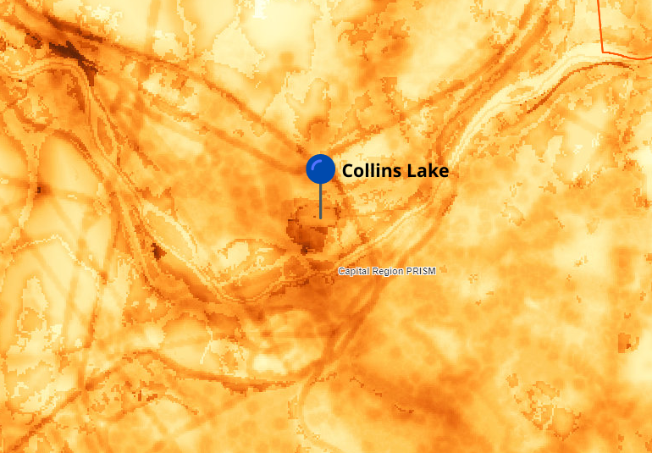

Does this site contain previously treated infestations?
- Water chestnut
  - Dredging from 1988-1992
  - Hand removals until ~2011
  - Village of Scotia plans to apply herbicide in 2022
- Eurasian watermilfoil
  - Treated June 2021

Section 2: Survey Result Summary

Aquatic Invasive Species Presence
- Water chestnut
  - New York Non-Native Animal Invasiveness Ranking -82
    - http://nyis.info/wp-content/uploads/2018/01/61a2d_Trapa-natans-NYS.pdf
- Curly-leaf pondweed
  - New York Non-Native Animal Invasiveness Ranking – 79.79
    - http://nyis.info/wp-content/uploads/2018/01/7223b_Potamogeton.crispus.NYS_.pdf
- Brittle naiad
  - New York Non-Native Animal Invasiveness Ranking – 64.84
    - http://nyis.info/wp-content/uploads/2018/01/2320f_Najas.minor_.NYS_.pdf
- Common carp
  - New York Non-Native Animal Invasiveness Ranking – 90.43
    - http://nyis.info/wp-content/uploads/2017/10/f9c07_Cyprinus-carpio-Ecological.pdf
- Eurasian watermilfoil
  - New York Non-Native Animal Invasiveness Ranking – 100
    - http://nyis.info/wp-content/uploads/2018/01/5cdc8_Myriophyllum.spicatum.NYS_.pdf

Common Name | Scientific Name | Location (GPS) | Growth Type | Phenology | Abundance
Water chestnut | Trapa natans | Multiple locations | Floating | Fruit ripening | Monoculture
Curly-leaf pondweed | Potamogeton crispus | Multiple locations | Submerged | Senesce | Sparse
Brittle naiad | Najas minor | 42.826432, -73.949395 | Submerged | Vegetative | Sparse
Common carp | Cyprinus carpio | Multiple locations | Animal | -- | Trace
Eurasian water-milfoil | Myriophyllum spicatum | Multiple locations | Submerged | Vegetative | Sparse
Growth Type: Tree, Shrub, Vine, Ground Cover, Herbaceous, Riparian, Submerged, Floating, Emergent, Wetland, Pest, Animal
Phenology: Flowering, Leaf unfolding, fruit ripening, leaf color change, dormant, swarming, spawning, emergence (insects), migrating, in seed, senesce
Distribution/Abundance: Trace (single plant/clump), Sparse (scattered plants/clumps), Dense plants/clumps, Linearly scattered, Monoculture

Native Species Presence
- Common Bladderwort (Utricularia vulgaris)
- Eelgrass (Zostera marina)
- White waterlily (Nymphaea odorata)
- Waterweed (Elodea spp.)
- Coontail (Ceratophyllum demersum)
- Muskgrass (Chara)
- Spatterdock (Nuphar variegate)

Map
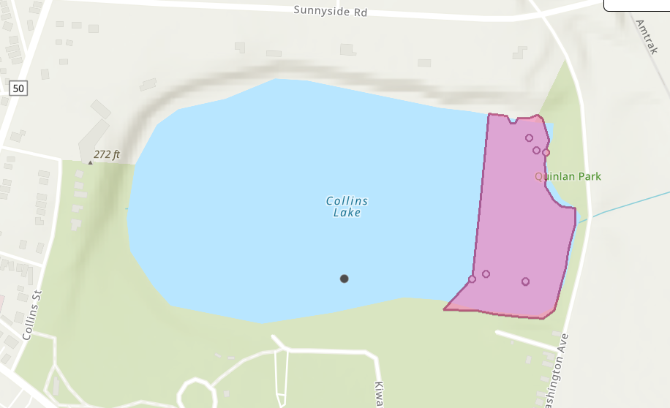
Presence polygon represents large dense plants/clumps and monoculture.

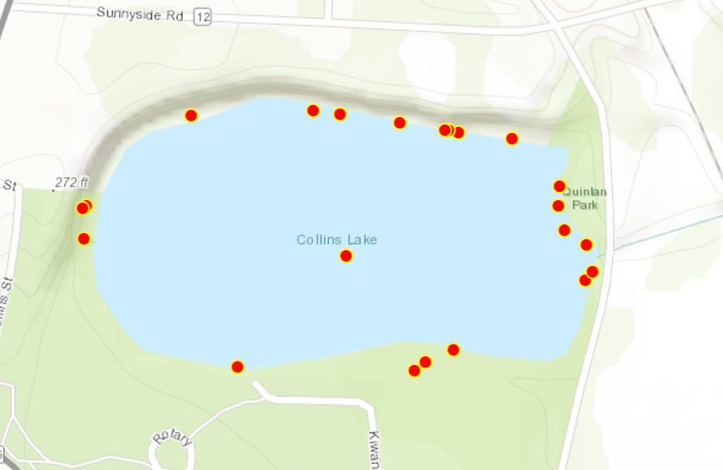
Eurasian Water-milfoil

Brittle Naiad

Section 3: Summary of Recommendations

Prevention
Ensure ample AIS signage is present in the parking and launch area.

Management

Water chestnut
Mechanical
- Hand-pulling
  - Conduct hand-pulls between mid-June-July before fruit has ripened and dropped to reduce chances of adding to the seed bank.
  - Multiple visits per season may be necessary to remove regrowth.
  - Management/post-treatment monitoring of site should continue for up to 10 years to ensure seed bank in depleted.
- Mechanical Harvester
  - Cuts vegetation and transfers biomass onto a conveyor system to be disposed of. Multiple cutting may be necessary for regrowth later in the season.
Chemical
- Herbicide (2, 4-D or Glyphosate)
  - Should be administered before the fruit has ripened and dropped to reduce chances of adding to the seed bank.
  - Potential negative impacts to non-target species. Application of aquatic herbicides requires both a licensed pesticide applicator and a permit from your state environmental regulatory agency.

Curly-leaf pondweed
Mechanical
- Curly-leaf pondweed can be managed mechanically by raking, hand cutting, or harvesting vegetation. Raking and hand cutting generally remove the plants at the sediment surface, while harvesting generally removes the top five feet of the plants. Diver-operated suction harvesting allows for the removal of both stems and turions, but is slow and costly. Mechanical methods control plants in the specific areas where they are causing a nuisance and there is immediate relief from the nuisance.
Physical
- Habitat manipulations such as water level drawdown, dredging, or bottom barriers can be used to manage curly-leaf pondweed. Fall drawdown can prevent curly-leaf pondweed from growing the following summer by exposing turions to freezing temperatures and desiccation. Dredging can be used to control curly-leaf pondweed by increasing water depth. In deep water rooted plants do not receive enough light to survive. Depending upon how much material is removed, dredging can prevent all rooted macrophytes from growing for many years. Bottom barriers can be used to prevent the growth of rooted aquatic macrophytes in small areas. Control of all rooted species is immediate and lasts as long as the barriers are well maintained. Barriers are expensive to install and maintain.
Chemical
- Only a few of the aquatic herbicides can be used to control curly-leaf pondweed (Tables 1, 2). Good to excellent control of curly-leaf can be obtained using formulations of diquat (e.g., Reward®) and endothall (e.g., Aquathol®). Whole lake treatment with fluridone can also be used to control curly-leaf pondweed. Diquat and endothall (especially the former) are contact herbicides that can be used in small areas. Endothall has been shown to be effective at lower temperatures, and is being used experimentally in largescale applications on entire beds of curly-leaf pondweed. Fluridone is a systemic herbicide that usually has to be applied to whole lakes or bays and requires over 60 days to control curlyleaf pondweed. Potential problems are failure of the herbicides to control curly-leaf, a lag time between treatment and plant knock down, regrowth of curly-leaf the following year, and the removal of beneficial native plants.
(John D. Madsen, Ph.D., GeoResources Institute, Mississippi State University)

Brittle naiad
Mechanical
- Manual removal of brittle naiad can be difficult due to how easy the plant can break off, leaving small fragments in the water for later reproduction. When manually removing the plant, caution must be taken to ensure that all parts of the plant are removed and placed in a disposal bin.
- Mechanical harvesters can be used to remove infestations of brittle naiad, however, they can further contribute to the spread of infestations due to fragmentation.
Chemical
- Herbicides can be effective in controlling larger infestations. Effective herbicides are diquat, endothall, and fluridone. However, care must be taken as these herbicides can have negative impacts on native aquatic plant species found within the infestations. Herbicides can cause oxygen depletion due to the decomposition of the dead plant material, which can kill fish. It is especially crucial that these herbicides are applied at the right place and the right time to avoid negative consequences. Please consult an expert or certified applicator when applying herbicides. Read and follow herbicide product labels as required by law. Seek out proper local, state, and federal permitting when applying herbicides.
Eurasian watermilfoil
• Harvest/Suctioning
• Chemical Treatment with Selective Herbicide
o A number of chemicals impact the growth and survival of M. spicatum. Amine salts of Endothall (Hyrothol 191®), and Dipotassium Salts of Endothall (Aquathol K®), Diquat dibromide (Reward®), Komeen® have been found to be effective. Some of these herbicides may also affect other non-target rooted submerged plants, including some rushes. Treatment is most effective in still water in the spring while the plant is actively growing.
The amine formulations of 2,4-D granules (Navigate®, Aquakleen®, Aquacide®) are effective on controlling Eurasian watermilfoil and will not damage most non-target grasses. This herbicide method, however, is not appropriate for large unmanageable areas of milfoil. One lose-dose application (10 µg/ L) of fluridone (brand names Sonar® and Avast!®) applied in the early stages of growth has the potential to provide season-long control of milfoil. However, this application rate causes collateral damage to native vegetation. Liquid triclopyr (Renovate 3® and Renovate® OTF) can control milfoil without unintended damage to cattails and grasses. Note: Always check state/provincial and local regulations for the most up-to-date information regarding permits for control methods. Follow all label instructions. Mention of chemicals, particularly the mention of brand names in this profile does not represent a recommendation by NY Sea Grant or Cornell University.
• Non-Selective Control Strategies
o Benthic Matts

Post-Survey Monitoring
Collins Lake is considered Priority Waterbody in the Capital Region PRISM. Early detection surveys will be conducted at Collins Lake on a biannual basis to ensure any infestations are detected early when eradication is still possible.
Will an Invasive Species Management Plan be created?
- No

Photos

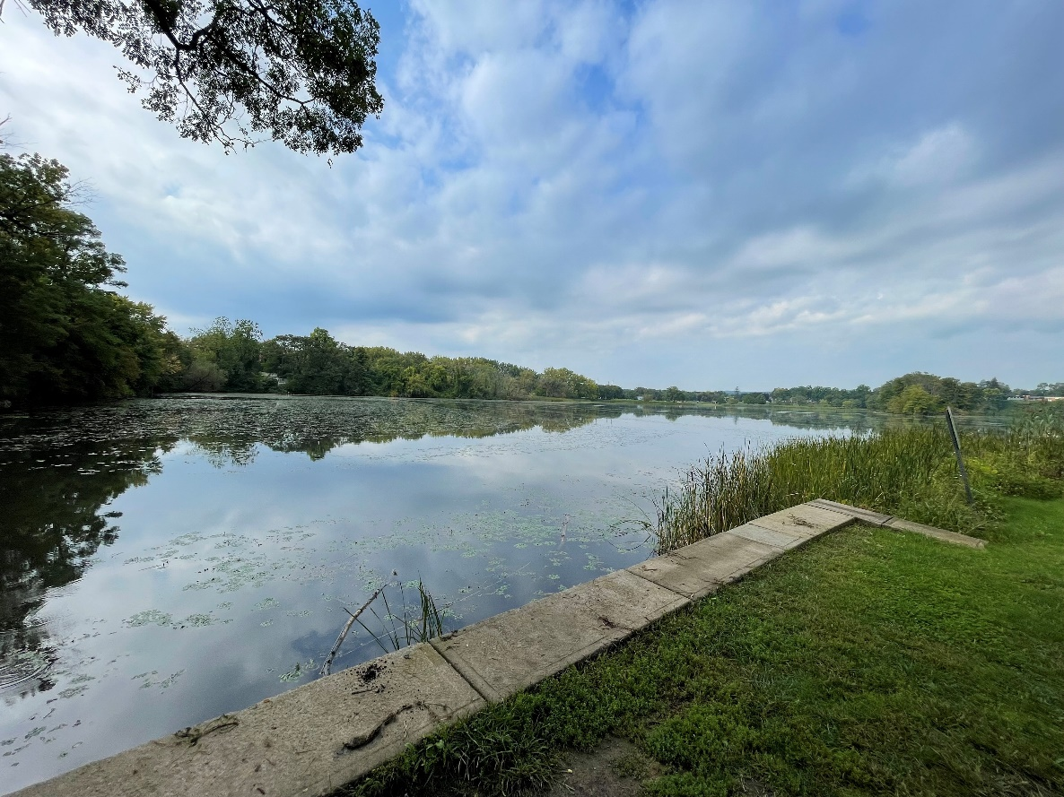

The New York State Department of Environmental Conservation provides financial support to The Capital Region PRISM via the Environmental Protection Fund

