Common Reed
Phragmites australis

Identification

Common reed is a tall, herbaceous grass that can reach heights of over 12 ft It has a bluish-green hollow stem and long, slender leaves that originate at each new segment on the stem. The leaves are stiff, sharp, flat blades that shoot up vertically from the stem. In the winter, the plant will lose its leaves, leaving just the stalk.

Reproduction
Between July and September, purple-brown seed heads will form. As the plant matures, the seed heads will turn progressively more brownish-tan. The seeds have a feathery appearance. Common reed produces a few thousand seeds per year but the seed viability changes from season to season. The plant spreads both by windborne seeds and rhizomes (root system off-shoots).The rhizomes can reach a radius of up to 70ft from the parent plant.

Habitat
Common reed is commonly found in marshes and wet areas. Rhizome fragments can survive in drier settings. The plant is commonly found along roadsides as well.
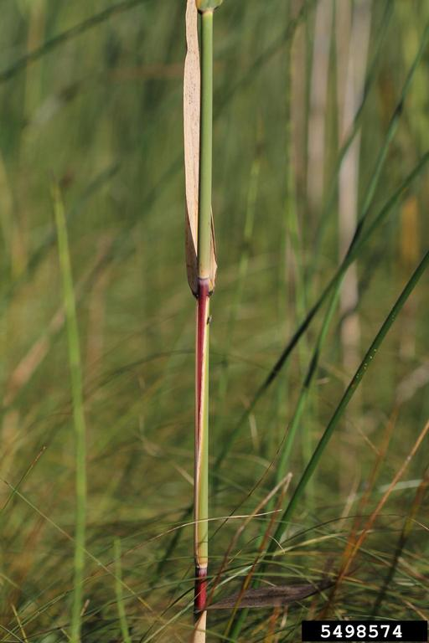

Threat
The plant grows very quickly and forms dense stands that can block access to waterways and hide important road signs. It also decreases water quality and crowds out native species.
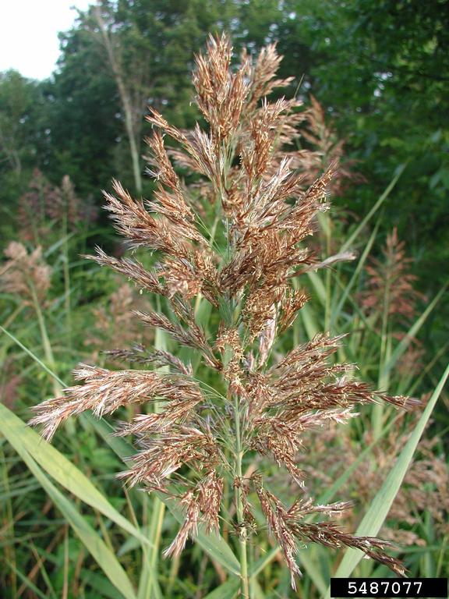

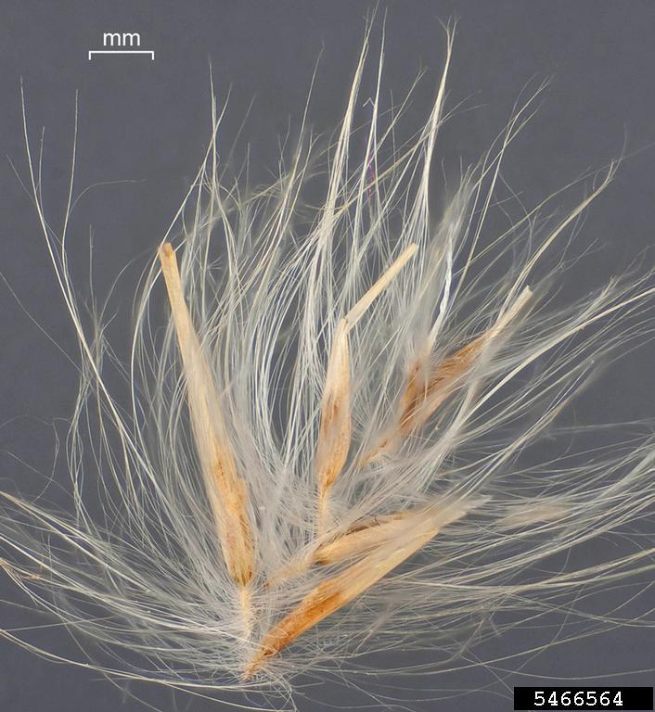

Integrated Pest Management for

Common Reed
Due to the threat of common reed to local ecosystems, it is important to reduce the size and limit the spread of existing populations. Invasive species are controlled through prevention, eradication, containment and suppression. An integrated pest management (IPM) approach should be adopted to control unwanted species. The integrated approach is a combination of manual, mechanical, biological and chemical controls. IPM requires post treatment monitoring and treatment over a period of several years, leading to more successful outcomes (https://nysipm.cornell.edu/about/defining-ipm/).

Practices to avoid
- DO NOT mow common reed. This will create small fragments of the stem which can start a new population.
- DO NOT leave any fragments. Leaving seed heads on permeable surfaces or on any equipment can facilitate the spread of the common reed and the formation of new infestations. Any fragments created should be placed in black plastic bags and left to solarize for at least two weeks before disposal.

Manual and Mechanical Control
Cutting and pulling does not stop the growth of the common reed, but can be beneficial to do in order to clear an area to allow for easier herbicide application. Cutting or pulling should occur before flowering, ideally between June and November, to set back the new growth and make for a less dense stand in the following season.
In highly aquatic environments, the common reed can be managed by manipulating water levels and salinity. This tactic is called water drawdowns and is typically performed by trained professionals to limit the adverse effects on the ecosystem as a whole.

Biological Control
There are currently no approved methods for biological control in the United States.

Herbicide Control
Herbicide is often the last resort for pest management due the impacts it can have on the surrounding environment, however, with very widespread and invasive species, such as the common reed, herbicides may be necessary in order to prevent growth and spread. Education on the proper chemicals and time to apply them is essential for successful herbicide treatments. Please consult an expert or certified applicator when applying herbicides Read and follow herbicide product labels as required by law. Seek out proper local, state, and federal permitting when applying herbicides.

Herbicide Treatment for Homeowners/Private Landowners

Time of Year: Late Summer (July-October)

Example Chemical(s) to Use: Read All Product Labels as Required by Law
Product names are listed as examples, and not as endorsement or recommendation. The suitability and details for specific use of these products are provides through their labels.
Chemical  (Products containing) | Timing | Application Technique | Notes
Glyphosate  (Rodeo,Aquaneat, Glyphomate 41) | July-October  (8 weeks after cutting) | Foliar Spray  Cut and Wipe | No soil activity  Highly selective method
Imazapyr  (Polaris, Habitat) | July-October  (8 weeks after cutting) | Foliar Spray | Do not apply in areas near trees due to long soil activity
If there is water present near the infestation, a permit from the DEC is required. For more information regarding aquatic pesticide permitting, please contact the nearest DEC Regional Office: Division of Environmental Permits at (518) 357-2069 or visit: http://www.dec.ny.gov/permits/209.html.

Timeline of Action

For More Information Seek out the Cornell Guidelines for Pesticide Use:
The Cornell Guidelines offer the latest information on topics such as pest management, crop production, and landscape plant maintenance. Each title in the series is updated by Cornell University researchers and Extension specialists and is designed as a practical guides. https://www.cornellstore.com/books/cornell-cooperative-ext-pmep-guidelines

Native Replacements
After removing or treating common reed, it is important to reseed or plant the disturbed soils with native species common in the geographic area. Replanting will help restore the ecosystem and prevent old infestations from re-establishing. Consider using stress tolerant plants in harsh environments that are best suited to a given site. If pre-existing native plants are present on site, protect these species from harm, during management. The surrounding native species can then be used to aid in the heathy reestablishment of the area. More information about native plants, shrubs and trees can be found:

Alternatives to Ornamental Invasive Plants “A Sustainable Solution for New York State”
- https://nysipm.cornell.edu/sites/nysipm.cornell.edu/files/shared/documents/NYSIPM-alt-inv.pdf

NYSDEC Native Plant Factsheets
- https://www.dec.ny.gov/docs/lands_forests_pdf/factnatives.pdf

Lady Bird Johnson Native Flower Database
- https://www.wildflower.org/plants/

Westchester Community College Native Plant Center
- https://www.sunywcc.edu/about/npc/

Definitions:
Manual Control: a technique to remove small infestations. Some examples of manual control is hand-pulling, mulching, burning, digging, and removal of the entire plant, portions of a plant, nests, egg masses, or other life stages. This type of control is only economically feasible for small infestations.
Herbicide Control: a technique which uses chemicals to remove or decrease the population of a species. Herbicides are usually one of the last choices for control as they are usually expensive and have adverse effects to the environment. There are different methods to apply an herbicide. Some examples are: foliar spray, basal bark, bundle and cut, and cut-stump treatment.
Biological Control: a technique where an animal, insect, fungi or disease is used to manage a large invasive species population. This control species is studied intensively to see if there could be any negative effects for native species.
Foliar Spray: method of herbicide control where the chemical is sprayed directly on the leaves. Sprayers can be hand held, on a backpack or mounted on a vehicle. If a plant has a waxy surface, a surfactant may be needed to allow the herbicide to work.
Selective herbicides: a type of herbicide which kills specific groups of plants but not others. For examples, a selective herbicide may kill broadleaf plants, like dandelions, but not grasses.
Non-selective herbicides: a type of herbicide which kills all types of plants. When using this herbicide, any plant that is sprayed will be effected.
DISCLAIMER
Please note that neither Cornell Cooperative Extension of Saratoga County nor any representative thereof makes any representation of any warranty, express or implied, of any particular result or application of the information provided by us or regarding any product. If a product is involved it is the sole responsibility of the User to read and follow all product labeling instructions and to check with the manufacturer or supplier for the most recent information. Nothing contained in this information should be interpreted as an express or implied endorsement of any particular product or criticism of unnamed products. With respect to any information on pest management the User is responsible for obtaining the most up-to-date pest management information. The information we provide is no substitute for pesticide labeling. The User is solely responsible for reading and following manufacturer’s labeling and instructions.

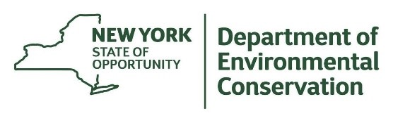
The New York State Department of Environmental Conservation provides financial support
to The Capital Mohawk PRISM via the Environmental Protection Fund.

