Capital Region (PRISM)
Partnership for Regional Invasive Species Management
2023 Annual Work Plan
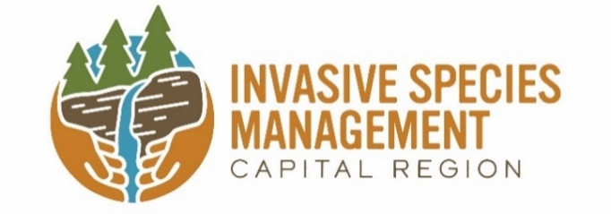

The PRISM’s 2023 Workplan is aligned with the goals and objectives described in Capital Region Prisms’ Five-year Strategic Plan 2023-2027 and outlines specific actions the Capital Region PRISM staff and partners will take in 2023 to advance the plan’s goals and objectives through priority work actions. The PRISM would like to thank our dedicated partners for their support and assistance in achieving our shared mission of reducing the impact of invasive species on our economy and ecology of the region.
The Capital Region Partnership for Regional Invasive Species Management (PRISM), one of eight PRISMs across New York State, is hosted by the Cornell Cooperative Extension of Saratoga County. Through the Cornell Cooperative Extension, the Capital Region PRISM proudly serves eleven counties, including Albany, Columbia, Montgomery, Rensselaer, Schenectady, and portions of Fulton, Greene, Herkimer, Saratoga, Warren, and Washington. More than three dozen cooperating organizations, partners, and volunteers support the Capital Region PRISM in its mission. To become a partner or volunteer please check out our website and contact a coordinator. Funding for the Capital Region PRISM is provided by the Environmental Protection Fund, as administered through the New York State Department of Environmental Conservation.

Invasive species are defined by Environmental Conservation Law (9-1703 (1)) as non-native species that can cause harm to the environment, economy, or to human health. They are a form of biological pollution that comes from around the world. The rate of invasion of these species is growing due to increasing international trade and climate change. A wide variety of invasive species negatively impact many sectors of our world: our ecosystems, including all-natural systems and managed forests; our food supply, including agricultural products and harvested wildlife, fish and shellfish; our built environments, including landscaping, infrastructure, industry, gardens and pets; and our economy, recreation, and human health. Responding to this growing problem, New York State has implemented recommendations of the New York Invasive Species Task Force (ISTF) established under legislation passed in 2003. In 2008, Title 17 of ECL Article 9 established the New York Invasive Species Council and Invasive Species Advisory Committee. This Council of nine state agencies is co-led by the New York State Departments of Environmental Conservation (DEC) and Agriculture and Markets (DAM). Among the Council’s numerous statutory responsibilities is: “supporting within available funds and encouraging Partnerships for Regional Invasive Species Management [PRISMs] in their efforts to address invasive species through coordination, recruitment, and training of volunteers, education, early detection, rapid response, eradication, research, and planning.”

A Special Thanks to: The New York State Department of Environmental Conservation, Invasive Species Coordination Section; the New York State Department of Agriculture and Markets; the New York State Invasive Species Council; Invasive Species Advisory Council; New York State Legislature; the Capital Region PRISM Steering Committee and our host organization the Cornell Cooperative Extension of Saratoga County.

2023 Capital Region Steering Committee Members
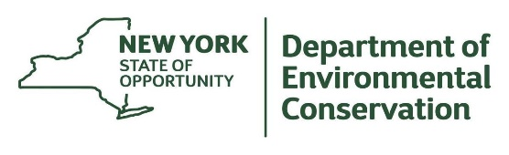
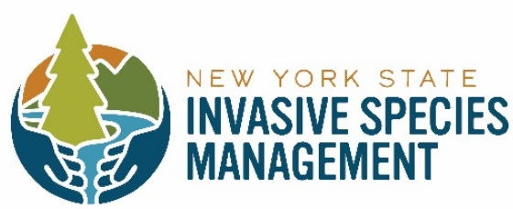
Robert Cole NYS Department of Environmental Conservation Division of Lands and Forest: Forester
Linda White National Park Service: Biological Technician
Neil Gifford Albany Pine Bush Preserve Commission: Conservation Director (former member)
Thomas Allgaier NYS Department of Agriculture and Markets: Invasive Species Coordinator
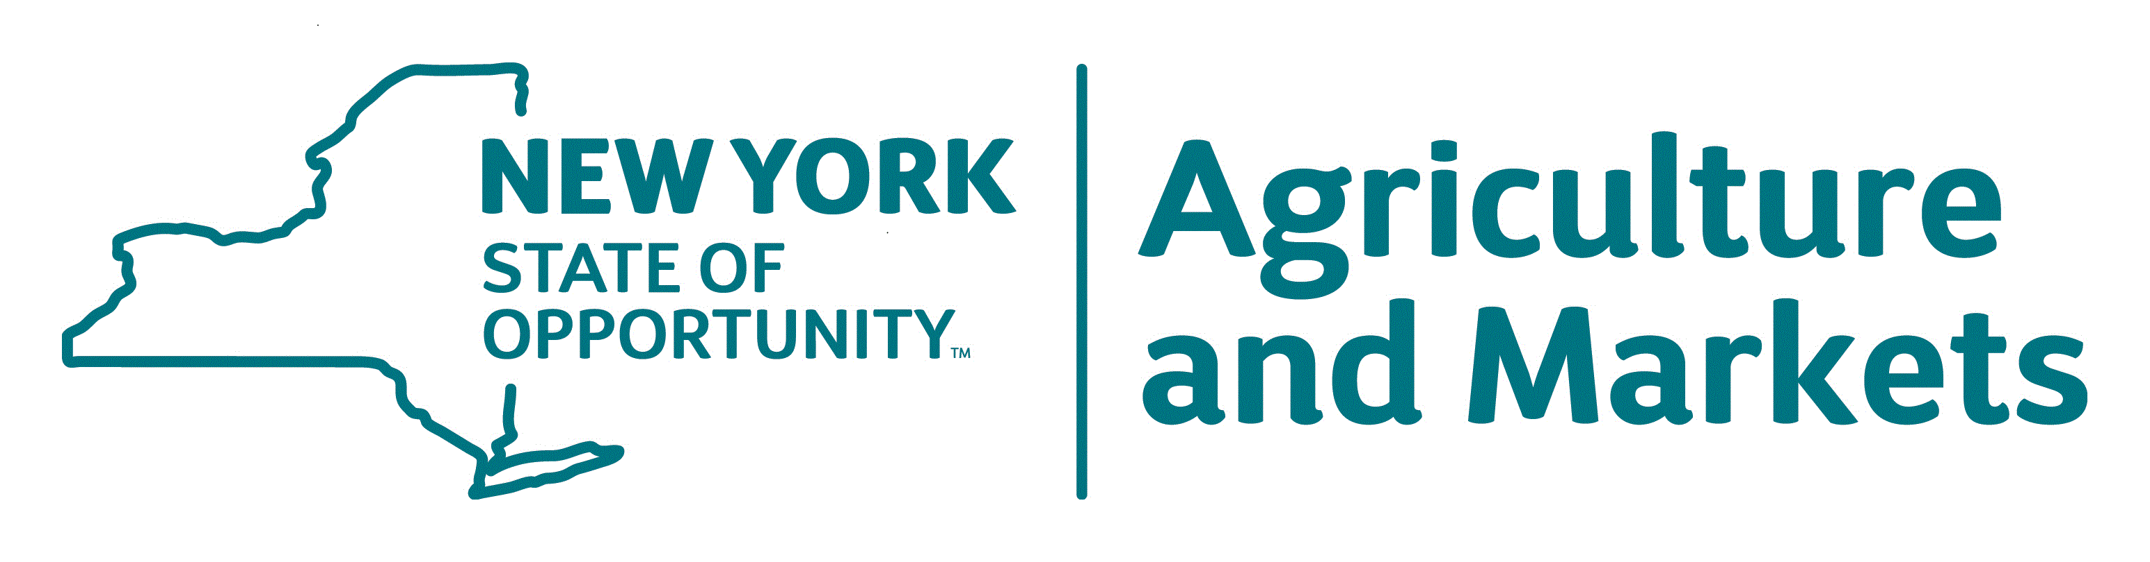
Loretta McNamee NYS Department of Transportation: Region 1: Environmental Specialist
Matthew Brincka NYS Office of Parks, Recreation, and Historic Preservation / Invasive Species Biologist
Dustin Lewis Saratoga County Soil and Water Conservation District: District Manager
Meg Wilkinson NYS Department of Environmental Conservation, Natural Heritage Program

VISION
To cultivate a region in which partners work together to address the harmful impacts associated with invasive species to protect its lands and waters, biodiversity, economy, and quality of life.

MISSION

Our mission is to prevent, detect, and respond to harmful invasive species in the PRISM region through collaboration, resource sharing, strategic messaging, and education.

Goal 1: Partnership

Coordinate and collaborate with partners to grow and strengthen regional capacity to prevent, detect, and respond to invasive species.

Goal 2: Prevent

Minimize the introduction and spread of harmful invasive species
into new areas.

Goal 3: Detect and Monitor

Detect and monitor harmful invasives species approaching and affecting the Capital Region.

Goal 4: Respond

Mitigate ecological and economic impacts of priority invasive species using an integrated pest management approach.

Goal 5: Outreach, Communication and Education

Build engaged communities that understand, support, and invest in the PRISM’s work to prevent, detect, and respond to harmful invasive species
in the Capital Region.

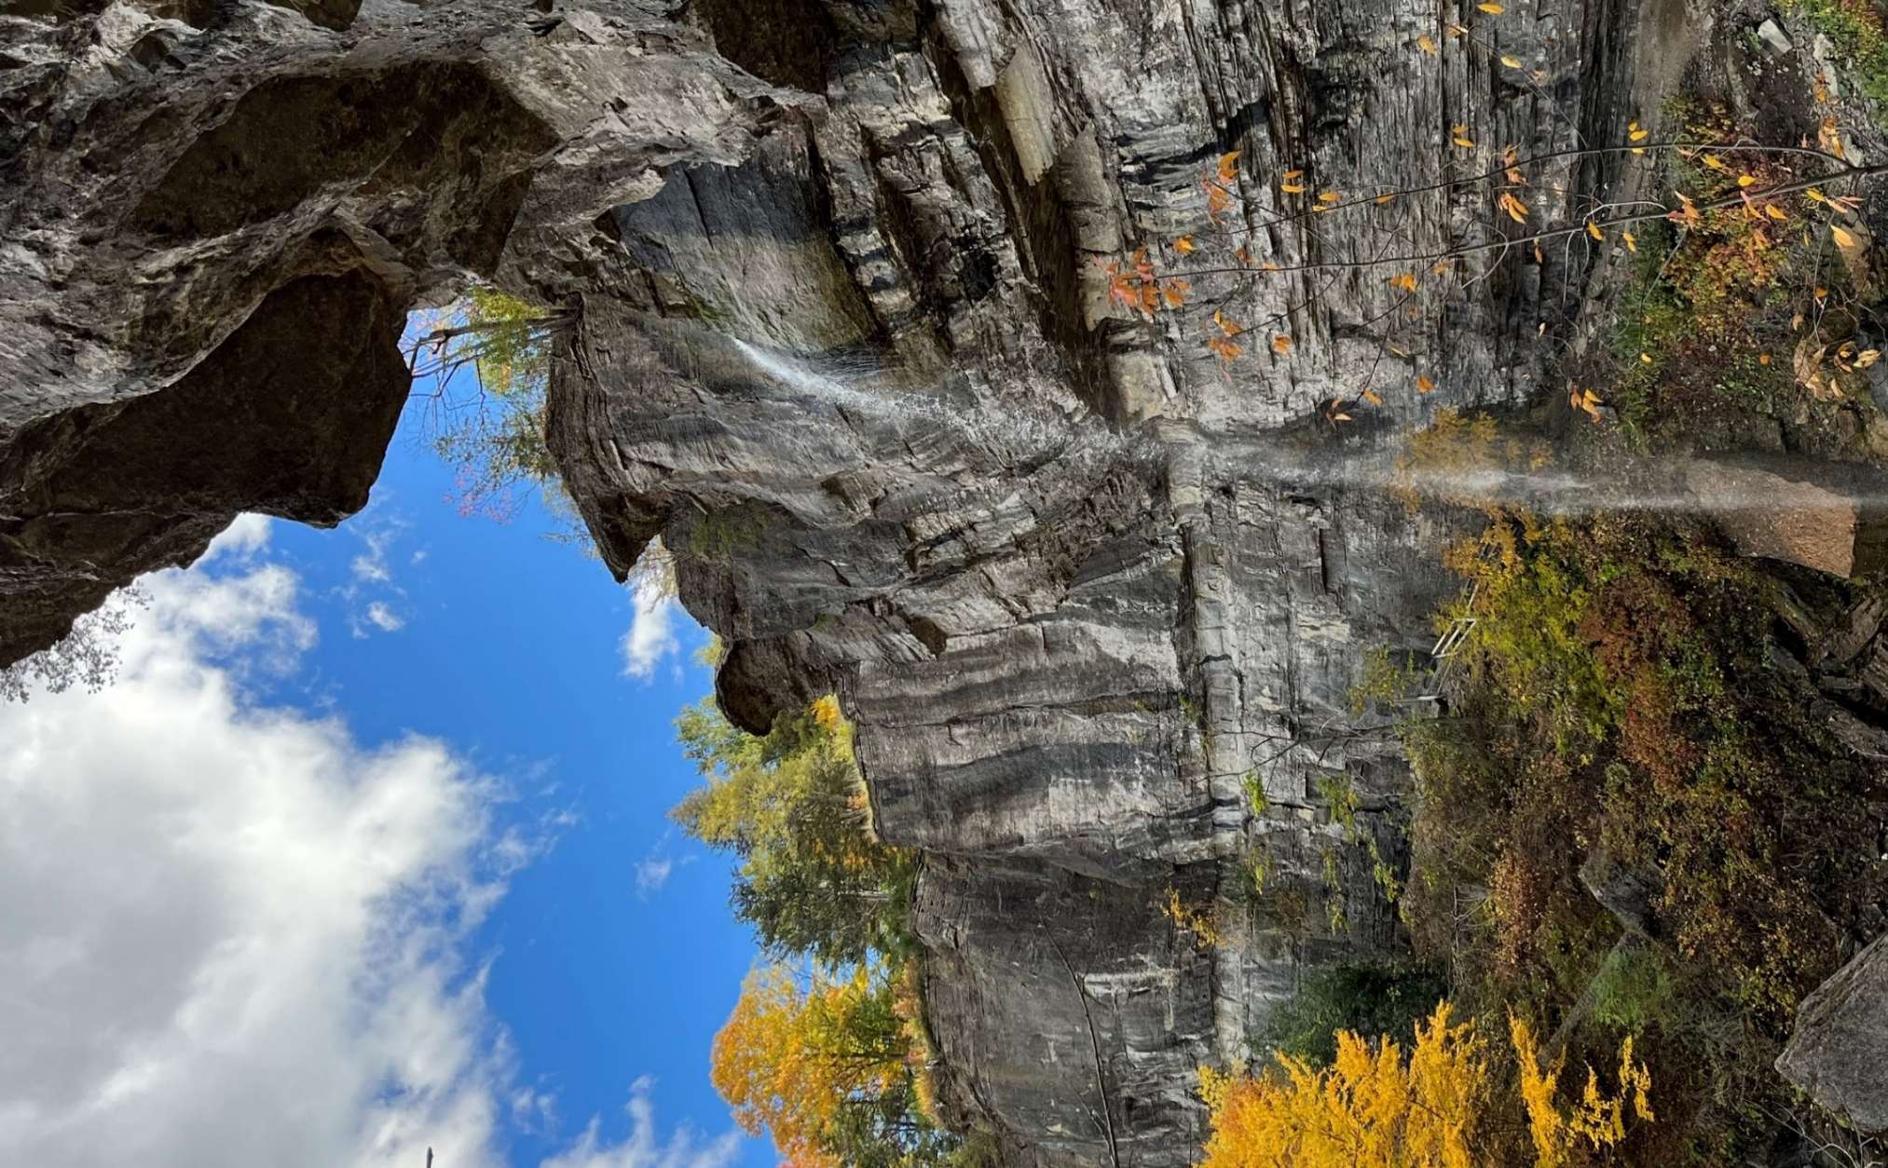

Capital Region PRISM Strategic Goals / Objectives
1 | Partnership
2 | Prevent
3 | Detect and Monitor
4 | Respond
5 | Outreach, Communication, and Education
Capital Region PRISM Staff
kbw44 | Team Leader /PRISM Coordinator: Kristopher Williams
hwe22 | Aquatic Invasive Species Program Manager: Hannah Coppola
ask263 | Education and Outreach Coordinator: Addison Kubik
ss986 | Terrestrial Invasive Species Coordinator: Samantha Schultz

Capital Region PRISM: Goals, Objectives, and Priority Actions
PARTNERSHIP
Goal 1: Coordinate and collaborate with partners to grow and strengthen regional capacity to prevent, detect, and respond to invasive species.

CR-PRISM understands that the nature and complexity of invasive species prevention and management are too great for one single entity to solve. Partners and communities are key to an effective framework of response. Partnerships are the foundation of the CR-PRISM.

Objectives | Priority Work Actions | Target Quarter /Assignment
Objective 1.1:  Invest in the PRISM partnership and other local networks to facilitate the sharing of information, resources, and expertise across the region. | - Provide opportunities for sharing information among partners through different communication channels, annual partner meetings, and topical meetings  - Strategically recruit new partners to reach new audiences and locations in the PRISM region  - Develop a mechanism for partners to report on their invasive species work, such as an annual survey  - Use a Request for Proposals (RFP) process to provide financial assistance for partners to implement CR-PRISM goals and objectives
Objective 1.2:  Coordinate and collaborate with statewide and regional partners on invasive species issues that cross PRISM boundaries. | - Work collaboratively to respond to statewide and local high threat invasive species issues  - Support, share, and provide opportunities for research with partner networks when appropriate  - Coordinate with other PRISMs and related agencies such as monthly PRISM calls, quarterly PRISM leader and coordinator meetings, workgroups  - Participate in biannual invasive species summit organized by NY’s Invasive Species Advisory Council
Objective 1.3:  Manage the partnership, CR-PRISM operations, and complete contract deliverables. | - Evaluate, adapt, and revise the CR-PRISM operational guidelines/bylaws, and strategic plan  - Update standard operating procedures to maintain institutional memory  - Craft an annual work plan in consultation with the Invasive Species Coordination Section and submit all required reports to NYSDEC  - Celebrate successes and lessons learned in the annual report  - Report all survey and treatment data in the New York State Invasive Species Data Base (iMapInvasives)  - Review and update partnership agreement, clarifying roles and responsibilities of PRISM partners, Steering Committee, subcommittees, and working groups

Capital Region PRISM: Goals, Objectives, and Priority Actions

PREVENT
Goal 2: Minimize the introduction and spread of harmful invasive species into new areas.

Prevention is the leading management strategy and the most cost-effective measure when addressing invasive species. Prevention includes limiting the spread of existing invasive species and new ones approaching the region. CR-PRISM staff and partners implement active prevention measures and conduct prevention outreach to develop public awareness about the harm caused by invasive species and how to control their spread.

Objectives | Priority Work Actions | Target Quarter / Assignment
Objective 2.1:  Actively reduce the spread of aquatic invasive species through a region-wide Watercraft Inspection Steward Program. | - Recruit, train, and deploy watercraft inspection stewards to prevent and detect aquatic invasive species from spreading across the region while promoting behavioral change messaging such as ‘Clean, Drain, Dry’  - Submit boat steward data via the Watercraft Inspection Steward Program Application and annual report
Objective 2.2:  Implement targeted prevention education for priority pathways of invasive species spread. | - Identify invasive species spread pathways and audiences that can be addressed through targeted education efforts and actions, such as guidelines for clean fill and materials  - Promote and assist partners with the creation of spread-prevention infrastructure and or materials to address specific pathways of terrestrial and aquatic invasive species spread such as boot brush stations
Objective 2.3:  Collaboratively address invasive species prevention with partners. | - Identify and engage local partners with prevention actions as needed relating to species of concern through event horizon scanning and related vectors within the CR-PRISM  - Identify and collaboratively work with statewide partners and other PRISMs to identify and/or address vectors beyond the CR-PRISM geography
Objective 2.4:  Anticipate new introductions and reassess current species of concern through event  horizon scanning. | - Annually update the CR-PRISM’s tier list and assist in revision to the statewide tier list  - Evaluate sleeper species that are more likely to spread as the climate changes  - Inform partners and the public about new and emerging species of concern using available tools

Capital Region PRISM: Goals, Objectives, and Priority Actions

DETECT AND MONITOR
Goal 3: Detect and monitor harmful invasives species approaching and affecting the PRISM Region

Detection and monitoring actions are critical to slowing the spread of invasive species and managing impacts. Early detection of new infestations is a cost-effective management strategy when paired with rapid response, providing the best opportunity to address harmful invasive species before they cause considerable damage to the environment.

Objectives | Priority Work Actions | Target Quarter/Assignment
Objective 3.1  Make effective use of limited resources by monitoring priority species and locations. | - Reevaluate natural areas for monitoring by updating and using prioritization models such as CR-PRISM Priority Waterbodies (PWB), Priority Conservation Areas (PCA), and other statewide resources  - Monitor priority pathways and highly probable areas for harmful invasive species  - Monitor for species by tier classification  - Explore and adopt new technologies for early detections over large areas and time such as eDNA, remote sensing and photo documentation, when appropriate
Objective 3.2:  Engage partners and the community in detecting and monitoring high-priority invasive species. | - Identify prime audiences with the capacity to monitor high-priority species and locations  - Train and support partners, community scientists, and subcontractors to conduct surveys and document findings using CR-PRISM templates
Objective 3.3:  Recruit and train volunteers to collect data on invasive species using iMapInvasives database. | - Recruit and train new and existing volunteer networks and volunteers of PRISM partners  - Continue, expand, and develop volunteer network programs that use iMapInvasives, such as spotted lanternfly grids and hemlock hunters  - Train partners to provide iMapInvasives trainings

Capital Region PRISM: Goals, Objectives, and Priority Actions

RESPOND
Goal 4: Mitigate ecological and economic impacts of priority invasive species using an integrated pest management approach.

Once a harmful invasive species is detected, CR-PRISM staff and partners determine how to respond. Invasive species response is multi-faceted and requires continued effort. The CR-PRISM staff uses an integrated pest management-based framework to respond to infestations; this is a tool to assess threats, risk, resource value, and removal feasibility to select the best response. Responses might include eradication, containment, suppression, monitoring, or no action. When an infestation is removed, post-treatment monitoring is used to evaluate success and restoration practices used to prevent

Objectives | Priority Work Actions | Target Quarter/Assignment
Objective 4.1:  Make effective use of limited resources by prioritizing responses to invasive species infestations. | - Use the framework of response/Integrated Pest Management approach to identify, delineate, and select management actions for high-priority species including post treatment actions, restoration, and when appropriate, research  - Deploy a response team that can quickly and effectively manage high-priority infestations  - Monitor known treatment sites to evaluate management effectiveness  - Coordinate access to private and public lands and waters for response actions
Objective 4.2:  Consult with partners to share information and resources to effectively respond to priority invasive species. | - Assist partners to develop programs for long-term invasive species management using the CR-PRISM’s framework of response and iMapInvasives  - Engage PRISM partners to build rapid response capacity throughout the PRISM region  - Host management workshops  - Enhance and share best management practices and guidelines as needed  - Facilitate equipment sharing among partners
Objective 4.3:  Restore sites following invasive species management and control efforts as needed. | - Evaluate and conduct restoration actions in areas vulnerable to climate shifts  - Provide guidance for restoration practices as requested
Objective 4.4:  Conduct and support research. | - Assist statewide partners and supporting agencies with research as requested, as time permits

Capital Region PRISM: Goals, Objectives, and Priority Actions

OUTREACH, COMMUNICATION, AND EDUCATION

Goal 5: Build engaged communities that understand, support, and invest in the PRISM’s work to prevent, detect, and respond to harmful invasive species in the Capital Region.

Education and outreach strategies are needed to reduce the harmful impacts of invasive species in the region. Many people are not aware of the harm caused by invasive species; others may be motivated to work on invasive species but may be overwhelmed by the scale of the problem. CR-PRISM staff seek to empower people through understanding the CR-PRISM approach to invasive species, their role in invasive species prevention, detection, and response, and providing resources for those who want to be more involved.

Objectives | Priority Work Actions | Target Quarter/Assignment
Objective 5.1:  Use consistent messaging on preventing, monitoring, and responding to invasive species. | - Identify priority audiences and assess information needs and communication preferences  - Identify and meet PRISM outreach and communication needs consistent with statewide approaches  - Highlight successes in invasive species work  - Develop empowering messages that incorporate concepts about co-existing with invasive species  - Develop and adopt new messaging campaigns as appropriate, especially those that are relevant a wide range of people, such as ‘Clean, Drain, Dry,’ ‘Play, Clean, Go,’ and ‘Pledge to Protect’
Objective 5.2:  Use effective communication channels and products to share invasive species information with different audiences. | - Maintain and enhance a website that serves as a central resource and repository for the Capital Region that complements existing statewide resources like the NY Invasive Species Clearinghouse  - Construct and share annual report with partnership and new members  - Deliver CR-PRISM quarterly newsletter, factsheets, email blast, social media outlets etc.  - Explore new communication channels to reach new audiences as identified  - Participate in informal tabling events with broad impacts
Objective 5.3  Collaborate and promote programs and events that engage specific audiences in the PRISM’s work to prevent, detect, and respond to harmful invasive species in the PRISM Region. | - Reach out to specific audiences for initial awareness and training, such as Master Gardeners, academic institutions, and local clubs  - Align education events with the interests of priority audiences  - Create programs for specific audiences such as land trusts, lake associations, and municipalities  - Promote Invasive Species Awareness Week and collaborate on events with partners

Acronyms:

AIS: Aquatic Invasive Species
BMP: Best Management Practices
CR-PRISM: Capital Region PRISM www.capitalregionprism.org
CAPS: Cooperative Agricultural Pest Survey
HPA: Highly Probable Areas.
ED/RR: Early detection rapid response.
Frame Work of Response:
iMapInvasives; www.nyimapinvasives.org
IPM: Integrated Pest Management.
ISAC: Invasive Species Advisory Committee.
ISAW: Invasive Species Awareness Week
ISMP: Invasive Species Management Plan
NYNHP: New York Natural Heritage Program
NYSHI: New York State Hemlock Initiative.
NYSIRI: New York State Invasive Species Research Institute.
PCA’s Priority Conservation Areas.
PWB’s Priority Water Bodies.
RFB: Request for Bids.
RFP: Request for Proposals.
TIS: Terrestrial Invasive Species.
WISP: Watercraft Inspection Steward Program.

