Capital Region PRISM Hemlock Woolly Adelgid Lake Survey Report(s)

Date: June 2nd to the 16th 2020

Site Name(s):
- Butler Pond Impoundment Warren County NY 43.35031 °-73.72773 °
- Butler Pond Reservoir Warren County NY 43.37139 ° -73.7357 °
- Lake Desolation Saratoga County NY 43.13805° -73.97105°
- Archer Fly Saratoga County 43.1575 °-73.96273 °
https://www.dec.ny.gov/lands/107155.html

Survey Leader(s): Kristopher Williams CRP Team Leader
Phone: 518.321.0189
Email: kbw44@cornell.edu
iMapInvasives User ID:9274

Point of Contact:
- Butler Pond Area. Access should be coordinated with our Water Filtration Plant Senior Operator Rick Smith 518-761-3850 Extension 140. Steve Gurzler, PE Water & Sewer Superintendent City Engineer City of Glens Falls, 2 Shermantown Road Glens Falls, NY 12801 518-761-3850 X 126 engineer@cityofglensfalls.com
- Lake Desolation access with Tinneystavern 498 Lake Desolation Road Middle Grove, NY 12850 518.450.1066 Tinneystavern@outlook.com

Summary
AIS early detection survey was conducted at the three lakes in Warren and Saratoga County while checking for HWA. Visual inspections of the surface and subsurface of the littoral zone were completed along with rake tosses when necessary. As of June 2020 the was no detection of invasive macrophyte plant species. Archer Vly has a presence for Mystery snail (species unknown) Cipangopaludina spp (species unknown)

Future sites for consideration in the County Areas
- Glen Lake Warren County
- Rush Pond Warren County
- Sunnyside Lake Warren County
- Galway Lake Saratoga County
- Nancy Lake Saratoga County

Survey Techniques:

- Meandering Rake Toss (Cornell Method 2006) Vissual Inspection Surface and Su Surface.

iMapInvasives Prioritization Model:

The searched areas are ranked moderately (fair) on the New York State Natural Heritage Prioritization Model when viewing the comprehensive score attribute. (moderate shade coloring on the heat map.) The surveyed areas are surrounded by ecologically important areas with higher comprehensive attribute scores.

- https://www.arcgis.com/home/webmap/viewer.html?webmap=57d30ff9bff7426c8950d90b0ba43bba&extent=-81.0352,39.2503,-70.2686,45.8067

Does this site contain previously treated infestations? No

Invasive Species Survey Results: NO Detection AIS (Plant) Macrophyts

Common Name | Scientific Name | Locations (GPS) | Survey Type | Status | Time/Survey
 |  | 43.35031 °-73.72773 °  Butler Pond Impound | Cornell Rake Toss  Visual | No Detection | 60 min
 |  | 43.37139 ° -73.7357 °  Butler Pond Reservoir | Cornell Rake Toss  Visual | No Detection | 120 min
 |  | 43.13805° -73.97105°  Lake Desolation | Cornell Rake Toss  Visual | No Detection | 120 min
Mystery snail | Cipangopaludina spp | 43.1575 °-73.96273 °  Archer Fly | Cornell Rake Toss  Visual |  | 90 min

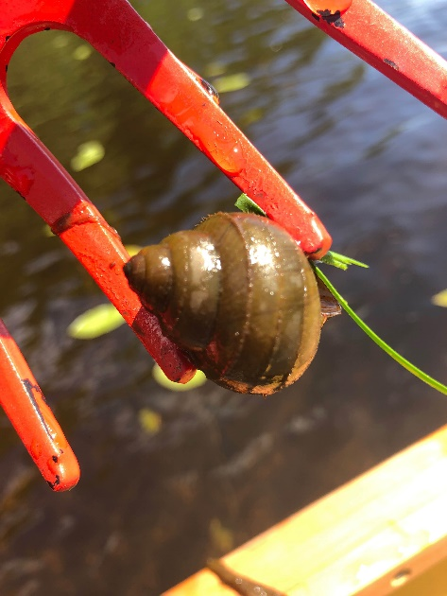

Map:

Develop a map of the survey area that has any iMapInvasives points and searched polygons included to clearly define infestation extent. Multiple maps may be added for multiple species or locations.

Butler Pond Impoundment Warren County NY 43.35031 °-73.72773 °
Van Dusen Preserve West Mountain Rd Queensbury, NY 12804
Butter Pond Reservoir 43.37139 ° -73.7357 °

Lake Desolation Saratoga County NY 43.13805° -73.97105°
Archer Fly Saratoga County 43.1575 °-73.96273 °

Section 2: Survey Result Summary

No Major Tier 1-4 Detections of Concern

Section 3: Summary of Recommendations
This page provides recommendations of any treatment methods, monitoring methods, and restoration efforts based on the survey.

Treatment: Describe briefly any recommendations for future treatment methods, why they are recommended, and any alternatives to consider. Please use abundance and site-specific factors in your treatment recommendation. Optional: Attach or reference BMP guidance document
None at this time
- Continue to monitor and develop sites for the future as posted on the front of the report.
- Survey ecologically important areas connected to the waterbodies with significant ecological value.

Basic Fact Sheet

Post- Survey Monitoring: Briefly explain the monitoring procedure, when it will occur, and who will complete it. Consider the phenology of species when suggesting time-lines. If a separate management or monitoring plan was developed or to be completed, attach or describe here.

The lakes should be monitored relatively often on an annual basis as they are relatively AIS free.

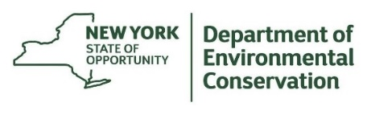
The New York State Department of Environmental Conservation provides financial support to The Capital Region PRISM via the Environmental Protection Fund

