Capital Region PRISM AIS Survey Report

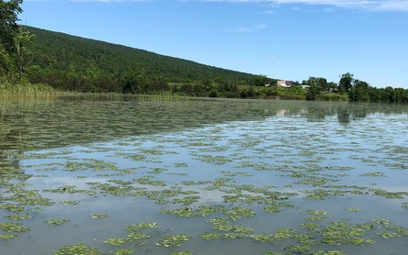
Date: September 4th 2020
Site Name: Fish Creek
Site Size: Saratoga to Stafford Bridge 2.7 miles one way
GPS Location:43.040263 -73.732050
Physical Address: Kayak Shak 251 County Road 67
County: Saratoga
Town: Saratoga Springs NY 12866

Property Owner Contact: unknown
Other: https://slpid.org/local-businesses/

Survey Leader: Kristopher Williams PRISM Coordinator
Lauren Henderson Aquatics Coordinator
Phone: 518.321.0189
Email: kbw44@cornell.edu ljh257@cornell.edu
iMapInvasives User ID:9274

Summary

On September 4th the Capital Region PRISM conducted a Water Chestnut (Trapa natans) assessment on Fish Creek between Saratoga and Stafford’s Bridge(s). The 2.7 mile traverse holds seven monocultures of water chestnut varying in size from 0.15 to 1.1 acres in size totaling 4.14 acres. European Frogbit (Hydrocharis morsus-ranae) is also present between the two bridges with trace to sparse populations along the shoreline. A dense patch is found near the Skidmore College Boat Garage.

Aquatic Invasive Species Present of Concern

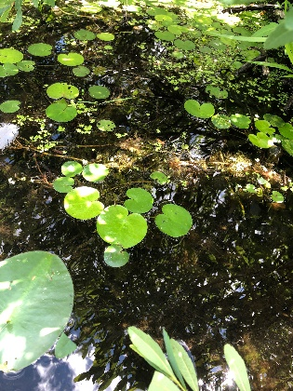
- European Frogbit (Hydrocharis morsus-ranae) is a very high threat species with a NEW YORK NON-NATIVE PLANT INVASIVENESS RANKING of 85. Found in trace to sparse populations between Saratoga and Stafford Bridges. The plant is free floating and observed in the shorelines. http://nyis.info/wp-content/uploads/2018/01/c6668_Hydrocharis-morsus-ranae.NYS_.pdf

- Water Chestnut (Trapa natans) is a very high threat species with a NEW YORK NON-NATIVE PLANT INVASIVENESS RANKING of 82. http://nyis.info/wp-content/uploads/2018/01/61a2d_Trapa-natans-NYS.pdf General Species Information http://nyis.info/invasive_species/water-chestnut/

Site Description:

Fish Creek flows east out of Saratoga Lake for 13 miles to Schuylerville, where it empties into the Hudson River. There is a small dam east of Bryant’s Bridge Rd that controls the level of the lake and creek. Motorboat traffic is heavy on the weekends, but is mostly concentrated on Saratoga Lake. The best put in for kayakers and canoeists is off of Stafford’s Bridge Rd at the Kayak Shak, which is part of Saratoga Outdoor Center.

iMapInvasives Prioritization Model:
(https://www.arcgis.com/home/webmap/viewer.html?webmap=57d30ff9bff7426c8950d90b0ba43bba&extent=-81.0352,39.2503,-70.2686,45.8067)

The area surrounding Fish Creek and Saratoga Lake is ranked moderately low on the prioritization model comprehensive score attribute with a weak coloring on the heat map.

Does this site contain previously treated infestations?
- No

Survey Techniques:
- Visual Inspection of Surface and Subsurface

Map:

http://fishing-app.gpsnauticalcharts.com/i-boating-fishing-web-app/fishing-marine-charts-navigation.html?title=Tomhannock+Reservoir+boating+app#11.29/43.0351/-73.6675

Section 2: Potential Treatment Species

Common Name | Scientific Name | Location (GPS) | Growth Type | Phenology | Abundance
European Frogbit; Common | Hydrocharis morsus-ranae | 43.07461 °  -73.69647 ° | Floating | Annual | Dense
Water Chestnut | Trapa natans | Note Seven Polygons | Surface/Rooted | In seed | Monoculture(s)

Areas of Concern:
The Presence polygons in red where dense abundance of European Frogbit, (Hydrocharis morsus-ranae) is observed for removal. There are trace to sparse populations running on the shore line of Fish Creek between the two bridges.
Polygon 1 iMap Invasives Searched Area Record ID: 1086029

iMap Invasives Presence Record Id 1069534
Location: 43.07461 °-73.69647 °
Area: (.1 Acre)

The Presence polygons in green where dense mats of Water Chestnut (Trapa natans) is observed for possible removal. There are also trace to sparse populations running on the shore line of Fish Creek between the two bridges.
Polygon 2 iMap Invasives Presence Record ID #1069183
Location: 43.08198 °-73.68512 °
Area: 3323 m² (0.8 Acre)

Polygon 3 iMap Invasives Presence Record ID #1069184
Location: 43.08198 °-73.68512 °
Area: 3323 m² (0.8 Acre)

Polygon 4 iMap Invasives Presence Record ID #1069185
Location: 43.08641 °-73.67787 °
Area: 575 m² (0.15 Acre)

Polygon 5 iMap Invasives Presence Record ID #1069186
Location: 43.08968 °-73.67413 °
Area: 721m² (0.18 Acre)

Polygon 6 iMap Invasives Presence Record ID #1069209
Location: 43.09196 °-73.66655 °
Area: 3240m² (0.8 Acre)

Polygon 7 iMap Invasives Presence Record ID #1069201
Location: 43.0918 °-73.66597 °
Area: 1259m² (0.31 Acre)

Polygon 8 iMap Invasives Presence Record ID #10691210
Location: 43.0913 °-73.66419 °
Area: 4559m² (1.1 Acre)

Section 3: Summary of Recommendations

Treatment:

A working group should convene to determine the prioritization level of conducting a pull on Fish Creek weighing the ecological, economic, and cultural impact of such an action.

Integrated Pest Management Results:
- https://www.ipmdat.org/

Manual and Mechanical Harvesting
- Water chestnut overwinters entirely by seeds that may remain viable in the sediment for up to 12 years, repeated annual control is critical to deplete the seed bank. Treatment generally is needed for five to twelve years. A calendar for treatment should be adhered to for successful removal. The best time for coordinating a pull is in August.

- Newly introduced populations of T. natans. Early detection of introductions and a rapid control response are key to preventing high-impact infestations. Because T. natans is an annual plant, effective control can be achieved if seed formation is prevented. Small populations can be controlled by hand pulling working from canoes or kayaks. As such the Fish Creek populations maybe too large for a complete removal by hand.

- A combination of Manual and Mechanical Harvesting maybe the best approach. A shallow water harvester would be most feasible.

- The Capital Region PRISM Recommends collaborating with local business to recruit volunteers for future removals. Removal Estimation
4 person crew
Tenth Acre; 32 bags estimated 2400 pounds of water chestnut de-watered 10 hours
Acre; 320 bags 24,000 pounds of water chestnut de-watered 30 hours

- Disposal of material would be best if aloud to decompose on site and then buried on preserve property. Location and modes of transportation need to be determined.

Basic Primer(s) on Water Chestnut and Common Frogbit
  - https://www.dec.ny.gov/docs/lands_forests_pdf/aiswatercfs.pdf
  - http://nyis.info/invasive_species/water-chestnut/
  - https://seagrant.sunysb.edu/ais/pdfs/WaterChestnutFactsheet.pdf
  - https://www.adkwatershed.org/files/frog-bitfactsheet_sea_grant_0.pdf
  - https://www.michigan.gov/invasives/0,5664,7-324-68002_71240_73848-364817--,00.html

Post- Survey Monitoring:

The Capital Region PRISM will continue to monitor the infestation(s) of Water Chestnut (Trapa natans) on a triannual cycle and delineate their size using collector polygons. The PRISM will also monitor for other AIS like European Frogbit, (Hydrocharis morsus-ranae)

Will post-treatment management be handled by another person/entity?
- No

Will an Invasive Species Management Plan be created?
- Not at this time until an action is determined.

The New York State Department of Environmental Conservation provides financial support to The Capital Region PRISM via the Environmental Protection Fund

