Capital Region PRISM Treatment Report

Site Information
Date: June 22nd, 2020
Site Name & Address: Beaver Pond, Fiver Rivers Environmental Center, 56 Game Farm Road, Delmar, NY
Property Owner: NYS DEC
Latitude: 42.6069869 Longitude: -73.8900783
Project Leader: SCA Interns and Anik Gibeau Email: anik.gibeau@dec.ny.gov
Team Members: Lauren Mercier, Katy, Isabelle, Garrett, Anik
iMapInvasives User ID: 10563

Project Information

Target Species: Water Chestnut (Trapa natans)
First year of treatment? Unknown
Size of infestation: Scattered across entire pond, 2.30 acres
Treatment Method (please be specific): Hand pull on kayak

% Completed: 40%, .86 acres
Amount removed (# bags, # plants, # mature, # seedlings): 1.5 bins (waiting on size from Anik)
Time spent on removal: 6 hours
Is follow-up needed? Yes, SCA Interns will be going out every week
Were treatments uploaded to iMapInvasives? No

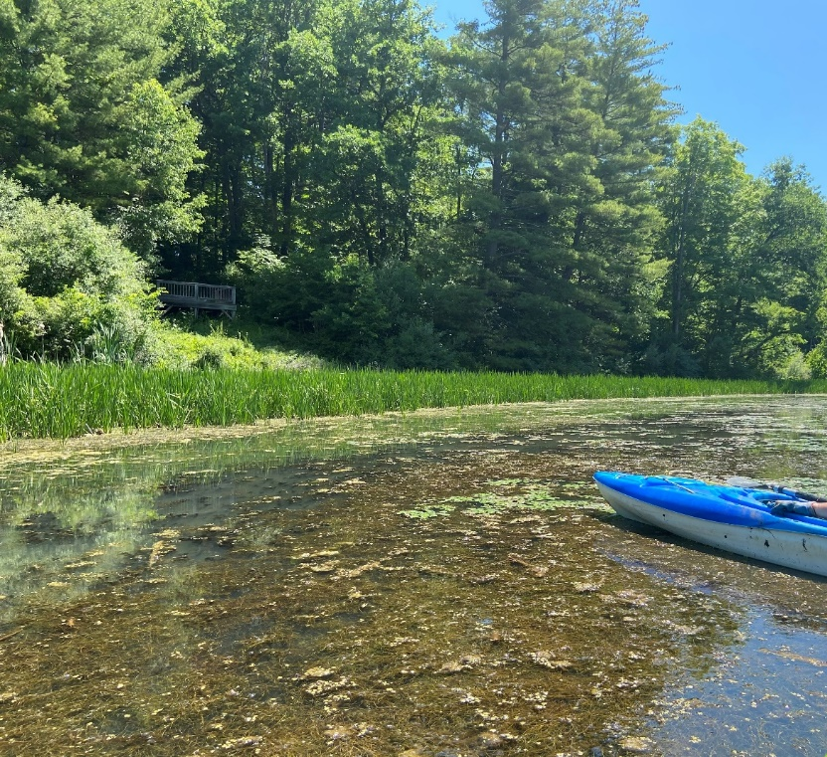
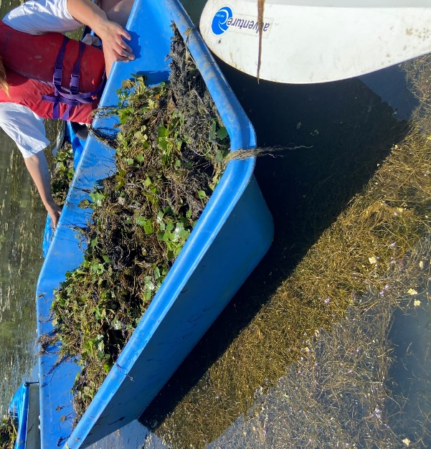
Photos and maps of the project:

