Capital Region PRISM AIS Survey and Treatment Report
Weaver Lake / Young Lake
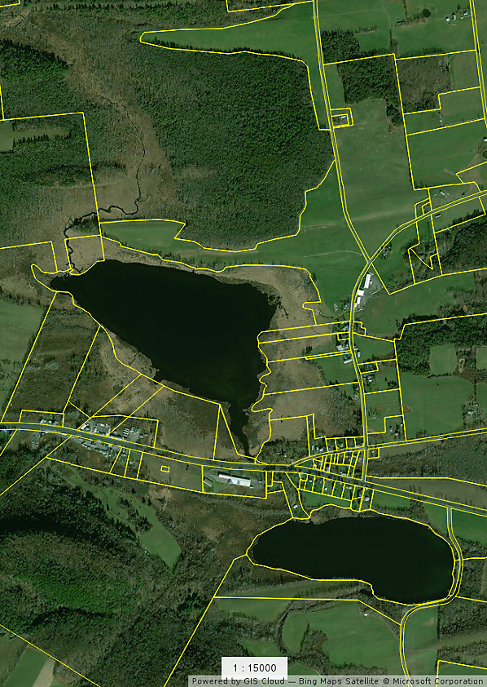
Date: June 25th and 29th 2020
Site Name: Weaver Lake
- DEC hand launch in the Town of Warren, off NYS Route 20.
- https://www.dec.ny.gov/outdoor/88103.html
Site Size: 100 acre(s)
Shore Line: 1.9 miles
Max and Mean Depth: 11/7.1 Feet
GPS Location of Site/Parking Lot: 42.8479 -74.9276
County: Herkimer
Town: Warren
Property Owner Contact(s): NYS DEC Tax Id 144.1-1-6

Survey Leader: Kristopher Williams and Lauren Henderson
Phone: 518.321.0189
Email: kbw44@cornell.edu/ljh257@cornell.edu
iMapInvasives User ID: 9274

Jeff O'Handley Program Director
Otsego County Conservation Association
607.282.4087 - www.occainfo.org

Site and Work Summary

On June 25th and 29th 2020 the Capital Region PRISM conducted a Survey and Treatment of European Frogbit (Hydrocharis morsus-ranae) at Weaver Lake in Herkimer County off route 20 in the Town of Warren. The shallow geomorphology of Weaver Lake is an ideal site for the proliferation of European Frog-bit and a source for contaminating water bodies to the south like Young Lake and Otsego Lake via Cripple Creek. Maumee Swamp is located north and could also contain the suspected aquatic invasive species. The swamp is not accessible and alternative methods like a drone or private access by land should be used to survey the location. The flow of water from the southern outlet of Weaver Lake is impeded by a beaver dam.

An IPMDAT report run by the PRISM late in the Fall of 2019 recommended containment of the Frog-Bit. A small team was assembled to clear the outlet of Weaver Lake from European Frog-Bit to slow the spread. On June 25th and 29th a small team from the Capital Region PRISM and Jeff O’Handly participated in a pull and conducted a more thorough assessment of plants presence in the lake. A full survey was not conducted on Young Lake on these dates, but the presence of frog-bit was observed from the shoreline in significantly lower quantities. The lake will also be surveyed by Adirondack Research and a report will be available at the end of the season; Ezra Schwartzberg is the main contact ezra@adkres.org

Aquatic Invasive Species Infestation

- European Frogbit (Hydrocharis morsus-ranae) is found in dense mats spread across the perimeter of the lake. The greatest abundancy is found in the first 1.5 meters of the shore line surrounding the entire lake. The European Frog-bit decreases in abundancy out from the perimeter of the lake by 10-15 meters from the shore. The Frogbit is found throughout the lake and is thriving under and near other aquatic plants like White Water-lily (Nymphaea odorata ssp. odorata) The shore is mostly a marsh and impassible by foot. The Frogbit is in too great a volume to be manually controlled by hand. The process of hand pulling for success with such a large infestation in a shallow lake with a marsh habitat is not feasible at this time. Very High Threat Ranking - Frogbit New York Non-Native Plant Invasive Ranking Form
- Eurasian water-milfoil (Myriophyllum spicatum L.) is found throughout the majority of lake in dense mats. -Very High Threat Ranking - Eurasian water-milfoil New York Non-Native Plant Invasive Ranking Form

- Curly-leaved pondweed; Potamogeton crispus is emerging in the lake with a several dense but small infestations. High Threat Ranking - Curly-leaved pondweed New York Non-Native Plant Invasive Ranking Form
Weaver Lake is severely fouled by AIS and provides for a good example of what can occur when waterbodies are left unmonitored and unmanaged.

Survey Techniques:
- Visual Inspection of Surface and Subsurface - the water is clear and shallow.

iMapInvasives Prioritization Model:

The area is ranked moderately high for ecological significance with a high comprehensive score as indicated on the New York State Natural Heritage prioritization model. The attribute scores are indicated by fairly dark colorization on the heat map linked below.
- https://www.arcgis.com/home/webmap/viewer.html?webmap=57d30ff9bff7426c8950d90b0ba43bba&extent=-81.0352,39.2503,-70.2686,45.8067

Does this site contain previously treated infestations? If yes- What species? NO.

Map:

Develop a map of the survey area that has any iMapInvasives points and searched polygons included to clearly define infestation extent. Multiple maps may be added for multiple species or locations.

Survey Area Presence Points
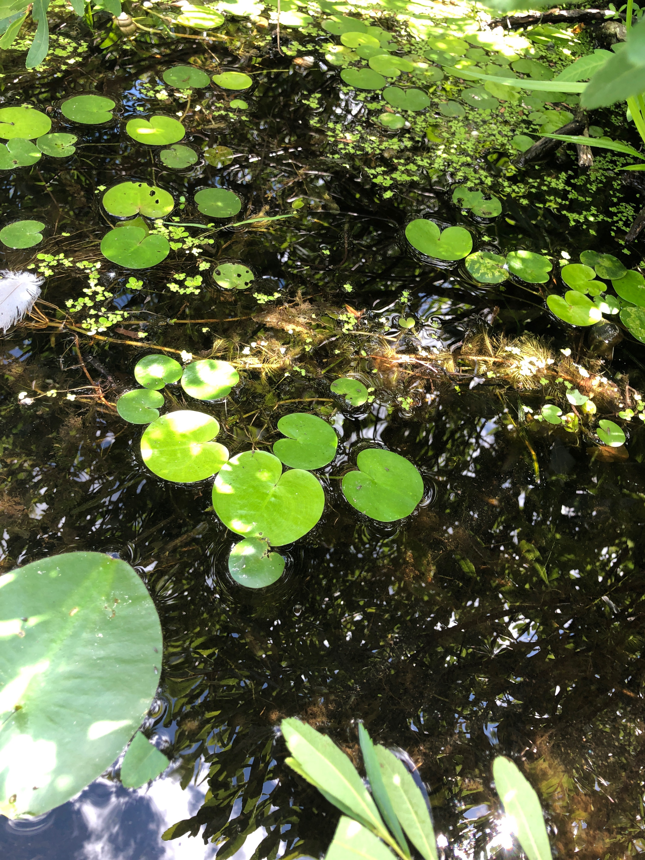

European Frogbit (Hydrocharis morsus-ranae) Weaver Lake NY

Weaver and Young Lake Herkimer NY European Frog-bit (Hydrocharis morsus-ranae)

Section 2: Survey Result Summary

Common Name | Scientific Name | Location (GPS) | Growth Type | Phenology | Abundance
Eurasian Water-milfoil; European Water-milfoil | Myriophyllum spicatum | Use presence record below | Submerged/Rooted | Emergent Growth | Wide spread Dense Mats
Curly Pondweed; Curly-leaved Pondweed | Potamogeton crispus | Use presence record below | Submerged/Rooted | Past Growth | Dense Clusters
European Frog-Bit | Hydrocharis morsus-ranae) | Use presence record below | Free Floating | Emergent Growth | Dense Shore Line and open water infestation
Estimated Treatment Polygon Drawn in iMap Invasives for European Frogbit (Hydrocharis morsus-ranae)

- iMap Invasive Treatment Record #18441
Search Area #1072582*

- iMap Invasive Search Area Record #1072583*
Presence Record #1056625

Section 3: Summary of Recommendations
This page provides recommendations of any treatment methods, monitoring methods, and restoration efforts based on the survey.

Treatment: Describe briefly any recommendations for future treatment methods, why they are recommended, and any alternatives to consider. Please use abundance and site-specific factors in your treatment recommendation. Optional: Attach or reference BMP guidance document
Basic Fact Sheet https://seagrant.sunysb.edu/ais/pdfs/Frog-bitFactsheet.pdf

Control: Recommendation for Chemical Control.

Consideration of EFB’s distribution in wetlands, lakes, canals and other waterbodies is crucial when developing a management plan. European frog-bit can become increasingly difficult to manage once it is established throughout the major wetland vegetation zones (Halpern 2017). Dense mats in the floating vegetation zone are often the target of management actions; however, turions and free-floating plants can reestablish from the emergent and submerged vegetation zones, respectively. Free-floating plants in the submerged vegetation zone are likely to disperse to new areas through wind, waves, and current and should therefore be considered a management priority (Halpern 2017). A coordinated management strategy that targets EFB in the emergent, floating, and submerged vegetation zones simultaneously may be required to reduce EFB’s reestablishment and dispersal potential.
- https://www.michigan.gov/documents/deq/wrd-ais-hcharis-morsus-ranae_499883_7.pdf
- Halpern AD (2017) Hydrocharis morsus-ranae L. in the Upper St. Lawrence River in New York:

Post- Survey Monitoring: Briefly explain the monitoring procedure, when it will occur, and who will complete it. Consider the phenology of species when suggesting time-lines. If a separate management or monitoring plan was developed or to be completed, attach or describe here.
Will post-treatment management be handled by another person/entity? Not Applicable at this time.
If yes- please provide the contact information:

Will an Invasive Species Management Plan be created? Not Applicable at this time.

The New York State Department of Environmental Conservation provides financial support to The Capital Region PRISM via the Environmental Protection Fund

