Monitoring and Treatment: Japanese Stiltgrass (Microstegium vimineum) Daniels Road State Forest

Date: 9.05.19

Address: (129) Daniels Road Assess is a shared right away. There are two parallel drive ways. Access is on the right which
passes an old garage with a gas pump outside. An old preexisting but now closed access point exist at the corner of Clinton Road and Daniels Road.

County: Saratoga

Latitude and Longitude: 43.11096 °-73.78818 °

WebSite: https://www.dec.ny.gov/lands/104708.html

Lead Contact for Project: Kristopher Williams CMP Coordinator

Site Owner Contact Information:

- DEC Region 5 Warrensburg Office: (518) 897-1200. State Forester McDermott, Rich (DEC) rich.mcdermott@dec.ny.gov

- Warren Visha owns the access road to the left when turning into the property. Warren and his wife have been receptive to work done by the Capital Mohawk PRISM regarding invasive removals.

Treatment Description:

The 523-acre Daniels Road State Forest is an Ecologically Significant Forest Community. The presence of wetland and mixed hardwood forest are characteristic features of the property. The Saratoga Mountain Bike Association (SMBA) maintains an extensive trail system throughout the state forest. The goal of the treatment was to contain the spread of the Japanese Stiltgrass by suppressing the plant from going into seed. The area treated included the parking lot and a .25 of road way access entering the parking area. Signs were posted alerting the public of the presence of the JSG. At two kiosks.

The presence of Japanese Stiltgrass (JSG) was found at the monitoring site in 2018. Note the IMap Invasive presence and treatment area record below. The JSG in this location has become entrenched around the perimeter of the parking area and access road. The JSG has not appeared to have entered the forest at this time. An expansive survey will be conducted in 2020 of the entire forest. The Stiltgrass is found along the roadside edges and decreases in abundance and or density as you transect away from the road and other related highly probable areas. The seeded vegetation from the Stiltgrass follows the disturbance of soil from vehicle traffic in pull-off ruts and puddles.

The Japanese Stiltgrass may have been unintentionally introduce in unclean gravel/crusher run used to improve road access and parking lot to the entrance of the forest. The presence of Japanese Stiltgrass at this location is the third known occurrence of this invasive in the Capital Mohawk PRISM where gravel was brought in for access road improvement.

Invasive Species Monitored and Treated:
Common Name | Scientific Name | Locations (GPS) | Growth Type | Phenology | Distribution/ Abundance
Japanese Stiltgrass | Microstegium vimineum | 43.11096 °-73.78818 ° | Grass | Vegetative not in seed(9.5.19) | Detected and Suppressed/Contained

iMap Invasive Searched Area Record: #1046261 iMap Invasive Treatment Record: #16968
Recommendations for the Future:
- The JSG is an annual and there is a possibility for eradication from the site.
- Monitoring and treatments will be expanded through 2020-2023 each time checking for feasibility of management. Additional treatment may be applied late in the fall of 2019.
- The current infestation should be suppressed over two days with a team of 4-6 people using mechanical methods. More research is needed on best management practices in containing the JSG.
- Saratoga Mountain Bike should be notified and included in educational meeting and volunteer work to help support suppression and containment efforts.
- The private property surrounding the access road should be surveyed and treated otherwise containment may be impossible. The JSG is found on the adjacent landing zone for logging.
- The legislature needs to pass a law for fill to be certified clean when used in ecologically sensitive areas.
Identification Notes:
Japanese stiltgrass (Microstegium vimineum), also called Nepalese browntop, is an aggressive invader of forest lands throughout the eastern United States. Infestations can impact the diversity of native species, reduce wildlife habitat, and disrupt important ecosystem functions. Stiltgrass is considered one of the most damaging invasive plant species in the United States. Infestations spread rapidly and the seed can remain viable in the soil for up to five years.
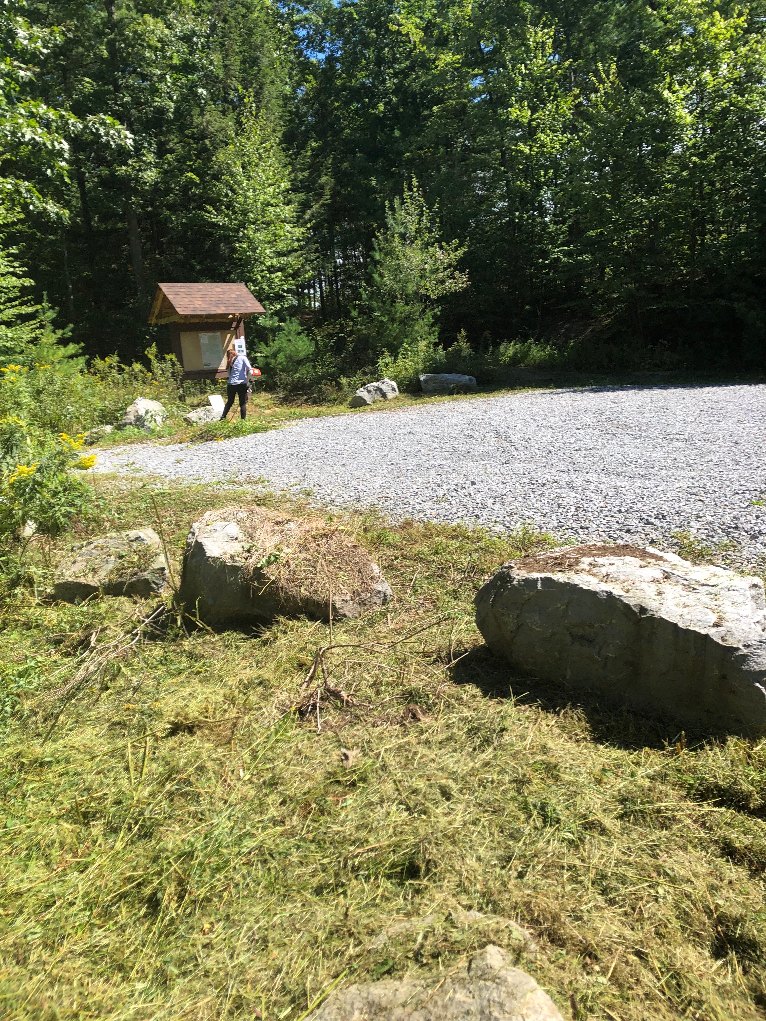
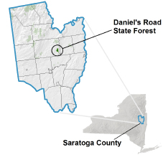
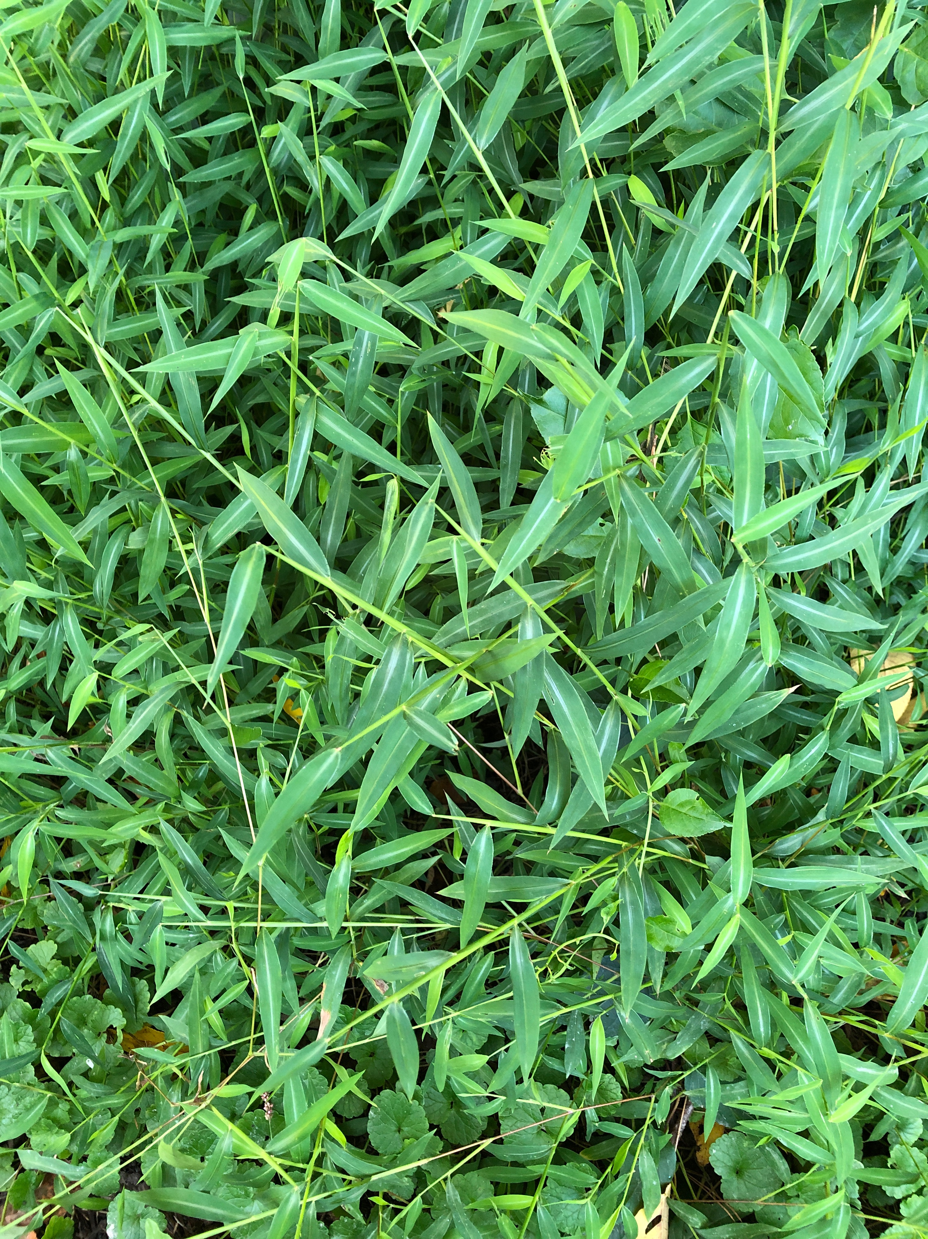

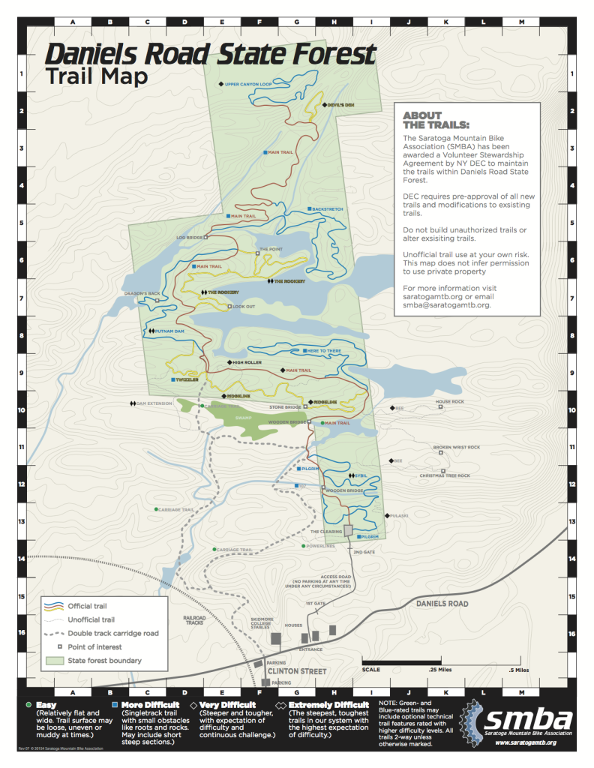

The New York State Department of Environmental Conservation provides financial
support to The Capital Mohawk PRISM via the Environmental Protection Fund.

