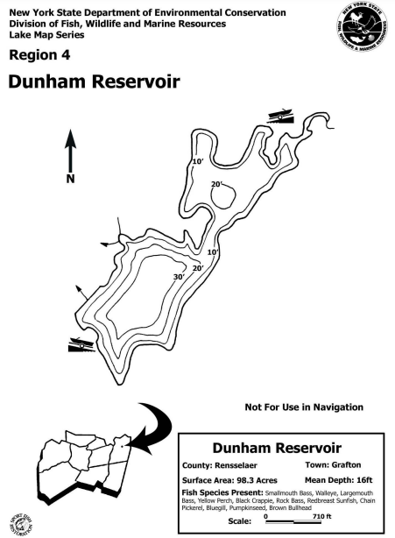
Capital Region PRISM AIS Survey Report
Date(s): August, 8th 2022
Site Name: Dunham Reservoir
Site Size: 98.8 acres
Waterbody Perimeter: 3.8 miles
Mean Depth: 16 feet

GPS Location: 42.750294, -73.483515
Physical Address: 213-19 Dunham Reservoir Rd, Cropseyville, NY 12052
Town: Cropseyville
County: Rensselaer

Property Owner Contact: Grafton Lakes State Park
Primary Contact: NYS OPRHP | (518) 279-1155 | graftonlakesadmin@parks.ny.gov
Secondary Contact:

Survey Leader: Pamela Aprilliano (AIS Watercraft Steward Supervisor)
Phone: (518) 885-8995
Team Members: Kristin Ching (AIS Watercraft Steward)
iMapInvasives User ID: 8406

Section 1: Survey Summary
On August 8th, 2022 the Capital Region PRISM conducted an aquatic survey on the west section of Dunham Reservoir located in Rensselaer County. The survey focused on early detection of Tier 1 and 2 aquatic invasive species. Upon completion of the macrophyte survey, it was confirmed that there continues to be no aquatic invasive species present in Dunham Reservoir.

Site Description
Dunham Reservoir is a 98.8-acre waterbody located in Cropseyville, NY. The waterbody substrate is rock, sand, and muck with a bottom cover of macrophytes.
Dunham Reservoir is a public waterbody that is within the Grafton Lakes State Park. There is a small trailer launch located at the southwest corner of the waterbody off of Dunham Reservoir Rd. There is also a small hand launch located at the northeast end of the waterbody along Johnson Rd.
According to the DEC website, only electric motors are allowed on the reservoir.

Survey Techniques
Partial waterbody, top water
- Top-side (visual)
- Rake toss

NYS Invasive Species Prioritization Model
Dunham Reservoir is located within Grafton Lakes State Park, which has a high to very high comprehensive score on the NYS Invasive Species Prioritization Model. Locations with higher comprehensive scores have high ecological significance, a high risk of spread of invasives into the area, and high value according to their protected status. Early detection is important in these locations to ensure timely management of new infestations if detected.
NYS Invasive Species Prioritization Model

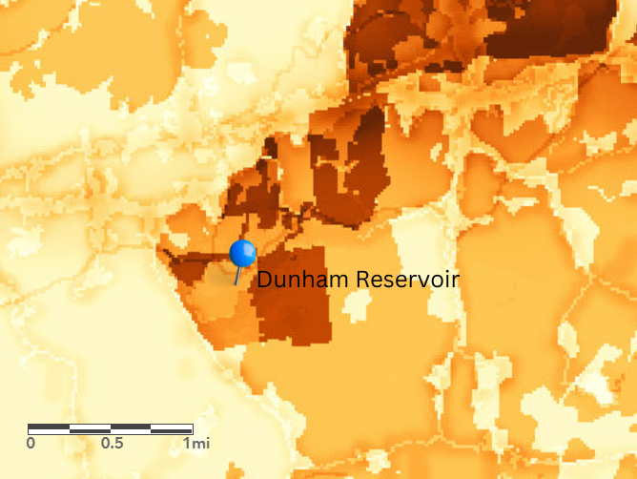

Does this site contain previously treated infestations?
No

Section 2: Survey Result Summary

Aquatic Invasive Species Presence
No aquatic invasive species present based on partial survey

Native Species Presence
- Arrow Arum (Peltranda sp.)
- Watershield (Brasenia schreberi)
- Robbin’s pondweed (Potamogeton robbinsii)
- Native Bladderwort (Utricularia sp.)
- Ribbon Pondweed (Potamogeton epihydrus)
- Spatterdock (Nuphar variegate)
- Bur-reed (Spargnium sp.)
- Muskgrass (Chara vulgaris)

Map

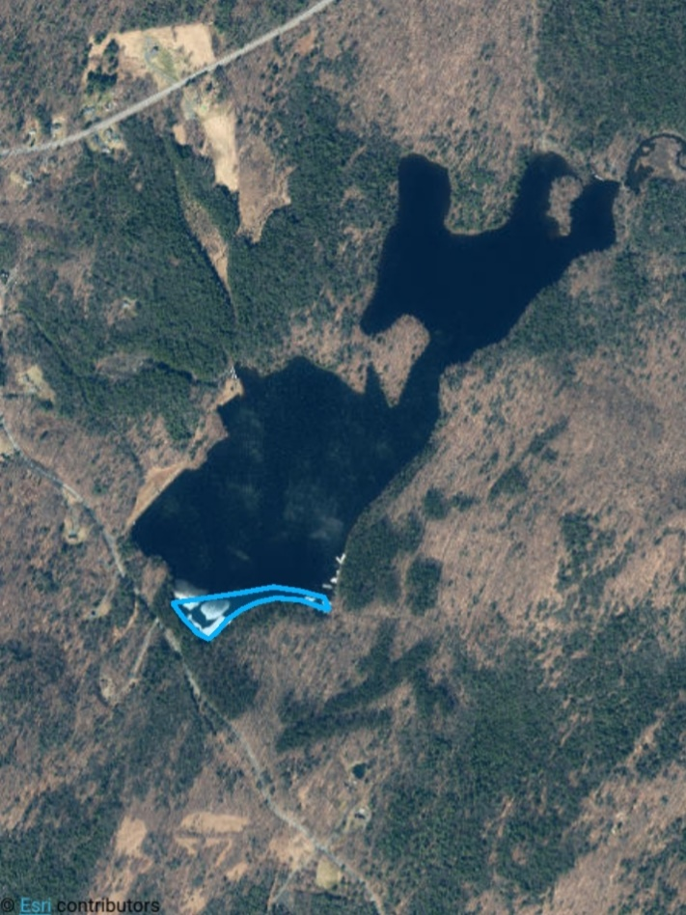

Section 3: Summary of Recommendations

Prevention
Prevention efforts are recommended to reduce the chance of new aquatic invasive species introductions into Dunham Reservoir. Restricted access for boaters (electric motors only) helps prevent unwanted species being introduced through reduction of visitors.
- Ensuring clean, drain, dry practices are being followed when transporting watercraft from one waterbody to another is also recommended.
- Identifying and reporting any suspected aquatic invasive species is encouraged to ensure early detection.

Management
No Management needed at this time

Post-Survey Monitoring
Dunham Reservoir is considered a Priority Waterbody in the Capital Region PRISM and will be surveyed on a biannual basis.

Will an Invasive Species Management Plan be created?
- Not at this time.

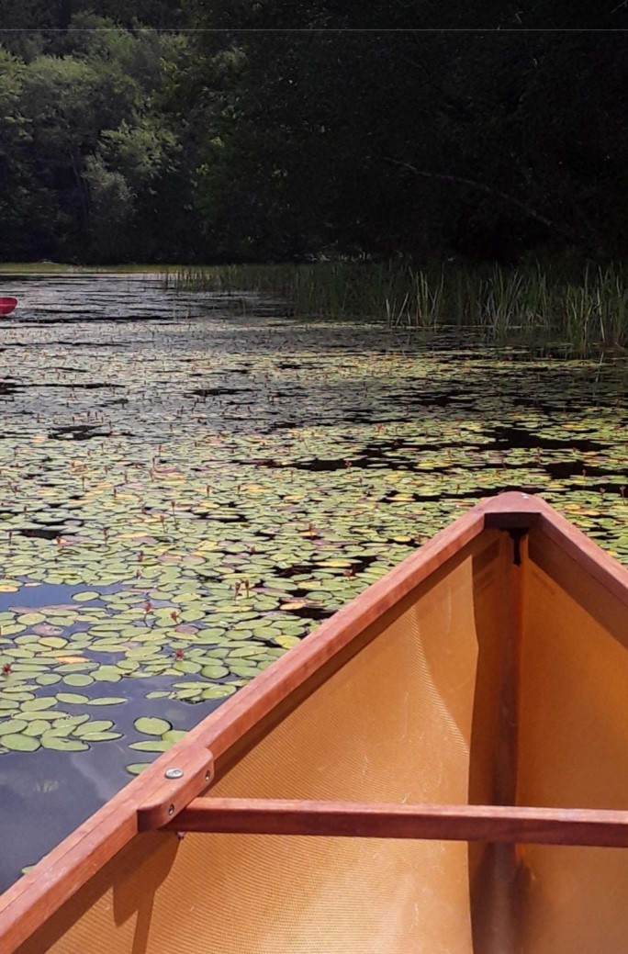
Photos

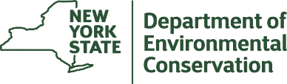
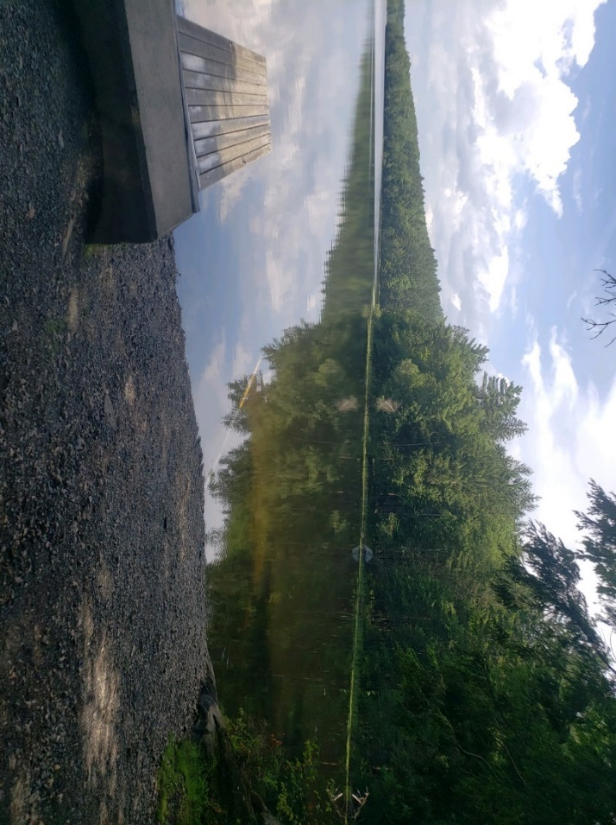
The New York State Department of Environmental Conservation provides financial support to The Capital Region PRISM via the Environmental Protection Fund.

