Eurasian Watermilfoil Scouting on Lake Myosotis (2019)
Gwendolyn Temple
Introduction: This survey was performed at the request of Anne Rhoads, the Executive Director of The Edmund Niles Huyck Preserve. Eurasian watermilfoil was only recently seen this past year in small numbers and a more accurate assessment of its population size and location was warranted. This species is classified as Tier 2 (eradication) within the preserve.

Type of Work Performed: Kayak survey

Date: August 27, 2019

Address: 5052 Delaware Turnpike, Rensselaerville, NY 12147
County: Albany
Latitude and Longitude: 42.518588; -74.148911
Website: https://www.huyckpreserve.org/

Lead Contact Information for Project: Gwendolyn Temple, ggt25@cornell.edu and Lindsay Charlop, lindsaycharlop@gmail.com

Project Description: Huyck Preserve is a relatively uninvaded location in terms of aquatic invasive species. Before the discovery of Eurasian watermilfoil this year, water chestnut was the only aquatic species of concern. When Eurasian watermilfoil was found this year at the preserve, Anne reached out to Capital Mohawk PRISM to help identify emergent populations of the species within Lake Myosotis. Only a handful of standalone plants were found and management occurred shortly after the completion of a full lake survey.

Invasive Species Present at Lake Myosotis:
Common Name | Scientific Name | Locations (GPS) | Growth Type | Phenology | Distribution/ Abundance
Purple loosestrife | Lythrum salicaria | 42.5203; -74.1466 | Wetland terrestrial species | Perennial | Scattered along the shoreline
Eurasian Watermilfoil | Myriophyllum spicatum | 42.5190; -74.1473 | Submerged aquatic plant | Perennial | Patchy, with a lack of native vegetation in the area surrounding the species

Capital Mohawk PRISM Strongly Recommends Uploading Points into https://www.imapinvasives.org/
Native Community Types: Freshwater Lake
Dominant Native Plants Present: N/A
Summary of Work Completed:
  - Survey completed of Lake Myosotis to determine population abundance
  - Scoped out area to identify other invasive aquatic vegetation
Recommendations for the Future: Resurvey Lake Myosotis next year to determine whether management of the species was successful. Subsequent hand-harvesting of the species in years following should help reduce populations of EWM and eventually lead to full eradication. Signs should be placed at the launching shore of Lake Myosotis with information on the species as well as clear messaging about cleaning, draining, and drying any and all equipment before entering and retrieving from the lake.

Figure 1: Consistent turbidity on Lake Myosotis makes the removal of Eurasian watermilfoil difficult.
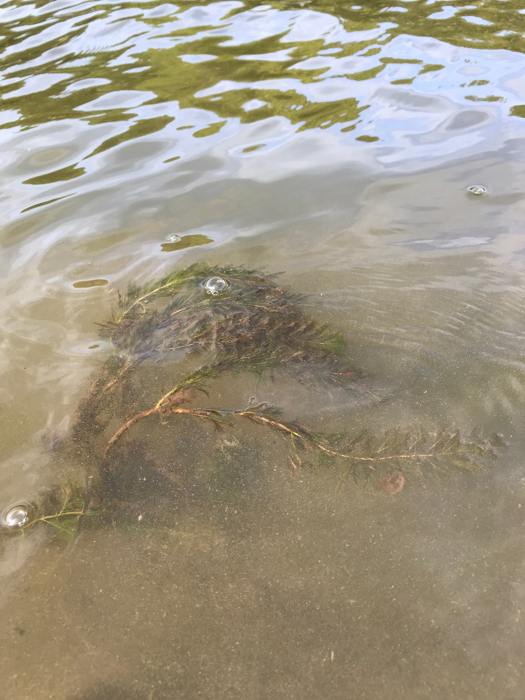
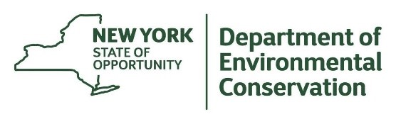
The New York State Department of Environmental Conservation provides financial
support to The Capital Mohawk PRISM via the Environmental Protection Fund.

