European Frog-bit Scouting on Cripple Creek, Weaver Lake (2019)
Gwendolyn Temple
Introduction: This survey was performed as a response to the Department of Environmental Conservation looking for samples of European frog-bit, an emerging invasive within the Capital Mohawk region. Prior to Gwendolyn starting her position as the Aquatic Invasive Species Coordinator, the former AIS Coordinator began development of a removal project on Weaver Lake to restrict the spread of the aquatic invasive. As such, this location has been the subject of interest to a number of organizations, including Otsego County Conservation Association and SUNY Oneonta.

Type of Work Performed: Shoreline survey

Date: July 25, 2019

Address: Weaver Lake Fishing Access Site, 144 Richfield Springs, NY 13439
County: Herkimer
Latitude and Longitude: 42.848077, -74.927412

Lead Contact Information for Project: Gwendolyn Temple, ggt25@cornell.edu

Project Description: During preliminary surveying at the Weaver Lake Fishing Access site off Cripple Creek which leads into Weaver Lake and Young Lake respectively, extensive populations of European frogbit were found along the shoreline. Cripple Creek appears to be dammed with detritus at the end leading toward Young Lake, likely from beaver activity. As such, more surveying will be performed on Young Lake to see if the frogbit has invaded that waterbody as well. Without a kayak, there is no way to identify the extent of the frogbit invasion within Weaver Lake, through population sizes on the shoreline of Cripple Creek suggest that it may be along the shoreline of the lake as well.

Invasive Species Present at Cripple Creek:
Common Name | Scientific Name | Locations (GPS) | Growth Type | Phenology | Distribution/ Abundance
European frogbit | Hydrocharis morsus ranae | 42.8478; -74.9254 | Free-floating aquatic plant | Annual | Extensive along the shoreline
Purple loosestrife | Lythrum salicaria | 42.8478; -74.9255 | Wetland terrestrial species | Perennial | Scattered along the shoreline
Eurasian Watermilfoil | Myriophyllum spicatum | 42.8478; -74.9254 | Submerged aquatic plant | Perennial | Interspersed amongst native species

Capital Mohawk PRISM Strongly Recommends Uploading Points into https://www.imapinvasives.org/
Native Community Types: Wetland
Dominant Native Plants Present: Native pondweeds and lilies
Summary of Work Completed:
  - Survey completed at shoreline of Cripple Creek leading into Weaver Lake
  - Scoped out area to determine extent of European frog-bit population
Recommendations for the Future: Return to the site to fully determine the extent of the European frog-bit invasion.
Figure 1. Photo of European frog-bit along the shore of Cripple Creek. Eurasian watermilfoil can be seen interspersed amongst the frog-bit.
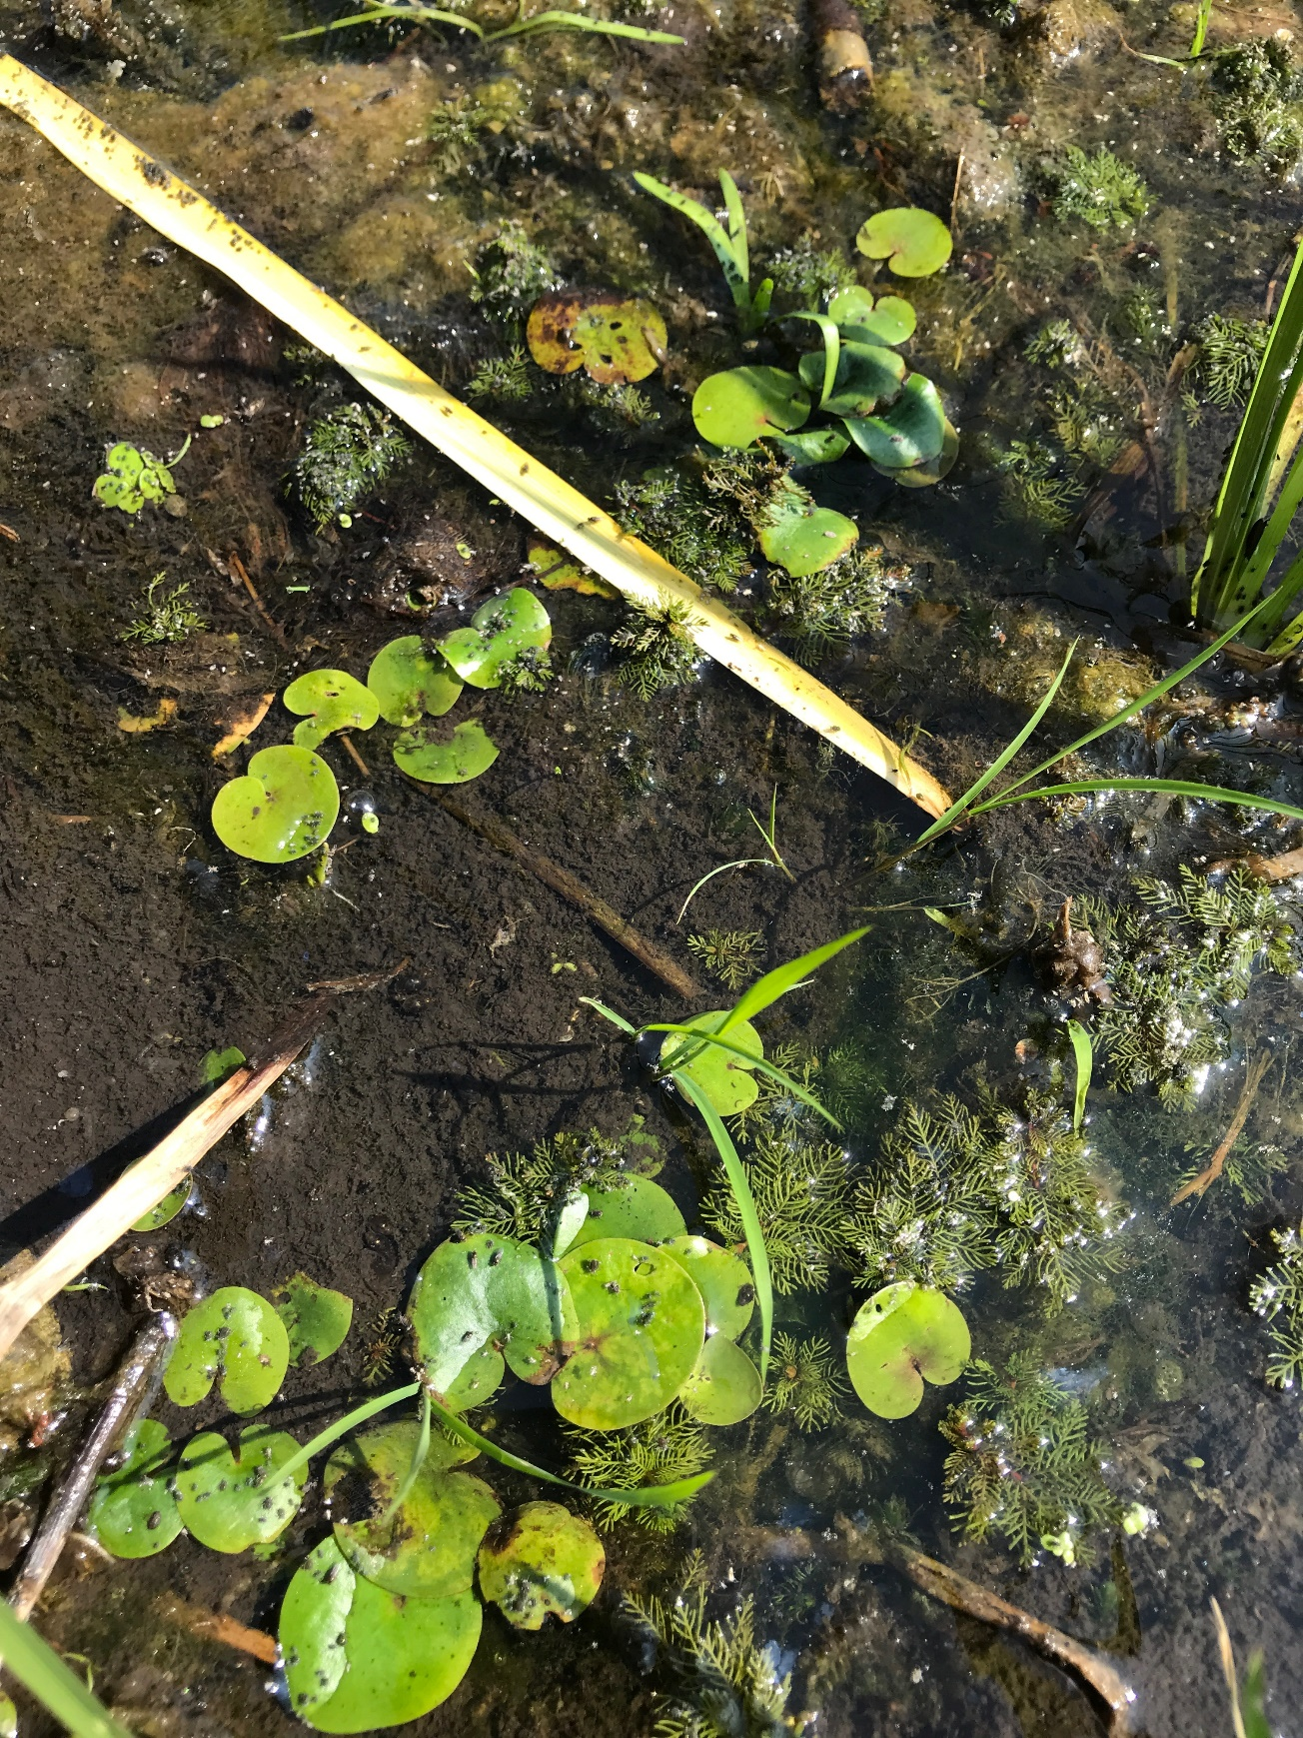
The New York State Department of Environmental Conservation provides financial
support to The Capital Mohawk PRISM via the Environmental Protection Fund.

