European Frog-bit Scouting on Weaver Lake (2019)
Gwendolyn Temple
Type of Work Performed: Shoreline survey

Date: August 13, 2019

Address: Weaver Lake Fishing Access Site, 144 Richfield Springs, NY 13439
County: Herkimer
Elevation: 1,350 feet
Area: 100 acres
Shoreline Length: 1.9 miles
Max Depth: 11 feet
Mean Depth: 7.1 feet
Latitude and Longitude: 42.848077, -74.927412
Contact Information for Local Organizations:
- Otsego Lake Association, info@otsegolakeassociation.org
- Otsego County Conservation Association, programdirector@occainfo.org, (607) 547 – 4488
- Donna Vogler, SUNY Oneonta, donna.vogler@oneonta.edu, (607) 436 – 3705

Lead Contact Information for Project: Gwendolyn Temple, ggt25@cornell.edu

Project Description: Following the prior shoreline survey, a kayak was taken to Weaver Lake in order to determine the full extent of the European frog-bit invasion. Once on Weaver Lake, European frog-bit can be found following the eastern shoreline, generally growing between 5-10 feet out from the population near shore, mixing heavily into the native lilies present. Western winds seem to push the frog-bit towards the eastern edge of the lake, as minimal specimens were found along the western edge as well as towards the middle of the lake. Plant growth also appears to be more extensive within Weaver Lake compared to other lakes. This may be a result of its depth or a result of nearby nutrient inputs, which may exacerbate the European frog-bit growth.

Eurasian watermilfoil, though not the primary species of concern, also appears to be a significant issue within Weaver Lake, mixing in with a number of native species such as American elodea (Elodea canadensis), white water lily (Nymphaea odorata), and Robbins pondweed (Potamogeton robbinsii). Weaver Lake has been heavily invaded by this submerged aquatic species, though it appears that many of the native species are growing extensively along with the watermilfoil.

Invasive Species Present at Weaver Lake:
Common Name | Scientific Name | Locations (GPS) | Growth Type | Phenology | Distribution/ Abundance
European frogbit | Hydrocharis morsus ranae | 42.8530; -74.9273 | Free-floating aquatic plant | Annual | Extensive along the shoreline
Purple loosestrife | Lythrum salicaria | 42.8525; -74.9271 | Wetland terrestrial species | Perennial | Scattered along the shoreline
Eurasian Watermilfoil | Myriophyllum spicatum | 42.8523; -74.9282 | Submerged aquatic plant | Perennial | Interspersed amongst native species
Capital Mohawk PRISM Strongly Recommends Uploading Points into https://www.imapinvasives.org/

Native Community Types: Wetland
Dominant Native Plants Present: Native pondweeds and lilies
Summary of Work Completed:
  - Shoreline survey from kayak of Weaver Lake
  - Scoped out area to determine extent of European frog-bit population
Recommendations for the Future: Due to the fact that European frog-bit is an annual species, manual removal would most likely be the best method for reducing its population size. Given that Weaver Lake is a relatively shallow lake, it may also behoove the Department of Environmental Conservation to restrict electric motors, as that would reduce spread potential from European frog-bit which can grow new plants from fragments. Without proper management of this species, it is likely to spread into Young Lake, which connects to Weaver Lake through Cripple Creek. iMapInvasives records have already been made of European frog-bit in Young Lake, Clarkes Pond, and Otsego Lake. Thus, this source point for the species must be managed in order to restrict its spread into uninvaded waterways.
For any questions regarding this report, please reach out to Gwendolyn Temple, Aquatic Invasive Species Coordinator, at ggt25@cornell.edu.
Figure 1 and 2. European frog-bit underneath native shrubs along the shoreline (left). Purple loosestrife mixed in with native shrubs (right).
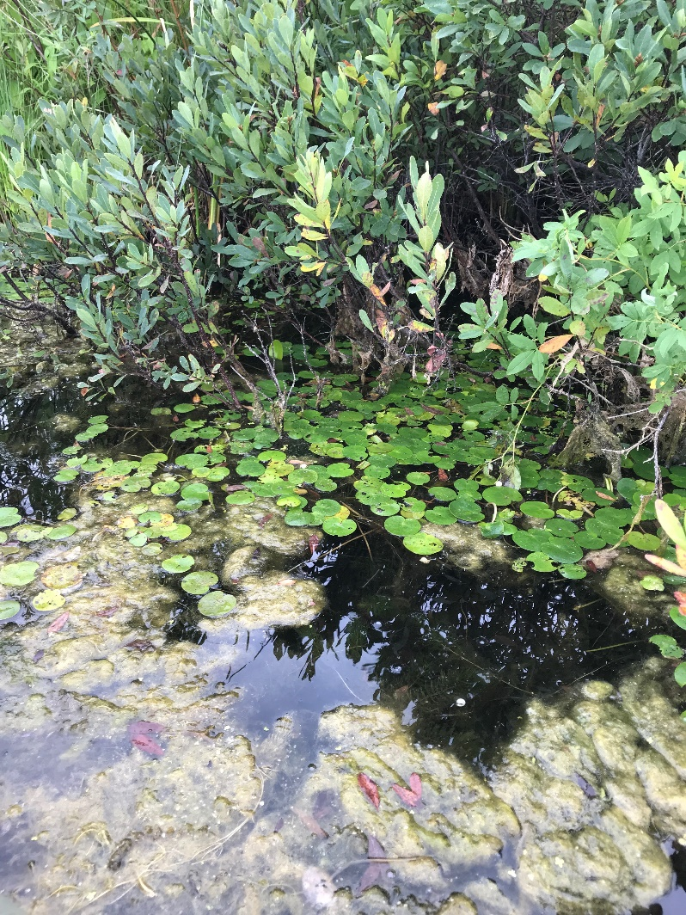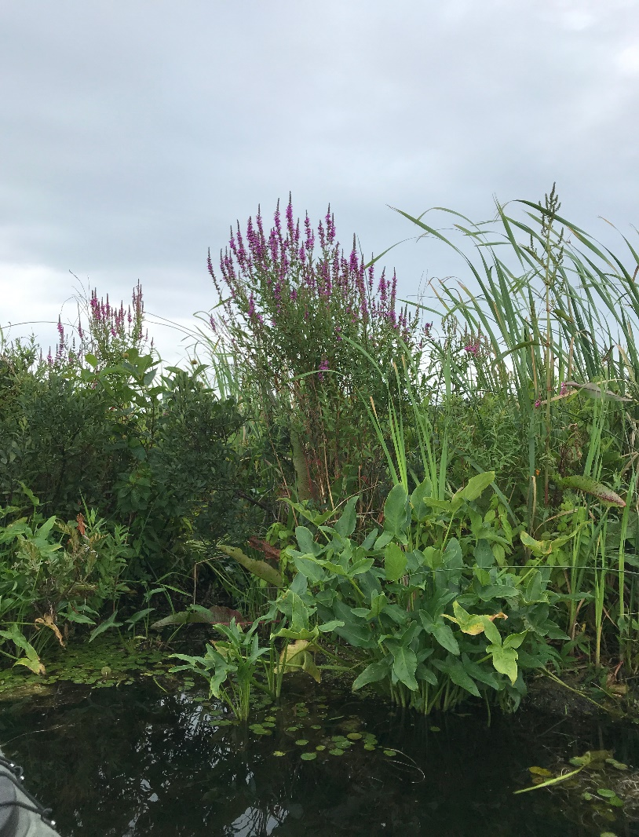

Figure 3. Shoreline survey of Weaver Lake.
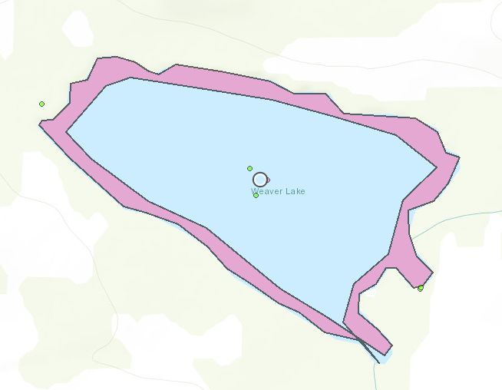

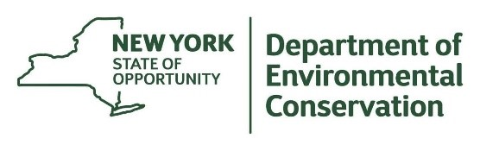
The New York State Department of Environmental Conservation provides financial
support to The Capital Mohawk PRISM via the Environmental Protection Fund.

