Capital Region PRISM Invasive Species Fact Sheet
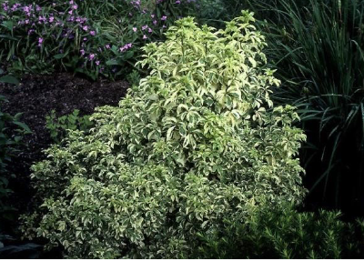
Five-leaf Aralia (Eleutherococcus pentaphyllus)
Background: This invasive shrub is native to China and has been used in landscape in shade gardens and shrub borders for its sharp thorns that keep out deer and intruders.
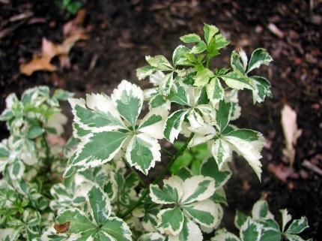
Description: This shrub has small green-white flowers that grow in umbels that appear in umbels in the spring. The species is dioecious, which means it needs male and female plants present to reproduce. When pollinated, it grows small black berries. The thorns appear beneath the stem nodes present at the base of the leaf’s petiole. Those leaves are palmate compound and sometimes variegated, while its stems smell like gin when broken. Average height for the shrub is seven to ten feet tall when fully grown and at that height it is known to reproduce by suckering.
Flowering: Small green-white umbels that bloom in the spring. The flowers are not the best identifying feature of this shrub due to their inconspicuousness.
Look-alikes: Though sharing a name with Aralia species such as Japanese Angelica Tree, the plant does not look much like it at all. The leaf structure does resemble Bishop's goutweed (invasive) and Virginia creeper (native).
Control Methods:
Manual/Mechanical: Cutting is not recommended.
Chemical: Chemical herbicides can be effective. Contact your local PRISM for more information on herbicide use. It is your responsibility to fully understand the laws, regulations and best practices required to apply pesticides in a responsible manner.

