Capital Region PRISM Invasive Species Fact Sheet
Yellow Archangel (Lamiastrum galeobdolon)
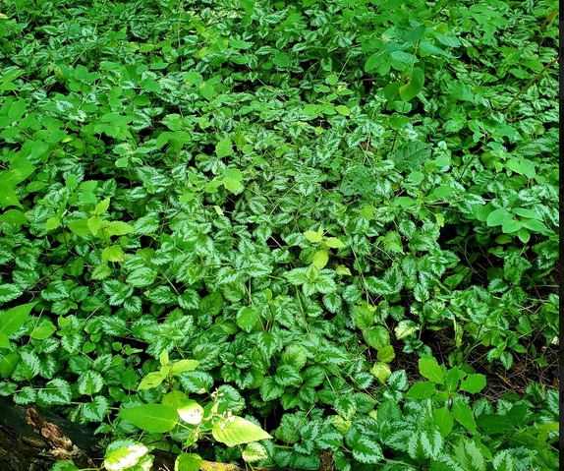
Background: Ornamental groundcovers have a way of becoming invasive. They form dense patches that shade out and outcompete natives. They easily escape cultivation and should be avoided regardless of how pretty the leaves are. Yellow archangel is a widespread plant in Europe and has been introduced elsewhere as an ornamental groundcover.
Description: This plant grows 1-2 feet tall and has underground runners that connect individuals. A member of the mint family, it looks the part, though with a variegated leaf. It can grow in deep shade and has a somewhat vine-like growth pattern similar to that of a creeping jenny or moneywort. It has hairy, square stems like other species in the family. The leaves are coarsely serrated and ovate to chordate.
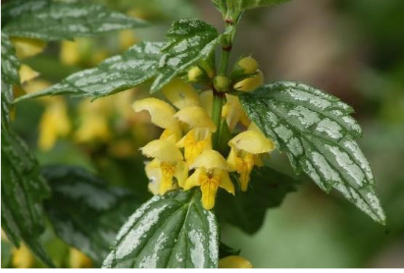
Flowering: Yellow Archangel flowers in the late spring-early summer months in small hooded flowers of a soft yellow color.
Look-alikes: None
Control Methods:
Manual/Mechanical: Yellow archangel has shallow but dense root systems so they are easy to pull but it is important to pull up as much of the roots as possible. Any fragments left in the soil can regenerate into a new plant. This is easiest to do when the soil is moist. Covering the infestation following manual hand-pulling is recommended, either with tarp or plastic then cover with mulch. Bag and dispose of plant material in the landfill, composting will not kill the plant.
Chemical: Systemic herbicides can be effective. Contact your local PRISM for more information on herbicide use. It is your responsibility to fully understand the laws, regulations and best practices required to apply pesticides in a responsible manner.

