Capital Region PRISM Invasive Species Fact Sheet
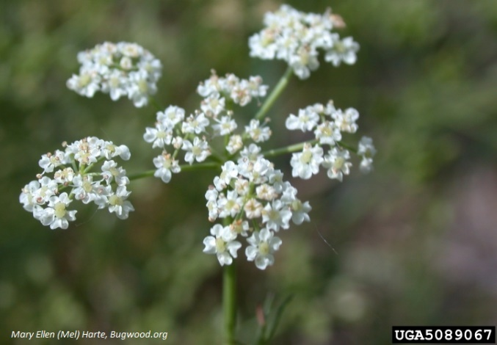
Common Caraway (Carum carvi)
Background: Wild, or Common Caraway, is a native to Eurasia can be found thriving in disturbed areas and roadsides. While it is naturalized in many locations, it has a high invasiveness score which indicates negative impacts to native ecosystems where it is established. Caraway can survive light frosts and temporary flooding.
Description: In the first year, you can identify this plant by the carrot-like leaves and slender tubers. Mature plants can be identified by the hollow stem and flowers.
Flowering: Flowers are white or pink and grow in compound umbels from June to July.
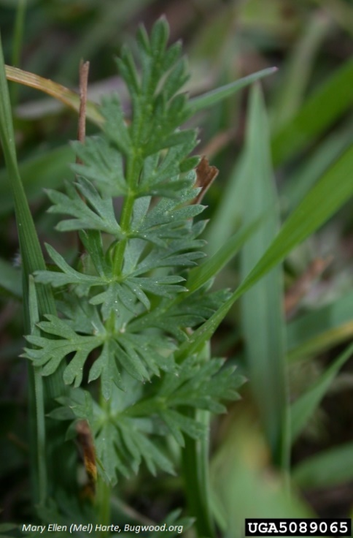
Look-alikes: Tree of Heaven (invasive but wide-spread) Devil’s Walking Stick and Prickly Ash (native)
Control Methods:
Manual/Mechanical: Hand pulling plants can be effective if care is taken not to drop seeds in the process. Bagging and disposing of plant material in a landfill is the safest way to dispose of this plant. Mowing and cutting is NOT effective as it will re-bloom below the cut. Removals may be necessary for several years until seed bank is depleted.
Chemical: Chemical herbicides applied within the first year of growth before bolting is the most effective. It is your responsibility to fully understand the laws, regulations and best practices required to apply pesticides in a responsible manner.

