Capital Region PRISM Invasive Species Fact Sheet
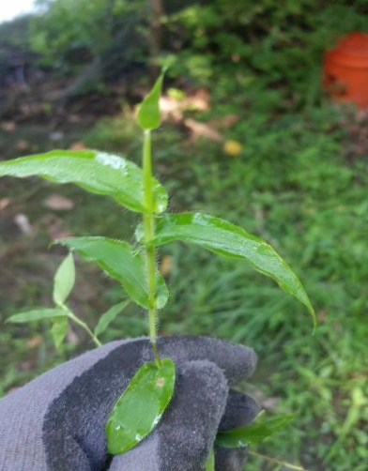
Small Carpetgrass (Arthraxon hispidus)
Background: Small carpetgrass is native to East & Southern Asia, and Africa and has only been found in a few locations state-wide, all along the Hudson River and its tributaries. The only population in the Capital region was found on Murderers Creek in Greene County. This plant poses a threat because of its high seed bank capability.
Description: This annual grass is smaller than some of its look-alikes, only growing about 1.5 feet tall. The most identifying feature of this grass are the somewhat wavy leaves that have hairs along the mar-gins. The flowers grow in spikelets that come out in September and October. It often grows along water-ways and in wet soils in sunny areas. It often grows in dense patches
Flowering: Flowers of this grass bloom in early fall, growing in spikes that reach three inches long.
Look-alikes: Wavyleaf Basketgrass (Invasive) and its look-alikes, Japanese Stiltgrass (Invasive) and Deer-Tongue Grass (native) and the closest lookalikes to this plant. Look for the hairy margins of Arthraxon as well as the heart-shaped leaf base that wraps all the way around the stem.
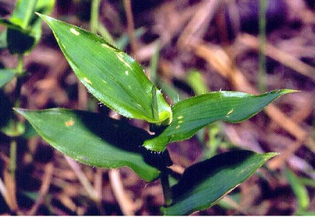
Control Methods:
Manual/Mechanical: Pull out grass and root system, put in a plastic bag, and dispose of in a secure system.
Chemical: Chemical herbicides applied can be effective, contact your local PRISM for more information.

