Capital Region PRISM Invasive Species Fact Sheet
Cow Parsley, Wild Chervil (Anthriscus sylvestris)
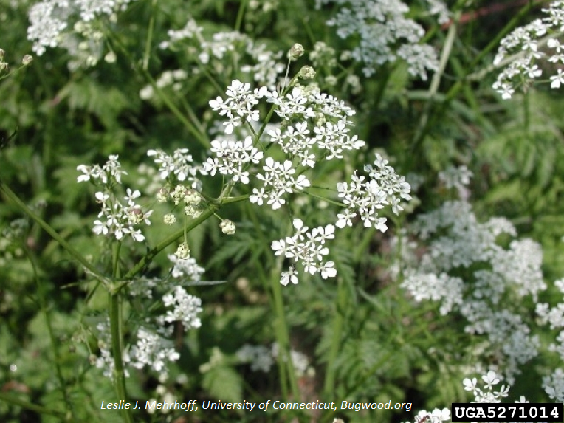
Background: Wild Chervil is a serious pasture invader. This European species was introduced to North America in wildflower seed packs and once established, has been documented to take over pastures and other areas, crowding out favorable forage and native species. This plant aggressively invades roadsides, open forests, and fields. Wild chervil is also a host to the parsnip yellow fleck virus, which is a virus that can infect and damage carrot, celery, and parsnip crops.
Description: This is an upright perennial herbaceous plant that grows up to 3 feet tall and has a tuberous root that can extent 6 feet below the soil. The leaves are alternate and have a fern-like appearance. Hard to distinguish from other parsley and carrot species but the stems are green and ribbed with hair on the lower part of the stem and hair around the stem nodes.
Flowering: Wild chervil flowers are umbels of small white flowers with 5 petals on each. They bloom April until July, depending on location.
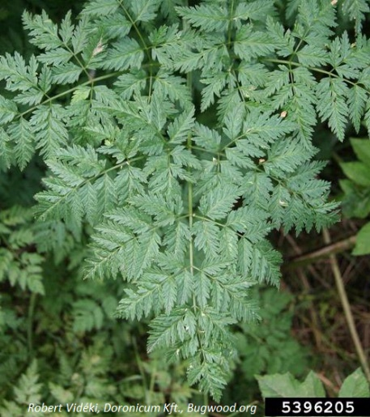
Look-alikes: Most species in the carrot family look similar.
Control Methods:
Mechanical: Hand pulling and digging up plants with care to make sure you remove the entire root system. Repeated mowing and cutting will deplete the energy stores in the root which can prevent the plant from going to seed and eventually kill the plant.
Chemical: Foliar spray can be effective. Visit the Wisconsin DNR website for a comprehensive guide to management of wild chervil. Always follow labels and adhere to you state laws.
*Plant may cause skin irritation. Use caution and wear gloves when handling.*

