Capital Region PRISM Invasive Species Fact Sheet
Cup-Plant (Silphium perfoliatum var. perfoliatum)
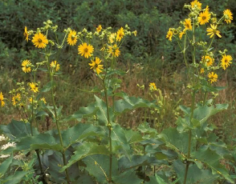
Background: The one documented occurrence of this plant in the Capital Region is at Saratoga Battlefield National Park. Though native to central US and Canada, this species is considered highly invasive in New York State where its large size can prevent native species from growing. There are larger populations of this plant in the Adirondacks in Keene Valley and along river’s edge sites.
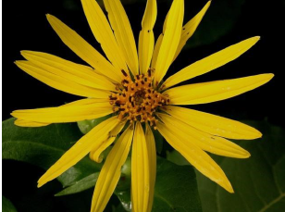
Description: This plant is a perennial and grows somewhere between four and ten feet tall. It has large, opposite leaves which form cups around the stem where the plant holds water. The seeds are spread via wind and water dispersal.
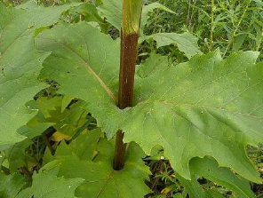
Flowering: The flowers resemble two to five inch sunflowers and have 20-35 rays around a darker yellow center. This plant blooms in early summer to early fall.

Look-alikes: Cup plant looks like sunflower species such as woodland sunflower but is distinguishable by its wide perfoliate leaves that can hold water as well as the hairless square stems.
Control Methods:
Manual/Mechanical: Plants can be hand pulled when possible, though there is a taproot that must be completely removed for true eradication efforts.
Chemical: Chemical herbicides can be effective. Contact your local PRISM for more information on herbicide use. It is your responsibility to fully understand the laws, regulations and best practices required to apply pesticides in a responsible manner.

