Capital Region PRISM Invasive Species Fact Sheet
Japanese Maple (Acer palmatum)
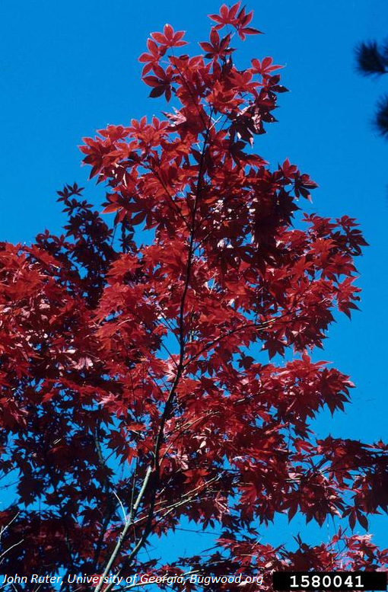
Background: Introduced in the 1800’s, Japanese maple is one of the most popular ornamental trees due to its extremely attractive foliage. While it is a prolific seeder, it seems to have a relatively low rate of escape from cultivation but in areas where more than one Japanese maple is planted, numerous seedlings have been found nearby. Though pretty, this is an adaptable, shade-tolerant tree that can take the place of native maples in our forest, providing little in the way of ecological value to native insects and animals. Deer do not browse this tree, so in areas of high deer browse pressure, native maples would succumb to browsing and unfavorable species such as this invasive can proliferate.
Description: With a wide variety of cultivars, this plant can have a wide variety of leaf shapes, though these are typically palmately lobed with an odd number of acutely pointed lobes. The fruit, like other species of maple, is a pair of winged samaras. (helicopter-like seeds that disperse by wind) It is noted that this tree has genetic variation that can be easily seen even in a single generation. Many seedlings display traits that the parent tree does not show. In our forests, seedlings from red ornamental trees often show up as small, innocuous green seedlings.
Flowering: Japanese maples have small reddish flowers that bloom between May-June. They are pollinated by insects.
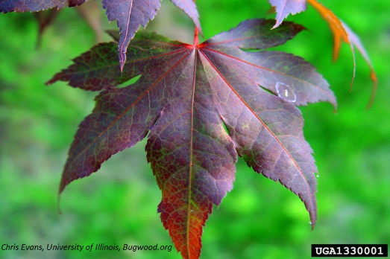
Look-alikes: This species most looks like the native Silver Maple (Acer saccharinum), one of the most populous trees in our forests. The lobes of Japanese Maple are much pointier than the wider Silver Maples.
Control Methods: Small seedlings and saplings can be pulled.

