Capital Region PRISM Invasive Species Fact Sheet
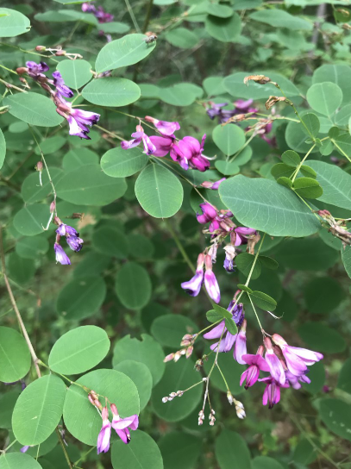
Shrubby Bushclover Lespedeza (Lespedeza bicolor)
Background: This unique bushclover, like its name suggests, is more of a shrub than an herbaceous plant. Planted for quail forage and sold in the nursery industry, there has only been one occurrence of this species in up-state New York, found in Daketown State Forest by Capital Region PRISM staff in 2018 and management began in 2019. This plant is a more serious pest in southern states, which makes it worth monitoring as the climate changes.
Description: This species, when fully grown, has a thin-stemmed shrubby look with twigs and branches that cascade downward. It grows up to ten feet tall with trifoliate leaves with almost circular leaflets. The leaves are alternate and the lower surface of the leaf is lighter than the top. It thrives in meadow habitat and strongly colonizes after burning.
Flowering: As this species is a legume, the flowers are pea-like and pink in color. Some of these flowers self-pollinate and therefore never open. The flowers that do open are present from June to September, producing flat seed pods holding a single black seed in August which persist through March.
Look-alikes: There are a few ornamental Lespedezas that resemble this species such as liukiuensis and thunbergii, but in terms of native species, most of the look-alikes are vining species such as hog peanut and to a lesser extent, poison ivy.
Control Methods:
Manual/Mechanical: Repeated cutting and mowing may suppress populations but currently there aren’t many successful manual methods for eradication.
Chemical: Herbicides can be effective. Contact your local PRISM for more information on herbicide use. It is your responsibility to fully understand the laws, regulations and best practices required to apply pesticides in a responsible manner.

