Capital Region PRISM Invasive Species Fact Sheet
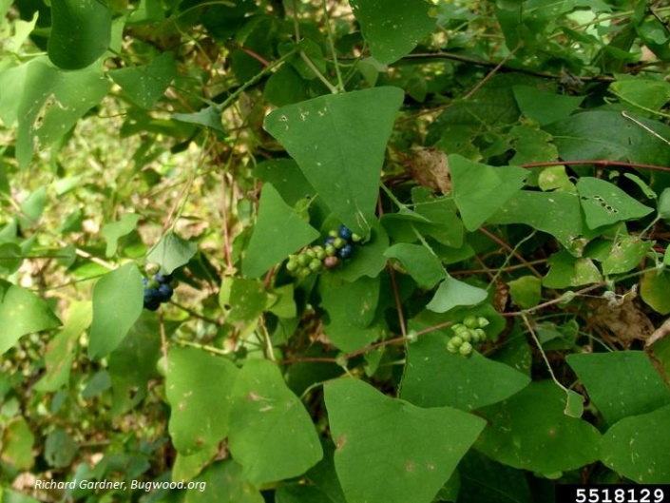
Mile-a-Minute Weed (Persicaria perfoliata)
Background: Mile-A-Minute Vine was introduced in Pennsylvania where it existed for about 40 years locally before its population exploded. Its native range includes India, Eastern Asia and the islands from Japan to the Philippines.
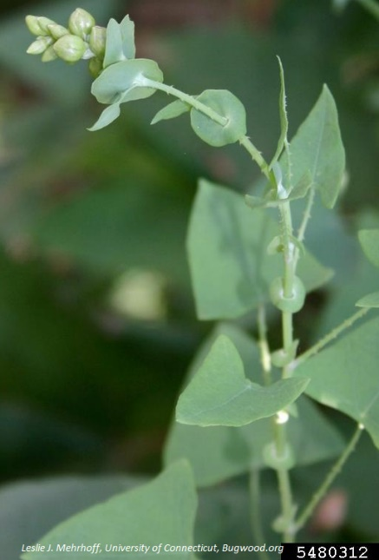
Description: The petioles and stems of this plant have recurved hooks which don’t necessarily hurt but can cause itching and discomfort. The plant begins to form green fruits that become metallic blue as they mature from a rounded ocrea structure in the late summer months. The leaves are almost precisely tri-angular as opposed to chordate and the stems are identifiably red in color. Sometimes the plant will have round holes in it from weevil browse.
Flowering: Mile-a-minute has small, white flowers that are at the ocrea where the fruit is later formed.
Look-alikes: Halberd-Leaved Tearthumb (native) has arrow shaped leaves as opposed to triangular.
Control Methods:
Manual/Mechanical: Young vines can be pulled by hand wearing gloves to avoid injury from the recurved barbs along the stems. All plant material should be bagged and left to solarize or sent to a sanitary landfill. Follow-up treatment will be necessary.
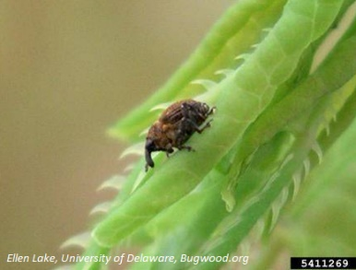
Chemical: It can be effectively controlled using herbicides. Contact your local PRISM for more information on herbicide use. It is your responsibility to fully understand the laws, regulations and best practices required to apply pesticides in a responsible manner.
Biological Control: The mile-a-minute weevil, Rhinocominus latipes Korotyaev, is a 2 mm long, black weevil which is often covered by an exuded orange film produced from the mile-a-minute plants it feeds on. This small weevil is host-specific to mile-a-minute weed and has been successfully released and recovered in multiple locations in the U.S.

