Capital Region PRISM Invasive Species Fact Sheet
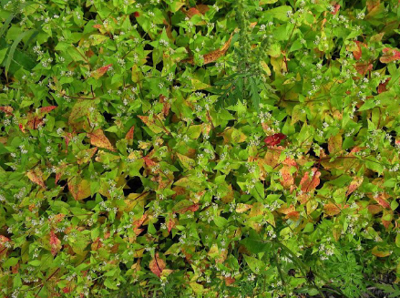
Nepalese Smartweed (Polygonum nepalense)
Background: This invasive has a vast predicted distribution range but is present in select spots at this point in time, making it a target for management at the state level. It is often found in gravel and right-of-way’s, growing in a weedy fashion much like other smartweeds.
Description: Nepalese Smartweed is a low growing herbaceous plant that is becoming more and more common in the Catskill region of New York. It has triangular, simple leaves which have a dark purplish marking and an entire leaf edge. It grows in a patchy formation and would rarely be noticed if only a single plant was present. The easiest way to recognize this plant is the flower, which blooms in late summer.
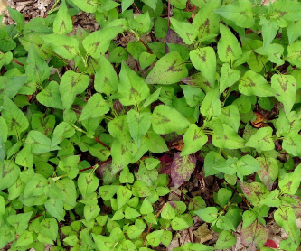
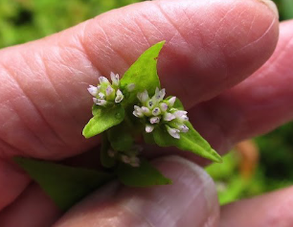
Flowering: The whitish pink flowers of Nepalese Smartweed are closed tightly and appear in late summer near the very end of August in our area.
Look-alikes: Other native smartweeds such as Pennsylvania Smartweed and non-native smartweeds such as Chinese Smartweed. The circular flower of this smartweed is fairly characteristic when combined with the very triangular leaf shape.
Control Methods:
Manual/Mechanical: This species can conceivably be controlled with hand-pulling when present in small patches, though there has been very little supporting information due to a lack of test projects. All plant material should be bagged and left to solarize or sent to a sanitary landfill. Follow-up treatment will be necessary.

