Capital Region PRISM Invasive Species Fact Sheet
Policeman’s Helmet, Himalayan Balsam
(Impatiens glandulifera)
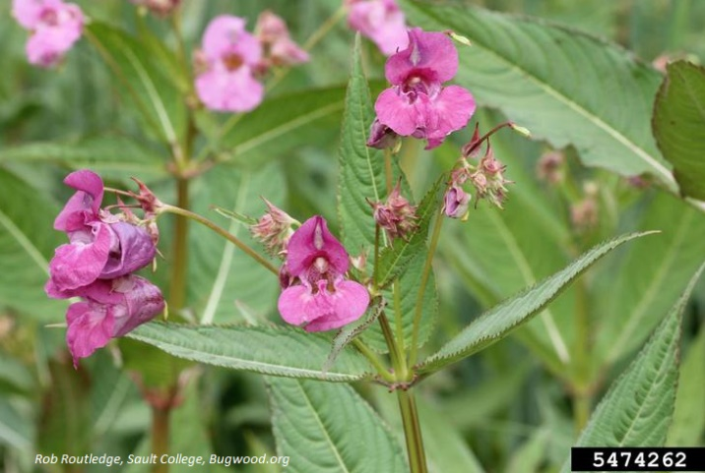
Background: Though there are a number of different infestations of this plant in New York State, there is only one re-ported in the Capital Region. This species is related to Jewelweed and shares the unfortunate trait of exploding seed pods with native Jewelweed species, making eradication efforts time sensitive so it is not spread.
Description: Though there are a number of different infestations of this plant in New York State, there is only one re-ported in the Capital-Mohawk Region. This species is related to Jewelweed and shares the unfortunate trait of exploding seed pods with native Jewelweed species, making eradication efforts time sensitive so it is not spread.
Flowering: This species is in flower from early August through September, when it usually begins fruiting. The flowers are hooded and white to pink with serrated edges.
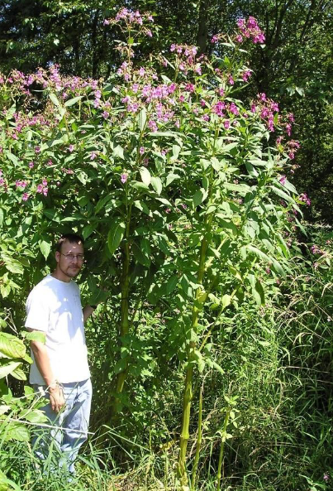
Look-alikes: Orange Jewelweed (native) has similar flowers and habitat to Policeman’s Helmet, though like the name suggests the flowers are a different col-or. The leaves show differences as well.
Control Methods:
Manual/Mechanical: This plant pulls up easily, making manual control for this plant a good option before the plant goes into seed in September.
Chemical: Systemic herbicides can be effective. Contact your local PRISM for more information on herbicide use. It is your responsibility to fully understand the laws, regulations and best practices required to apply pesticides in a responsible manner.

