Capital Region PRISM Invasive Species Fact Sheet
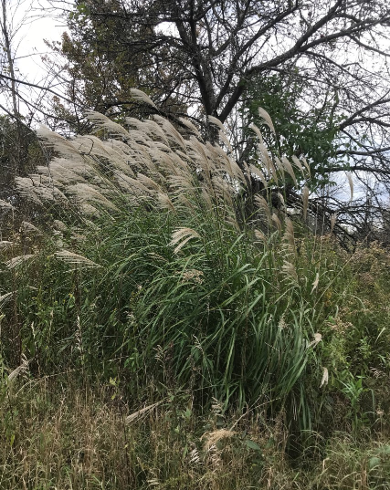
Chinese Silvergrass (Miscanthus sinensis)
Background: Miscanthus is arguably one of the most popular invasive landscaping plants and exists in over 50 cultivars that have their invasiveness potential under review. The plant is on the restricted species list and would most commonly be seen in a grassland or meadow habitat. Chinese silvergrass is native to China, Japan, Taiwan, and Korea. There are cultivars of Miscanthus that may not possess invasive characteristics or are sterile. It is important to know which species and cultivars you have and the regulations associated with them to prevent spread of Miscanthus sinensis.
Description: Miscanthus is identifiable from the silvery mid-vein that runs along the length of the grass and its large feathery seed heads. It grows in clumps, and can be grown in a wide variety of soils and sun exposures. This is a tall grass, growing to three to seven feet tall when uncut. It slowly expands via the rhizomes that form the clump-like structure beneath the plant. The leaves often tilt down in a fountain-like formation
Flowering: The fan-shaped flowerheads bloom in September to November and the fruits persist through the winter.
Look-alikes: Eastern gamagrass (native) does not have showy flowering spikes like Miscanthus and its seeds are chunky like corn kernels. Japanese Silver Grass, a less-common invasive Miscanthus species, has also been reported in New York.
Control Methods:
Manual/Mechanical: Control of this plant can be achieved by digging up entire root structure with a pick mattock, which will work much better than a shovel. All plant material should be bagged and left to solarize or sent to a sanitary landfill. Follow-up treatment will be necessary.
Chemical: It can be effectively controlled using any of several readily available general use herbicides such as glyphosate or imazapyr. Contact your local PRISM for more information on herbicide use. It is your responsibility to fully understand the laws, regulations and best practices required to apply pesticides in a responsible manner.

