Capital Region PRISM Invasive Species Fact Sheet
Japanese Spiraea (Spiraea japonica)
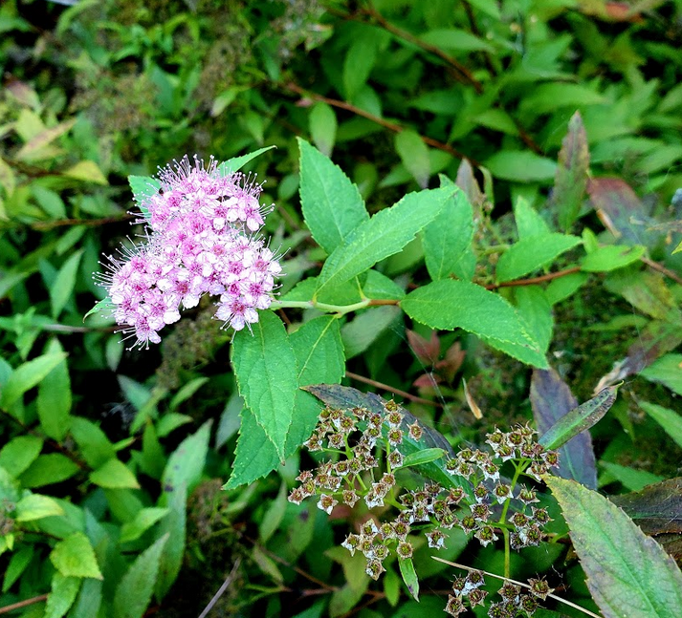
Background: A common presence in landscaping, Japanese Spirea has escaped cultivation in the Lower Hudson valley as well as in Columbia Co. There are many cultivars of this plant available and it was first introduced in the 1870s to the US where it spread throughout the Mid-west and Northeast.

Description: This plant has alternate, simple leaves on reddish-brown stems. The edges of the leaves are sharply toothed, unlike the lobed native meadow-sweets. This plant appears to prefer wetland habitats and riparian areas in the U.S and loses its leaves in the winter. Each plant is capable of vigorous seed production, and the seeds are then spread by the running water in its preferred habitat. The plant is usually four to six feet in height

Flowering: Flowers of this plant grow in clusters, often pink or white in color. These clusters appear at the tips of the branches.

Look-alikes: There are a number of native meadow-sweets but again, they can be differentiated by leaf shape and sometimes leaf color. Steeplebush is the closest look alike but its leaves end in a rounded tip unlike the pointy tip of Japanese Spiraea.
Control Methods:
Manual/Mechanical: Repeated mowing and cutting of this plant can help to control it in specific areas but may not eradicate the population. Small plants may be pulled by hand. Bag all plant parts and dispose of in a sanitary landfill. Repeated pulling may be needed.
Chemical: Foliar herbicide can be affective for large infestations. Contact your local PRISM for more information on herbicide use. It is your responsibility to fully understand the laws, regulations and best practices required to apply pesticides in a responsible manner.

