Capital Region PRISM Invasive Species Fact Sheet
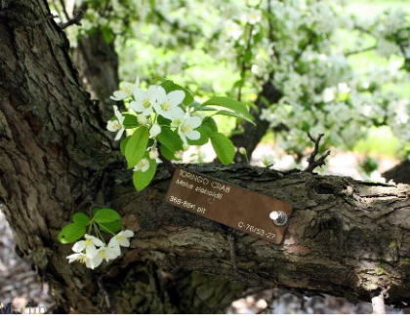
Toringo Crabapple (Malus sieboldii)
Background: There is one patch of Toringo Crabapple reported in the region, right on the border of Columbia County. This plant is widespread in New Jersey and more populations are probably present in the region.
Description: The bark of Toringo Crabapple is thin, smooth, and grey. Leaves are variable, with some appearing as simple and oblong and others with a characteristic three-lobed shape, though all leaves are slightly serrated. Fruit are yellow to red, somewhat small and growing in clusters that stick out on stems a few centimeters long from the main twig. The family generally enjoys full sun and slightly acidic soils.
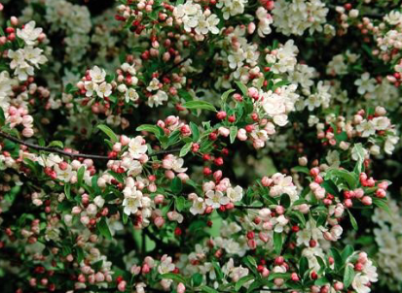
Flowering: Flowers of this plant are white and showy with five petals which bloom in spring.
Look-alikes: Other species of crabapple in the genus Malus look like Toringo Crabapple, though they each have individual differences, commonly in the flowers.

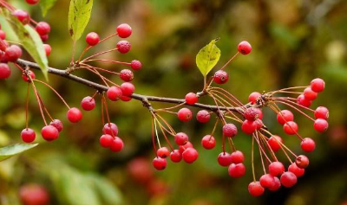
Control Methods:
Manual/Mechanical: Seedlings can be pulled up but manual control is harder for large, mature trees.
Chemical: Herbicides can be effective. Contact your local PRISM for more information on herbicide use. It is your responsibility to fully understand the laws, regulations and best practices required to apply pesticides in a responsible manner.

