## Capital Region PRISM Invasive Species Fact Sheet

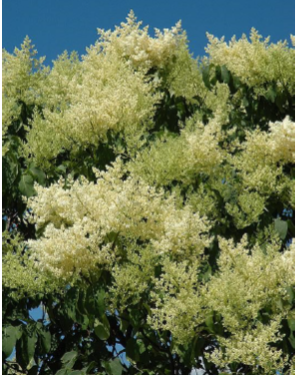Japanese Tree Lilac (Syringa reticulata)

**Background:** This invasive species is one of the few that has no populations in New York State outside of the Capital region, making it a strong regional priority. There is a large infestation in the East Nassau area where a population has been allowed to grow un-checked probably for many years

**Description**: This tree grows larger than the shrub lilacs, from 15 to 40 feet tall. It has reddish-brown, cherry-like bark with lenticels and its simple leaves grow in opposite formation. The leaves are ovate and dark green with a rounded base. The fruit of this plant grows in dry capsules that group together like the flowers. This plant is in the olive family and loses its leaves in the fall. The stems are shiny and brown and buds have four pairs of scales.

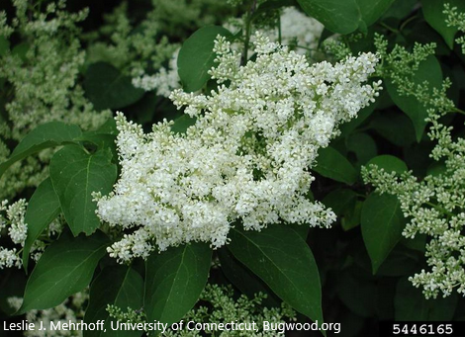**Flowering:** The small, fragrant flowers grow in large white clusters in the spring usually the beginning of June, lasting only for a couple weeks.

**Look-alikes:** Looks like the Chinese Tree Lilac (non-native) as well as shrub Lilacs. (Non-native).

**Control Methods:   
  
Manual/Mechanical:** Small saplings can be hand pulled. Larger trees are harder to manage. Pruning can reduce flowering.

**Chemical:** Unknown